The 20th International DAAAM SYMPOSIUM
"Intelligent Manufacturing & Automation: Theory, Practice & Education"
25-28th November 2009, Vienna, Austria

STUDY OF INCREMENTAL HOT TUBE BENDING

Keran, Z[denka]; Novosel, I[vica] & Math, M[iljenko]

Abstract: Hot tube bending is used when bending of large diameters, range 150 to 400 mm and wall thickness in range 15 to 25 mm is needed. Processing of prescribed dimensional characteristics requires two possible bending types which are flat pattern tube bending and incremental hot bending. The best process characteristics are obtained with incremental hot bending. This process is still very new and needs further improvement. The article gives detailed description of two types of incremental hot bending. Also, graphic presentation of stresses and strains in a tube wall is given too. This graphical data are reached by numerical simulation using MSC Marc Mentat program package.
Key words: flat hot tube bending, incremental hot bending, large diameters and wall thickness.

1. Introduction

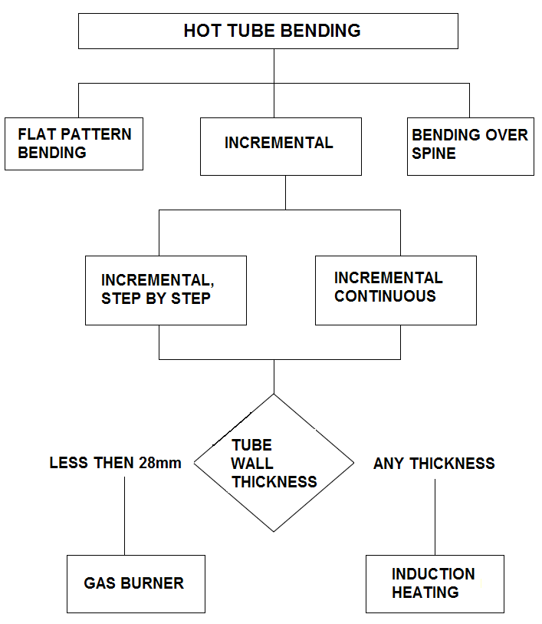
Fig. 1. Division of tube bending processes in hot state.

Tube bending to a predetermined radius is an important part of technological process of steam boiler building and also of building of pressurized delivery pipe. Bend is defined by tube radius, wall thickness, and middle bend radius that goes through centre of ideally circular cross-section of the tube. During bending process changes of initial geometry occur. Tube is deformed in a way that its wall becomes thicker on the inside radius and thinner on the outside radius. Cross-section is no longer ideally circular and it becomes oval (Hribar, 1975). Appearance of cracking and wrinkling can happen on the outside or inside radius of bend (Al-Qureshi, 1999). Tolerances of geometry changes are defined by specifications. Other defects like cracking and wrinkling are not allowed.
Hot tube bending is used when bending of large diameters is needed or when large deformation takes place. If tubes of large diameters are subjected to large pressure, their wall thickness must also be great. Bending of such tubes is also performed in hot state using flat pattern bending or incremental tube bending.
In distinction from flat pattern bending, incremental tube bending is newer procedure, and is still approved by new acknowledgements and researches. It is showing some advantages regarding flat pattern bending which was recently standard forming procedure for mentioned purpose.
Forming parameters like temperature and forming speed are different form one procedure to another. When using incremental bending, very rapid are transitions from cold to hot areas. Also, this procedure uses cold area as some sort of a tool. Because of that, stress-strain fields act differently and favourably for mentioned use.

- HOT TUBE BENDING USING CONTINUOUS INCREMENTAL PROCEDURE

Searching bending procedure that could be automated, continuous incremental procedure has been developed. It is arranged in a way that tube is fixed to a movable hand and mechanically or hydraulically forced through induction or gas heater. Bending occurs in locally heated part of a tube because movable hand is rotating around centre of rotation, and during that rotation tube is bending following the track of the hand. Heated and bended zone needs to be immediately cooled. Cooling is accomplished using air under high pressure, or using water jet. Forcing speed is dependable to a tube thickness, tube material and to a temperature field through the tube wall. Bending radius is determined by adjustment of jaws position on the movable hand.
Bending process on a machine that is shown on Fig. 2 is performed on the following way:
1 – The tube (1) is fixed, in horizontal position, on the machine body, so that the first part of tube arc is in the same plane as heater (4). It is clutched into movable hand jaws (2) and drew onto forcing spine (10).
2 – The position of jaws (2) is determined by demanded bending radius.
3 – Tube heater is activated and starts heating the bended tube zone.
4 – Turning on a machine drive, the forcing spine is moved, it is pushing a tube which is now bended around centre of rotation of the moving hand.
5 – Bended part of a tube is cooled using water jets.
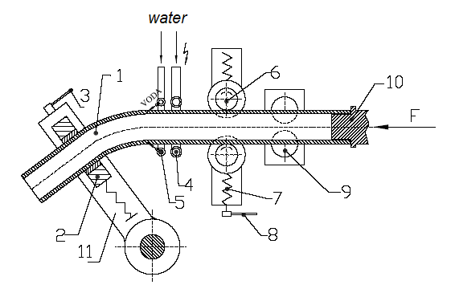
Fig. 2. Functional scheme of continuous incremental bending procedure: (1) Tube, (2) Jaw, (3) Handle, (4) Gas or induction heater, (5) Cooling water jets, (6) Support rollers, (7) Leading rollers, (9) Cross slide, (10) Forcing spine, (11) Movable hand (Novosel, 2008).
- HEATING PROCEDURES

There are two possible procedures of tube heating. The first and older one is heating by gas burner. The second is new – heating using electric induction.
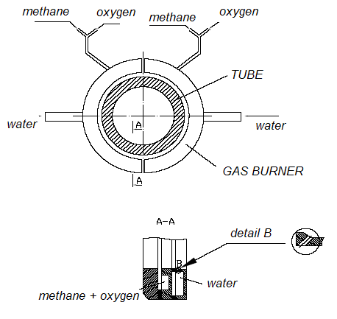
Fig. 3. Gas burner that is used on the first machine for incremental hot bending (Novosel, 2008).

The very first models for incremental hot tube bending used gas burner for tube heating before bending takes a part. Gas burner uses mixture of methane and oxygen. When heating with this mixture, the tube is heated on working temperature of ~900ºC. Heating speed is a little bit lower then it is if electric induction is used, and heated depth is maximally 28 mm. When middle-sized boilers are produced, the tube thickness is rarely greater then 28 mm. Gas burner is made of two separated halves of a ring and each one possesses two chambers: one for the gas, and the other for the water. In the gas chamber the gas mixture is made, it is exuding through a small seam between the chamber and flange.
When the gas mixture is out of the chamber it is burning and making concentric flame around the tube. The water chamber is cooling a gas burner, and also directing a water jet to a bended tube. The water is now cooling the tube. Every tube diameter has its own gas burner. Clearances between the gas burner and the tube must be optimal. The great advantage of gas burner toward electric induction is simple achieving of intensive heating of internal arc radius.
The main characteristic of electric induction tube heating in relation to heating by gas burner is that heat is generated in the tube itself and the time of heating is very short.
Fig. 4 shows functional scheme of induction heater. Its structure is very simple and composed of two tubes bended in a circle. The first – made in copper is inductor that is cooled by water circulation from the inside. The second tube – made in steel is used for cooling of bended part of the tube (working part). It has holes through its wall that direct trickles under pressure on bended tube. The distance between inductor and cooler can be regulated.
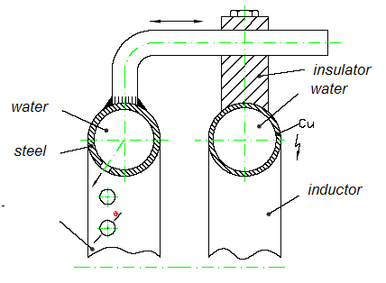
Fig. 4. Functional scheme of induction heater and cooling setup (Novosel, 2008).
4. SIMULATION OF BENDING PROCEDURE

The main intention of numerical simulation of incremental tube bending was to visualise stresses that occur in a tube wall. The numerical analysis was performed using MSC Marc Mentat elasto-plastic program package. In the presented bending problem the full Newton-Raphson iterative procedure is chosen to solve the iteration process and nonlinear equations of motion. 3D model was created by 3D shell elements. It is four nodes, thick shell element with global displacements and rotations. Bilinear interpolation is used for the coordinates, displacements and rotations. The membrane strains are obtained from the displacement field, the curvatures from the rotation field (MARC, 2001). This 3D model is particularly interesting because wrinkling occurrence can be easily detected (Li, 2009).
As it is shown on Fig. 5, if mathematical model consists of similar conditions as the real incremental bending problem, the simulation result shows no occurrences cracks and wrinkling.
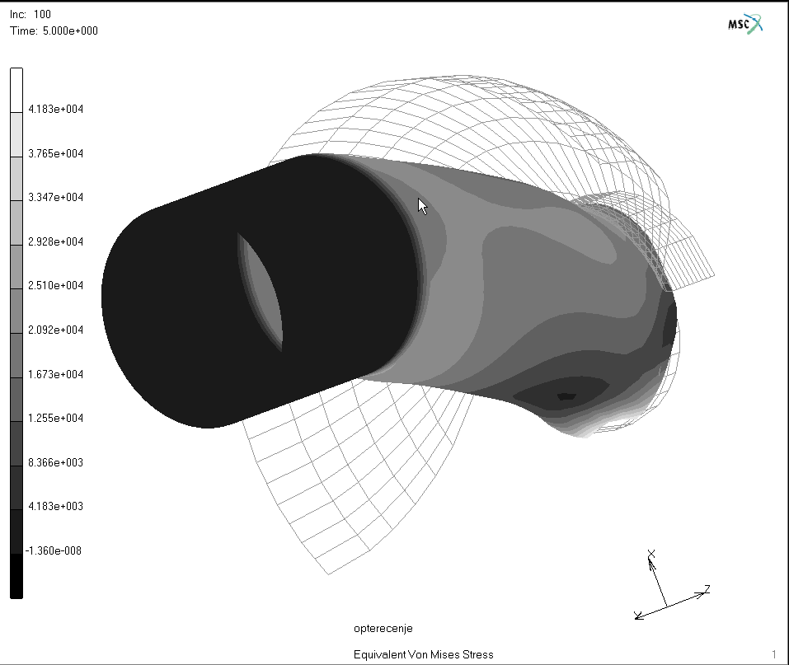
Fig. 5. Equivalent stress in tube bending process calculated using MSC Marc Mentat

5. CONCLUSION

In this article the hot incremental tube bending process has been presented as newer technology for very specific purposes in bending operation. It presents improvement in tube bending technology that occurred in last few years. Also, supporting heating systems have been described and their advantages and disadvantages that can be helpful when choosing the best solution in solving a specific production problem. Finally, numeric simulation confirmed an assertion about usableness of described process. But, as all new technologies, hot incremental tube bending still passes through the process of refinement, particularly in the area of heating procedures.

6. REFERENCES

Al-Qureshi, H. A. (1999). Elastic-plastic analysis of tube bending, International Journal of Machine Tools and Manufacture, Vol. 39, January 1999, Pages 87-104, Available from: http://www.sciencedirect.com/ Accessed: 2009-07-03
Hribar, J. (1975). Plastična obrada metala, SN Liber, ISBN 953-6163-02, Zagreb
Li, H .; Yang, H. & Zhan, M. (2009). A study on plastic wrinkling in thin-walled tube bending via an energy-based wrinkling prediction model, Modelling Simul. Mater. Sci. Eng. Vol. 17, pp.33, Available from: http://www.iop.org/EJ/ Accessed: 2009-07-03

MARC (2001). Product Manual – Program Input, Vol. C, MSC Corporation, Palo Alto
Novosel, I. (2008). Inkermentalno toplo savijanje cijevi velikog promjera, Master Thesis, Available from: http://www.fsb.hr/atlantis/upload/newsboard/17_12_2008__9913_Novosel_magistarski_rad.pdf, Accessed:2008-12-17

