Impact of structure and building orientation on strentgh of 3D printed models
T. Galeta, Slavonski Brod (Croatia)
P. Raos, Slavonski Brod (Croatia)
M. Somolanji, Zagreb (Croatia)

Abstract: The main objective of research was to determine the impact of sample’s structure and building orientation on the tensile strength of 3D printed samples and thus to determine the combination that provides the highest strength. Test samples were prepared on a Z Corporation’s 3D printer model Z310, with variations of internal geometrical structure, variations of longitudinal orientation and also variations of base alignment. Results of tensile test revealed that the honeycomb structured samples built by orienting along axis Y and aligned over their thinner bases inside the printer building box exhibit the highest strength. Moreover, analysis of variance revealed that only individual main factors (structure, orientation and base) and the interaction of all three of them are significant, as well. All experiment combinations revealed applicable strength when compared to full-bodied samples

Keywords: Additive Manufacturing, Lattice-shaped structures, Rapid prototyping, Tensile strength, Three-dimensional printing
- Introduction
Additive Manufacturing (AM), the relatively young manufacturing technology of layer-based automated fabrication process for making three-dimensional physical objects directly from 3D CAD data set was originally called Rapid Prototyping (RP) when the first commercial process – Stereolitography was entered the market in 1987. This technology is still frequently called Rapid Prototyping. An important difference between Additive Manufacturing and two other traditional production techniques – Subtractive Manufacturing (milling, turning etc.) and Formative Manufacturing (casting, forging etc.) is the fact that all of these new techniques build parts by adding material layer by layer. Today, there are many different additive manufacturing techniques with high accuracy and large choices of materials available on the market. The most successfully developed techniques are: Stereolithography (SLA), Selective Laser Sintering (SLS), Laminated Object Manufacturing (LOM), Fused Deposition Modeling (FDM), 3D Printing etc.
During last two decades techniques of additive manufacturing have been tested and used in many different areas: automotive industry, aerospace industry, industry of consumer goods, toy industry, art and history of art, foundry and casting technology, mould and die making industry, architecture and landscaping, medical applications etc. Some of common advantages of existing additive manufacturing techniques are: speed (model building in one day); manufacturing flexibility (almost any geometry can be replicated); high degree of control over part microstructure; wide variety of engineering materials (plastic, metals, and ceramics). They also have some common shortcomings such as: lack of required mechanical properties depending on material combination; lower accuracy (can be improved by additional machining); high computational demands and limited bio-compatibility (important in manufacturing of medical products). Yet, most of listed shortcomings can be successfully avoided in particular case with proper selection of techniques and materials [1].
In our research we have been concentrated on three-dimensional printing (3DP) technique. This process combines a layered approach from RP technologies and a conventional ink-jet printing. It prints a binder fluid through the conventional ink-jet print head into a powder, one layer onto another, from the lowest model’s cross-section to the highest (Figure 1). After printing, the printed models are dried in a building box, then removed from the powder bed, de-powered by compressed air, dried in the oven and infiltrated for maximum strength.
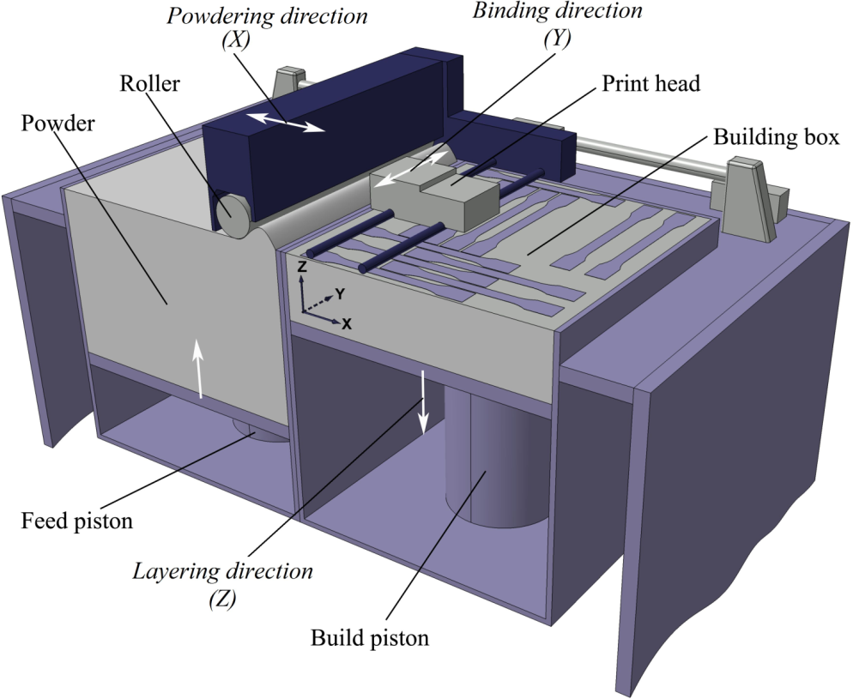
Figure 1: 3D Printer main components – a section view
3D printing technique delivers slightly less details and a rougher surface and it is also less accurate comparing to other AM technologies (e.g. stereolithography, polymer jetting/printing techniques) [2]. The models obtained by 3D printing are not transparent too, but this AM technique is fast and cheap and therefore widely accepted in many areas of application. A comprehensive overview of the capabilities of 3DP processes is presented and evaluated in [3]. It shows the application of 3D printing beyond concept modeling. There are many other studies dealing with various aspects of 3DP processing characteristics, cost evaluation and accuracy, e.g. [4–6].
The investigations on impact of various hollow lattice-shaped structures seem to be very interesting since these structures are very important, particularly in medical tissue engineering applications, but also in some other engineering (light-weight structures, precise casting patterns etc.). Recently, there are many studies on building complex three-dimensional scaffold-like structures using rapid prototyping techniques [7–11]. Although use of rapid prototyping techniques allows the generation of physical objects that would have previously been impossible to manufacture problems are still encountered. Strong influences of chosen additive manufacturing technique in obtaining accurate feature sizes and good pore definition of scaffold-like structures and suitable design of interior microstructure with proper connectivity aiming to obtain a good biological behavior are only some of many studies performing nowadays. However, in all such applications a scoring of sufficient strength and mechanical integrity of structure is a key issue in avoiding a possible fracture risk.
Therefore, the main objective of the research presented in this paper was to determine the impact of sample’s structure and building orientation (longitudinal orientation and base alignment of the model) on the tensile strength of 3D printed samples and thus to determine the combination that provides the highest strength. It is expecting to give us some general observations leading to better design and more efficient additive manufacturing of hollow lattice-shaped structures.
- Equipment, materials and method
The machine, 3D printer, used for these experiments, was the model Z310, a product of Z Corporation, recently acquired by 3D Systems Corporation. It is a low-cost monochrome 3D printer suitable for RP education or for small and medium sized companies. The printer firmware version was 10.158 and test samples were prepared in printer software ZPrint version 7.10.
There are several base materials, i.e. powder types, available for the above mentioned 3D printer. For our experiment we used a plaster-based powder zp130 with an appropriate binder zb56. The powder zp130 is recommended for the accuracy and for delicate models. It is a mixture of plaster, vinyl polymer and sulphate salt [12]. After drying, the samples were infiltrated with the infiltrant, cyanoacrylate-based adhesive Loctite 406.
Three influencing factors were considered in the experiments: sample structure, longitudinal building orientation and base alignment.
In our experiments we used models derived from standard specimens for tensile tests defined in ISO 527:2012 standard. Tensile test model was selected as the base because the tensile strength was the main property tested in these experiments. Three different hollow lattice-shaped structures were considered: honeycomb, drills and stripes (Figure 2). Also, one set of standard compact full-bodied specimens were printed and tested as a control set, analogous to control group in randomized controlled trial.
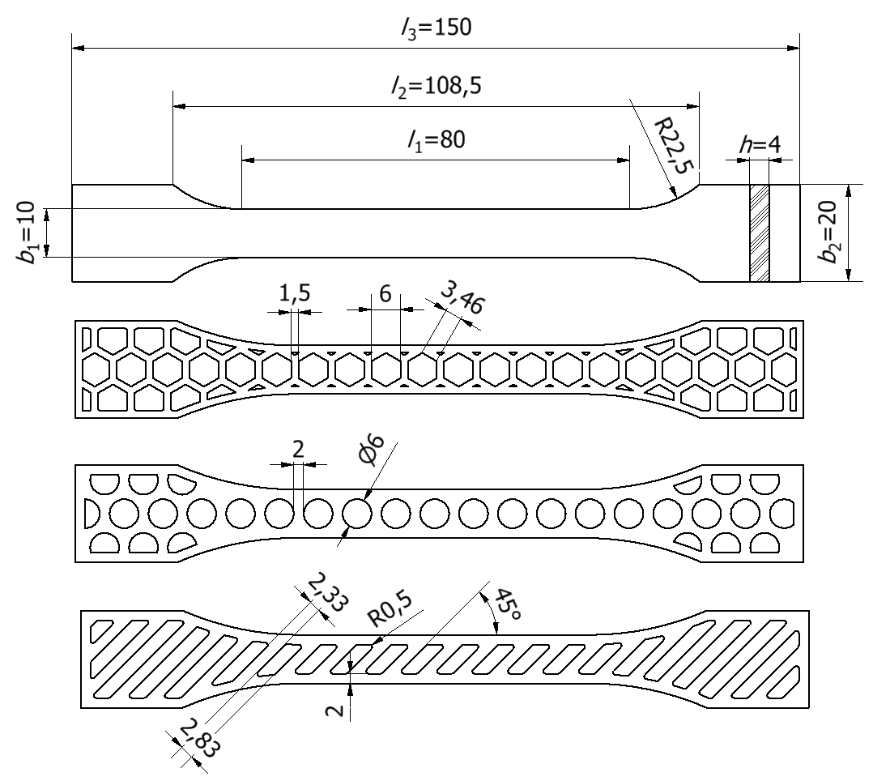
Figure 2: Sample structure types and dimensions (full, honeycombs, drills, stripes)
Every combination of processing factors was denoted with appropriate unique label made of three characters (Table 1). The type of the structure is marked with letter in the front of the label for a particular combination of factors. Experimental factors scheme is shown on Figure 1.
Table 1: Combination of processing factors and experiment labels
Structure | Honeycomb (H) |  |  |  | Drills (D) |  |  |  | Stripes (S) |  |  |  | Full (F)
Orientation | X |  | Y |  | X |  | Y |  | X |  | Y |  | Y
Base | W | H | W | H | W | H | W | H | W | H | W | H | W
Experiment label | HXW | HXH | HYW | HYH | DXW | DXH | DYW | DYH | SXW | SXH | SYW | SYH | FYW

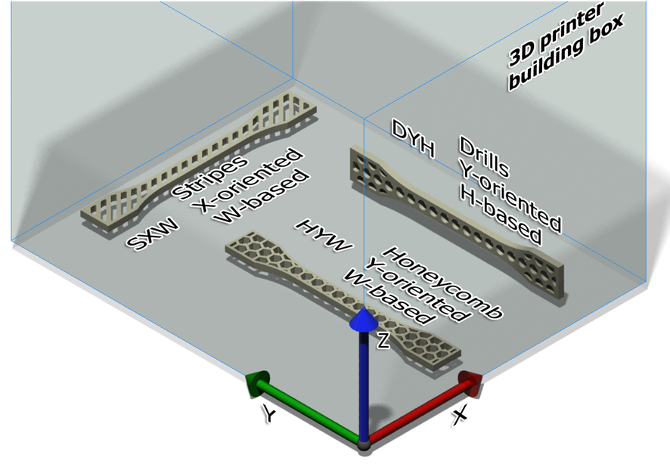
Figure 3: Experimental factors scheme
The sample model can be longitudinally oriented in any possible direction inside the printer building box. Two main longitudinal directions were considered: 1st direction when sample is oriented with largest dimension L towards the building axis X and 2nd direction when oriented towards axis Y (Figure 3). In the experiment label of a particular combination of factors, longitudinal orientation is marked on the second place of the label with letter X or Y respectively. The longitudinal orientation towards the building axis Z was omitted since it significantly prolonged the printing time: for example to print five samples oriented with largest dimension L towards the building axis X it takes only 15 minutes in 39 printed layers; same time and layers are necessary when oriented towards the building axis Y; but when oriented towards axis Z it is prolonged to 3 hours and 51 minutes in 1476 layers. Although all other orientations are also available to combine, additional combinations were omitted in order to reduce the total number of experiments. However, if results of experiments would present significant influence of the orientation on the tensile strength, additional experiments could be performed.
In order to reveal if arising of the samples may affect the strength, two cases of the base alignment or the base orientation were considered. Default printer alignment, when samples are aligned at the bottom of the building box with the face i.e. base determined by the length (L) and width (W) of the sample, were marked with letter W at the end of the experiment label (Figure 3). Raised samples, aligned at the bottom with the base made by length and height (H) were marked with letter H (Figure 3). Full-bodied, compact samples were built in one combination of factors only, Y-longitudinal orientation and W-base alignment (Table 1). Such orientation with the largest dimension of model oriented toward Y axis and the 2nd largest toward X axis is default selection in ZPrint software since it provides the highest printing time.
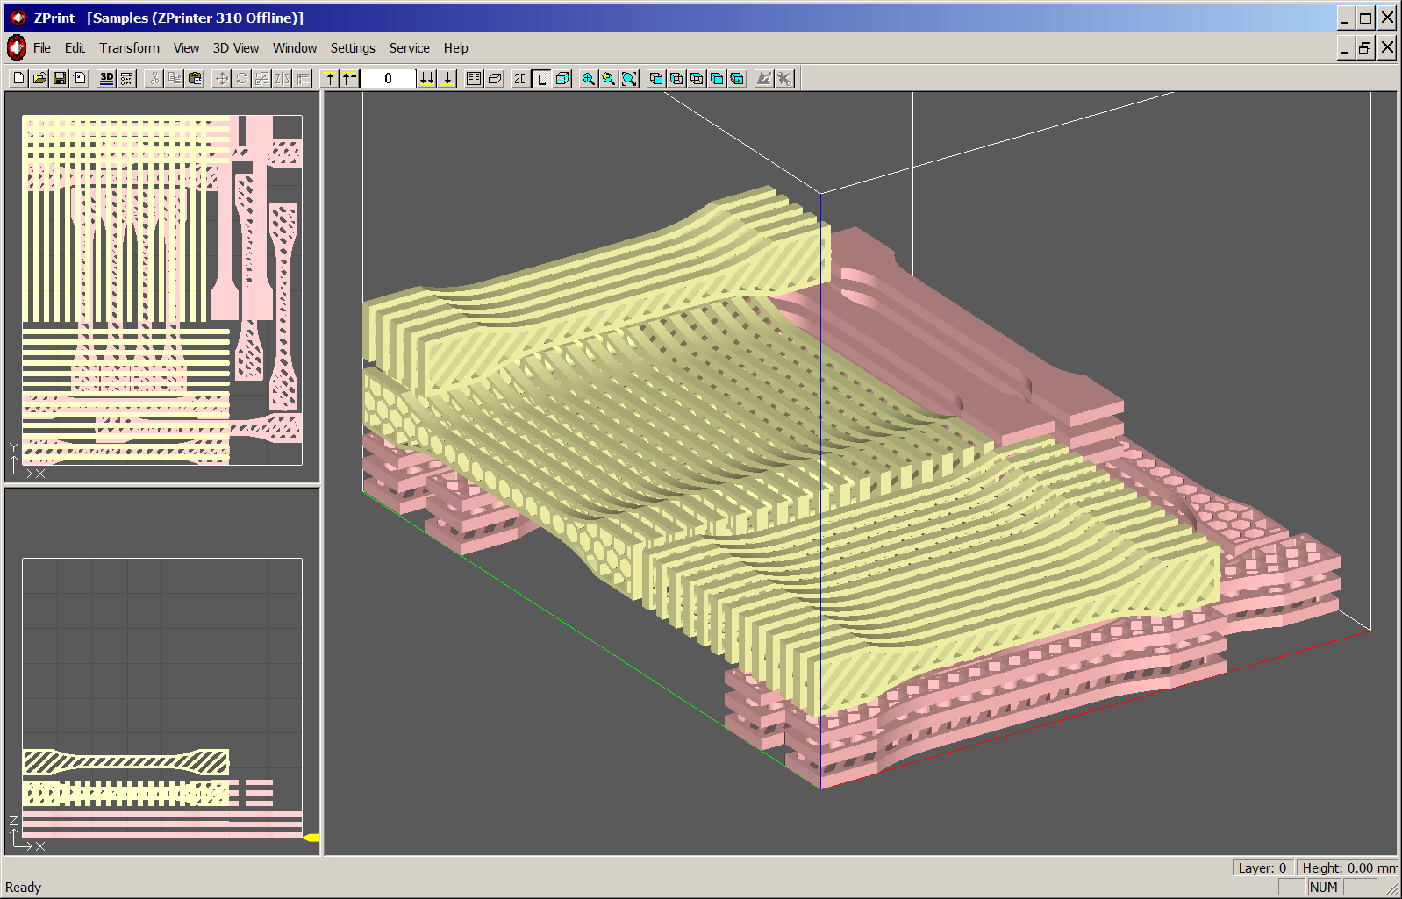
Figure 4: Build setup of test samples in software ZPrint
In order to reduce time needed for printing and to assure same conditions, samples were prepared in one build i.e. in one setup file (Figure 4). Samples aligned on W-base are presented in light yellow and H-based samples in light red, but colored simply for easier visibility because considered 3D printer Z301 may produce only monochromatic models. Build setup contained a total of 78 test samples. Printing time for the build was 2 hours and 50 minutes, printed in 637 layers, with layer thickness 0,1 mm, total build height 64,72 mm, binder usage 142,8 ml and total volume of printed samples 406,76 cubic centimeters.
- Results
The influence of structure, longitudinal and base orientation on strength of 3D printed models was tested by experiment. Samples were prepared combining three different structures, two main longitudinal directions and two cases of the base alignment. After preparing, samples were measured and analyzed. Measured values of sample masses and breaking forces are presented in related tables (Table 2 and Table 3). Measured values of full-bodied samples (FYW) we used as control data sets only (Table 2 and Table 3). The last three rows in each of the following tables contain calculated values: arithmetic mean (ẋ), standard deviation (S) and coefficient of variation (CV). The coefficient of variation (CV) shows measure of dispersion in relation to arithmetic mean of measured data.
Table 2: Measured values of masses
Mass, m [g]
Experiment label | HXW | HXH | HYW | HYH | DXW | DXH | DYW | DYH | SXW | SXH | SYW | SYH | FYW
1 | 9,10 | 7,76 | 8,48 | 7,89 | 10,39 | 9,31 | 10,10 | 8,99 | 10,39 | 9,23 | 10,35 | 9,16 | 10,72
2 | 7,81 | 7,99 | 8,63 | 7,86 | 8,30 | 9,16 | 9,82 | 8,86 | 9,89 | 8,89 | 10,22 | 8,99 | 10,63
3 | 8,90 | 7,89 | 8,99 | 7,81 | 9,93 | 9,10 | 10,16 | 9,13 | 10,43 | 8,72 | 8,83 | 9,29 | 10,55
4 | 9,07 | 7,87 | 8,74 | 7,94 | 10,08 | 9,04 | 10,03 | 9,04 | 10,26 | 8,74 | 8,85 | 9,22 | 10,57
5 | 9,25 | 8,09 | 8,53 | 7,83 | 10,24 | 8,95 | 8,72 | 8,92 | 8,94 | 8,91 | 10,35 | 9,19 | 10,96
6 | 9,27 | 7,86 | 7,01 | 7,69 | 10,32 | 9,39 | 8,63 | 8,84 | 10,50 | 8,81 | 10,49 | 9,14 | 10,46
ẋ | 8,90 | 7,91 | 8,40 | 7,84 | 9,88 | 9,16 | 9,58 | 8,96 | 10,07 | 8,88 | 9,85 | 9,17 | 10,65
S | 0,55 | 0,11 | 0,70 | 0,09 | 0,79 | 0,17 | 0,71 | 0,11 | 0,59 | 0,19 | 0,79 | 0,10 | 0,18
CV | 0,06 | 0,01 | 0,08 | 0,01 | 0,08 | 0,02 | 0,07 | 0,01 | 0,06 | 0,02 | 0,08 | 0,01 | 0,02
Table 3: Measured values of breaking forces

Breaking force, F_{p} [N]
Experiment label | HXW | HXH | HYW | HYH | DXW | DXH | DYW | DYH | SXW | SXH | SYW | SYH | FYW
1 | 132 | 86 | 154 | 151 | 144 | 94 | 163 | 140 | 106 | 118 | 131 | 60 | 204
2 | 124 | 104 | 160 | 151 | 120 | 120 | 162 | 158 | 94 | 98 | 146 | 128 | 198
3 | 132 | 98 | 24 | 147 | 140 | 88 | 196 | 143 | 114 | 106 | 161 | 104 | 77
4 | 148 | 108 | 167 | 142 | 132 | 128 | 167 | 154 | 108 | 94 | 169 | 145 | 180
5 | 136 | 116 | 171 | 136 | 146 | 169 | 170 | 162 | 82 | 118 | 164 | 73 | 188
6 | 128 | 136 | 153 | 145 | 148 | 173 | 156 | 165 | 110 | 124 | 176 | 156 | 190
ẋ | 133 | 108 | 138 | 145 | 138 | 129 | 169 | 154 | 102 | 110 | 158 | 111 | 173
S | 8,26 | 17,02 | 56,38 | 5,75 | 10,61 | 36,12 | 14,06 | 10,17 | 12,03 | 12,16 | 16,51 | 38,89 | 48
CV | 0,06 | 0,16 | 0,41 | 0,04 | 0,08 | 0,28 | 0,08 | 0,07 | 0,12 | 0,11 | 0,10 | 0,35 | 0,28
Results of tensile test are expressed by values of tensile strength at break (R_{p}) (Table 4). Tensile strength at break (R_{p}) is calculated in a way that measured values of breaking force () were divided by minimum cross-section area values. Minimum cross-section area for honeycomb, drilled and striped samples amounts consecutive 12,29 mm², 16 mm² and 16 mm².
Table 4 : Tensile strengths at break

Tensile strength at break, R_{p} [MPa]
Experiment label | HXW | HXH | HYW | HYH | DXW | DXH | DYW | DYH | SXW | SXH | SYW | SYH | FYW
1 | 10,74 | 7,00 | 12,55 | 12,27 | 9,00 | 5,88 | 10,20 | 8,73 | 6,63 | 7,38 | 8,16 | 3,73 | 5,08
2 | 10,09 | 8,46 | 13,00 | 12,27 | 7,50 | 7,50 | 10,13 | 9,85 | 5,88 | 6,13 | 9,14 | 8,02 | 4,89
3 | 10,74 | 7,98 | 1,92 | 12,00 | 8,75 | 5,50 | 12,24 | 8,93 | 7,13 | 6,63 | 10,06 | 6,48 | 1,93
4 | 12,04 | 8,79 | 13,56 | 11,54 | 8,25 | 8,00 | 10,41 | 9,64 | 6,75 | 5,88 | 10,55 | 9,07 | 4,49
5 | 11,07 | 9,43 | 13,92 | 11,08 | 9,13 | 10,55 | 10,62 | 10,13 | 5,13 | 7,39 | 10,27 | 4,57 | 4,60
6 | 10,42 | 11,08 | 12,46 | 11,82 | 9,25 | 10,83 | 9,78 | 10,34 | 6,88 | 7,74 | 10,98 | 9,78 | 4,80
ẋ | 10,87 | 8,79 | 11,24 | 11,67 | 8,68 | 8,04 | 10,34 | 9,60 | 6,40 | 6,94 | 9,86 | 6,94 | 4,30
S | 0,75 | 1,39 | 4,60 | 0,59 | 0,61 | 2,26 | 0,99 | 0,65 | 0,75 | 0,73 | 1,03 | 2,44 | 1,18
CV | 0,07 | 0,16 | 0,41 | 0,05 | 0,07 | 0,28 | 0,10 | 0,07 | 0,12 | 0,11 | 0,10 | 0,35 | 0,27
- Discussion
Coefficient of variation (CV) from tables 3 and 4 shows that in most cases the combination of structure and orientation (longitudinal and base) do not vary significantly in relation to arithmetic mean of combination. Thereby, it can be concluded that data sets of breaking force and tensile strength values, in each combination of structure and orientation, are normally distributed.
Maximum particular tensile strength at break (13,92 MPa) was achieved by the 5th sample from the set labelled as HYW (i.e. the sample of honeycomb structure (H) was printed oriented along Y axis and aligned at the bottom of the building box with the base determined by the length and width (W)). This value is shaded with green colour in Table 4. Minimum particular tensile strength at break (1,92 MPa) was achieved by 3rd sample from the same experimental set HYW. This overall lowest value is shaded in yellow in Table 4. The results in this experimental set exhibit the highest standard deviation (S = 4,60) and highest coefficient of variation (CV = 0,41), that both refer to significant dispersing of strength values in relation to their arithmetic mean and therefore an uncertainty of expected returns when taking into account normal distribution of observed data set.
With the aim of evaluating a possible advantage of lattice structure, we calculated values of specific tensile strength at break (Rp/m) by dividing values of tensile strength at break by corresponding sample mass (Table 5).
Table 5: Specific tensile strengths at break

Specific tensile strength at break, R_{p}/m [MPa/g]
Experiment label | HXW | HXH | HYW | HYH | DXW | DXH | DYW | DYH | SXW | SXH | SYW | SYH | FYW
1 | 1,18 | 0,90 | 1,48 | 1,56 | 0,87 | 0,63 | 1,01 | 0,97 | 0,64 | 0,80 | 0,79 | 0,41 | 0,47
2 | 1,29 | 1,06 | 1,51 | 1,56 | 0,90 | 0,82 | 1,03 | 1,11 | 0,59 | 0,69 | 0,89 | 0,89 | 0,46
3 | 1,21 | 1,01 | 0,21 | 1,54 | 0,88 | 0,60 | 1,21 | 0,98 | 0,68 | 0,76 | 1,14 | 0,70 | 0,18
4 | 1,33 | 1,12 | 1,55 | 1,45 | 0,82 | 0,89 | 1,04 | 1,07 | 0,66 | 0,67 | 1,19 | 0,98 | 0,42
5 | 1,20 | 1,17 | 1,63 | 1,42 | 0,89 | 1,18 | 1,22 | 1,14 | 0,57 | 0,83 | 0,99 | 0,50 | 0,42
6 | 1,12 | 1,41 | 1,78 | 1,54 | 0,90 | 1,15 | 1,13 | 1,17 | 0,65 | 0,88 | 1,05 | 1,07 | 0,46
ẋ | 1,22 | 1,11 | 1,36 | 1,51 | 0,88 | 0,88 | 1,11 | 1,07 | 0,63 | 0,77 | 1,01 | 0,76 | 0,40
S | 0,08 | 0,17 | 0,57 | 0,06 | 0,03 | 0,25 | 0,09 | 0,08 | 0,04 | 0,08 | 0,15 | 0,27 | 0,11
CV | 0,06 | 0,16 | 0,42 | 0,04 | 0,03 | 0,28 | 0,08 | 0,08 | 0,07 | 0,11 | 0,15 | 0,35 | 0,28
As it was expected, considering results of tensile strength at break presented in Table 4, and normally distributed measured values of masses presented in Table 2, maximum (1,78 MPa/g) and minimum (0,21 MPa/g) particular specific tensile strength at break were both achieved in the same data set labelled as HYW. Those values are shaded with green and yellow colour in Table 4. Also, the results in HYW experimental set exhibit the highest standard deviation (S = 0,57) and highest coefficient of variation (CV = 0,42), that both refer to significant dispersing of specific strength values in relation to their arithmetic mean. An overview of average tensile strength and average specific tensile strength presented in Table 4 and Table 5, reveals the strongest and the weakest experimental sets. The strongest experimental set was not the same set from which the strongest particular sample comes (the one labelled as HYW). The highest average strength was revealed by the set labelled as HYH, having the lowest standard deviation (S) and coefficient of variation (CV), too. The weakest experimental set is SXW and again it was not the same set from which the weakest particular sample comes (the one labelled as HYW). This set also exposed moderate standard deviation and coefficient of variation that refers to moderate dispersing of strength values.
Summarized, Figure 5 and Table 6 shows that honeycomb-structured samples exhibit the highest strength, when comparing only type of structure as influencing factor.
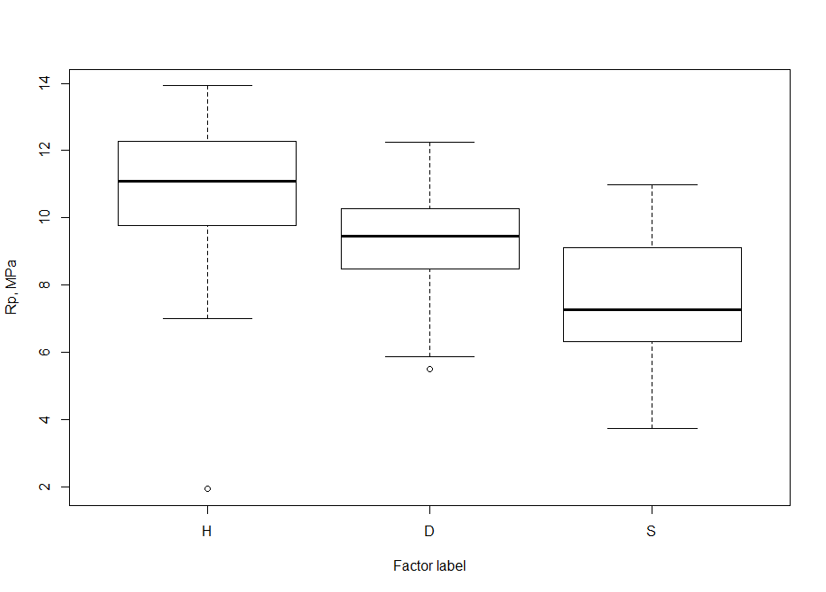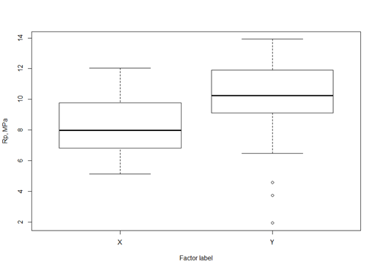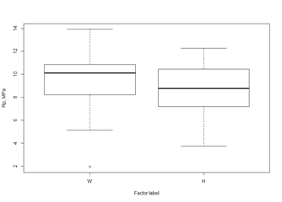
Figure 5:Box plots of tensile strengths at break (a - structure, b - longitudinal orientation, c – base alignment)

Table 6: Tensile strength at break for structure, longitudinal orientation and base alignment
 | Honeycomb | Drills | Stripes | X | Y | W | H
ẋ | 10,67 | 9,19 | 7,51 | 8,26 | 9,98 | 9,58 | 8,70
S | 2,50 | 1,49 | 1,89 | 1,82 | 2,53 | 2,45 | 2,22
CV | 0,23 | 0,16 | 0,25 | 0,22 | 0,25 | 0,26 | 0,26

The samples oriented along building axis Y provided somewhat better strength than those oriented along the axis X. Also the samples aligned at the bottom of the building box over their broader bases (samples denoted as W) exhibit slightly better strength than those aligned over their narrower bases (samples denoted as H).
A box plot (box-and-whisker diagram) of tensile strengths at break (Figure 6) helps us to graphically depicting all groups of experimental data sets easy and clearly through their five-number summaries: the smallest observed strengths (samples’ minimum), lower quartile strengths, median strengths, upper quartile strengths, and largest observed strengths (samples’ maximum).
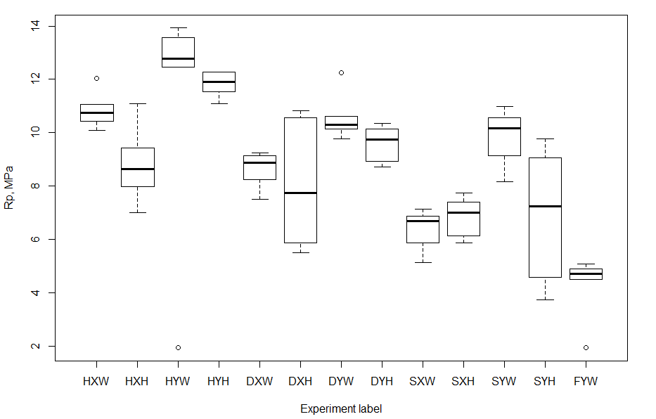
Figure 6: Box plot of tensile strengths at break for all experimental data sets

The spacing between the different parts of the box helps to indicate the degree of dispersion (spread) and skewness in the experimental data, and identify, if exists, an outlying observation. In our case an outlying observation (or outlier) is experimental data set HYW that appears to deviate markedly from other data sets (Figure 6). This support our previous notice on significant dispersing of strength values in relation to their arithmetic mean. It is also interesting to compare the results of testing structured samples with compact ones (experimental label FYW). On first sight the results may be confusing since the compact samples exhibits lower strengths comparing with results obtained by all structured samples (Table 4, Table 5 and Figure 6). However, it could be explained by internal structure of 3D printed samples. Base powder and binder used in printer to fuse powder, provides only primary or strength of so called “green model”. Such strength is sufficient to handle green model out of the printer for infiltration. Infiltration brings final strength to model. Infiltrant penetrates into the model, but depending on the type of the infiltrant and thickness of the model, it does not penetrate completely through the model. Cyanoacrylate penetrates several millimeters into the model and it should infiltrate almost complete volume of samples. Nevertheless, results of strength tests and look of the cracking reveals structural differences between the core and the surface of the model.
In order to verify above observations and understand completely the effect of factors on relative deviation and tensile strength at break, we performed a factorial analysis of variance (ANOVA). ANOVA was carried out by using R software [13] and is presented in Table 7.
Table 7: ANOVA of the processing factors for tensile strength at break
Factors | Sum of squares  (SS) | Degrees of freedom  (DOF) | Mean square  (MS) | Probability  (P) | Fischer  Distribution  (F_{0,95})
Structure | 120,41 | 2 | 60,20 | 4,87×e-7 | 18,701
Orientation | 54,62 | 1 | 54,62 | 0,000118 | 16,966
Base | 15,09 | 1 | 15,09 | 0,034393 | 4,686
Structure : Orientation | 0,01 | 2 | 0,01 | 0,998208 | 0,002
Structure : Base | 0,90 | 2 | 0,45 | 0,869618 | 0,140
Orientation : Base | 0,59 | 1 | 0,59 | 0,671104 | 0,182
Structure : Orientation : Base | 27,29 | 2 | 13,64 | 0,018982 | 4,238
Residuals | 193,15 | 60 | 3,22

Analysis of variance (ANOVA) has shown that at the 0,95 confidence level of significance (α = 0,05), each of three main factors (structure, orientation and base) has significant influence on resulting strength of samples as well a combination of structure, orientation and base alignment (their P values are lower than 0,05). In other words, each of main factors and a combination structure:orientation:base, as well has an decisive impact on the strength of 3D printed models. However, single influences of structure and orientation have the strongest impact for they are the most significant factors. The analysis also indicates minor influence of all other combinations of influencing factors on samples’ strengths (Table 7).
Aiming to get a closer view into the samples’ breaking mechanisms, we also carried out a structural finite element analysis (FEA) in Autodesk Inventor software. In analysis, all samples were loaded with force of magnitude 120 N and assumed ultimate tensile strength was 11 MPa. FEA hints to locations of maximum stress vary and to possible locations of cracking (Figure 7). Locations of the maximum stress depend mostly on the structure and present the fragile part of samples. Analysis reveals that stress distribution is the most uniform for drilled models with the lowest stress, while striped models showed the highest stress and the most dispersed stress distribution.

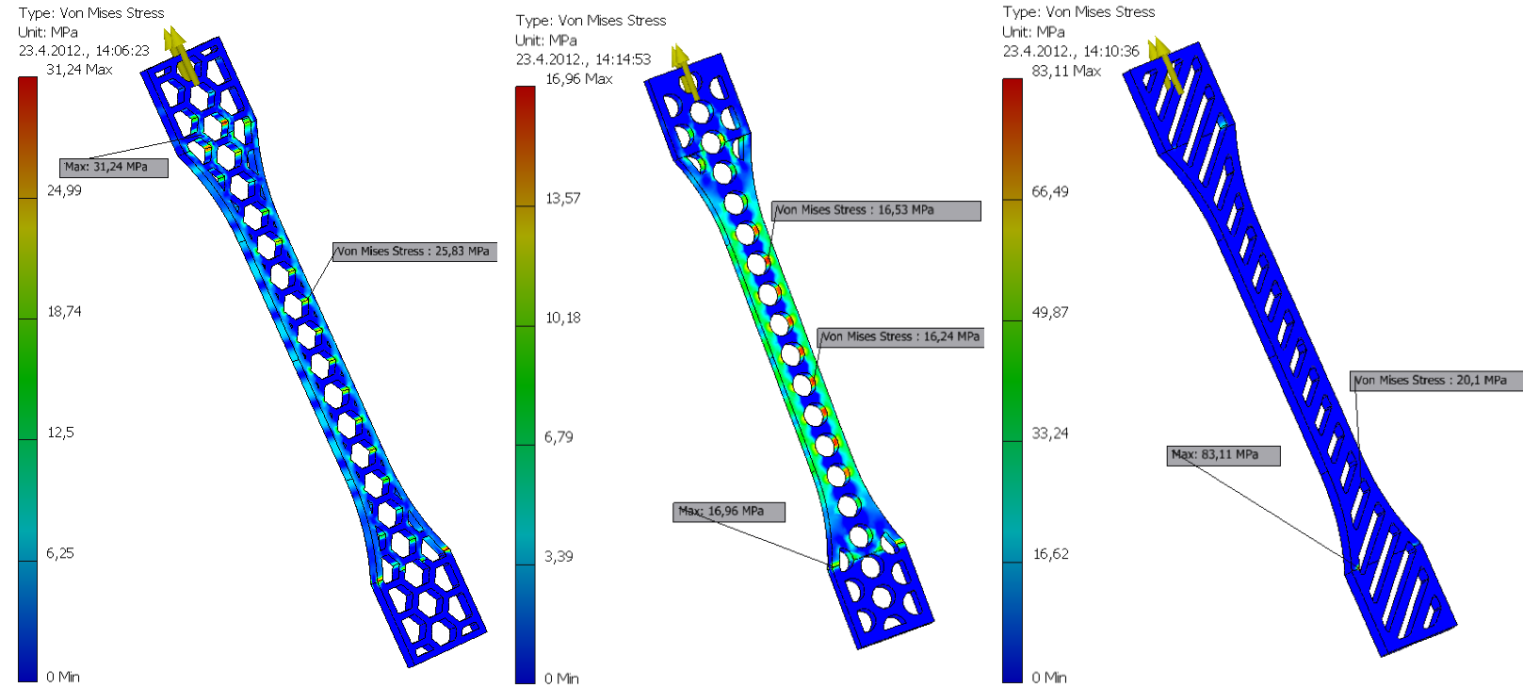
Figure 7: Locations of maximum stress

As revealed after experiments, actual locations of cracking are not concentrated at locations of maximum stress obtained from FEA, but accidentally distributed along sample´s length (Figure 8). Such distribution of cracking location indicates the internal structural inconsistency and its significant influence on mechanical properties of 3DP models.

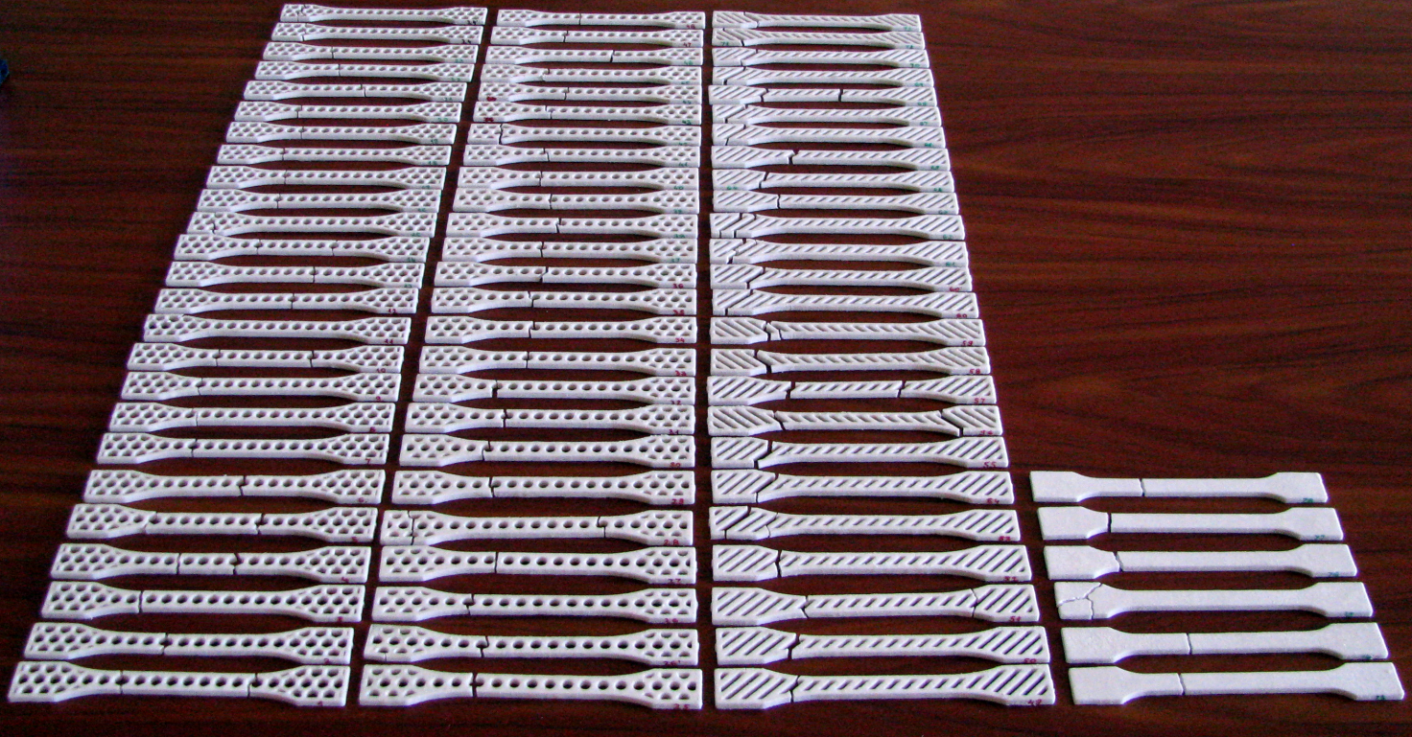
Figure 8: Locations of cracking
- Conclusions
When taking into account only the main factors, the analysis of tensile strength at break showed that honeycomb-structure H, longitudinal orientation Y and base alignment W exhibit the highest strength.
Comparing with results obtained by lattice-shaped samples, compact samples proved to be once with lower strengths although compact samples beard the highest breaking forces. Analysis of specific tensile strengths at break revealed that lattice-shaped structure may provide sufficient strength with reduced mass of 3D printed models. Reduced mass combined with retained sufficient strength may significantly reduce 3D printing time and printing costs, enhancing by that the use of 3D printed lattice-shaped models in specific areas like in manufacturing of medical implants.
Factorial analysis of variance further exposed that only individual main factors (structure, orientation and base) along with the interaction of them all (structure:orientation:base) have significant influence on the tensile strengths at break, while the interaction of any two combinations of main factors does not have significant influence. However, influence of the structure and the orientation are much more significant than influence of base alignment alone and combination of all three factors, as well. The structure is the most significant factor and thereby has the strongest impact on the strength of 3D printed models.
Further research and analysis of the factors that have the significant influence on strength of 3D printed models for different material combinations should be also performed prior to implementation.

Acknowledgment
The authors wish to thank Professor Mladen Šercer for supporting the work on this paper; to Dr. Andrijana Milinović and Ana Pilipović for their assistance in experiments. The work presented in this paper was financially supported by the Ministry of Science, Education and Sports of the Republic of Croatia through the scientific research project No. 152-1521473-1474 (Advanced Technologies of Direct Manufacturing of Polymeric Products).

References
[1] A. Pilipović, P. Raos, and M. Šercer, “Experimental testing of quality of polymer parts produced by laminated object manufacturing – LOM,” Tehnički vjesnik - Technical Gazette, vol. 18, no. 2, pp. 253-260, 2011.
[2] A. Pilipović, P. Raos, and M. Šercer, “Experimental analysis of properties of materials for rapid prototyping,” The International Journal of Advanced Manufacturing Technology, vol. 40, no. 1-2, pp. 105-115, Dec. 2009.
[3] D. Dimitrov, K. Schreve, and N. D. Beer, “Advances in three dimensional printing – state of the art and future perspectives,” Rapid Prototyping Journal, vol. 12, no. 3, pp. 136-147, 2006.
[4] T. Galeta, M. Kljajin, and M. Karakašić, “Cost Evaluation of Shell and Compact Models in 3D Printing,” Výrobné Inžinierstvo - Manufacturing Engineering, vol. 7, no. 3, pp. 27-29, 2008.
[5] T. Galeta, M. Kljajin, and M. Karakašić, “Geometric Accuracy by 2-D Printing Model,” Strojniški vestnik - Journal of Mechanical Engineering, vol. 54, no. 10, pp. 725-733, 2008.
[6] J. Novak-Marcincin, J. Barna, L. Novakova-Marcincinova, and V. Fecova, “Analyses and solutions on technical and economical aspects of rapid prototyping technology,” Tehnički vjesnik-Technical Gazette, vol. 18, no. 4, pp. 657-661, 2011.
[7] P. S. Maher, R. P. Keatch, K. Donnelly, R. E. Mackay, and J. Z. Paxton, “Construction of 3D biological matrices using rapid prototyping technology,” Rapid Prototyping Journal, vol. 15, no. 3, pp. 204-210, 2009.
[8] U. M. Namasivayam and C. C. Seepersad, “Topology design and freeform fabrication of deployable structures with lattice skins,” Rapid Prototyping Journal, vol. 17, no. 1, pp. 5-16, 2011.
[9] Z. Chen, D. Li, B. Lu, Y. Tang, M. Sun, and Z. Wang, “Fabrication of artificial bioactive bone using rapid prototyping,” Rapid Prototyping Journal, vol. 10, no. 5, pp. 327-333, Jan. 2004.
[10] R. Bibb and G. Sisias, “Bone structure models using stereolithography: a technical note,” Rapid Prototyping Journal, vol. 8, no. 1, pp. 25-29, Jan. 2002.
[11] X. Li, C. Wang, W. Zhang, and Y. Li, “Fabrication and compressive properties of Ti6Al4V implant with honeycomb-like structure for biomedical applications,” Rapid Prototyping Journal, vol. 16, no. 1, pp. 44-49, 2010.
[12] “Material Safety Data Sheet zp130 Powder,” Exposure, vol. 2002, no. 1999. Burlington, pp. 1-7, 2007.
[13] R. R Development Core Team, “R: A Language and Environment for Statistical Computing,” R Foundation for Statistical Computing, vol. 1, no. 2.11.1. R Foundation for Statistical Computing, p. 409, 2011.

Corresponding author:
Prof. Dr. Pero Raos
Mechanical Engineering Faculty in Slavonski Brod
University J.J. Strossmayer of Osijek
I.B. Mažuranić 2
HR- 35000 Slavonski Brod
praos@sfsb.hr

