THE LOGISTICS CONCEPT OF OPTIMIZED RETRO-REFLECTION DYNAMIC TEST OF ROAD MARKS ON THE ROADS IN THE REPUBLIC OFCROATIA

AUTHORS

RožićTomislav
University of Zagreb
Faculty of Transport and Traffic Sciences
Vukelićeva 4, 10000 Zagreb
tomislav.rozic@fpz.hr

Fiolić Mario, student
University of Zagreb
Faculty of Transport and Traffic Sciences
Vukelićeva 4, 10000 Zagreb
mario.fiolic@yahoo.com

BačuraMatko, dipl. ing. petrol
TEHNO-DOM d.o.o.
Karlovačkacesta 52c
10020 Zagreb
matko.bacura@tehno-dom.hr

ABSTRACT
Road traffic safetyis an importantfactor whichdependson the effortsof the entire society, throughincreasedinvestment inroad safetyandtrafficdevelopmentof cultureof all road users. This paperwill set out thebasic aspectsof the logisticsconceptandapplication ofanalysisof the logisticsconceptforoptimizingthe dynamictestsof retro-reflectionmarkson the pavement. Applyinglogisticconceptallowsthedisplay ofthe positionmeasurementof vehicles inreal time, and optimizedrouting ofvehicles tofulfill theadditional requirementsthattestsmeasuringsection.

- INTRODUCTION
Transport infrastructure isfundamental, and certainlyone of themost important elementsof manufacturing alltypes oftransportationproducts. Along withthe supply of energyand water it is the core ofeconomic infrastructure.The transport infrastructure consists of transportation routes, facilities, equipment, plant, different means to work, always fixed in certain places that serve the production of products and the regulation of traffic and safety of all production processes in all types of transport industry.
Trafficsuperstructureis an essentialelement ofthe productionof transportproducts.Bearing inmind thefundamentalprinciples ofthe conceptof transport infrastructure, which consists oftransportationroutes, facilities, equipment permanentlyfixedtoa certainplace andservingthe production ofproducts andregulatetrafficand traffic safety, trafficsuperstructureconsists oftransportand transshipmentat (reloading) meansthatusing thetransportation infrastructurecrucialenable the productionof transportproducts.
Itactuallymeans thatthe transportsuperstructureconsists ofall movableassetsforwhichare used forhandling, transportation, transmission, transfercasetraffic(iefreight, passenger, power, data, value)or,simplified, transportsuperstructureconsists ofall fundsfor the work,except fortransport infrastructure, which servethe productionof transportproducts.

- INFORMATION TECHNOLOGIES
The fact is that no traffic product in any traffic process industry, can’t be produced without the support and information to support such processes. Also is the fact that information was the product of information technology.
It could be argued that information technologies are system of intelligent, automated, telecommunication procedures that enable the production, storage, distribution and exchange of information between transport operators in the micro, meta, macro, and global mega-transport systems.
Such procedures provide traffic information systems with their subsystems, elements and components.
Bearing in mind the above observations can be argued that information technologies are certainly one of the most important elements of the production of transport products that in conjunction with other elements of the production of transport of products produced synergistic effects in the processes of transport industry and contribute directly to increasing the value of intellectual capital in the transport company.

- FLEET MANAGEMENT
Fleet Management is a professional system for satellite tracking of vehicles using GPRS technology to transmit real-time vehicle information, and provides a constant and complete control of the fleet.
With Fleet Management System is possible to:
- monitor vehicle at all times to
- Increase theutilization ofthe fleet
- Reducecommunicationcosts
- Optimizeoperating costs
- check drivers
- cut generalcosts

In today's modern era logistics requires accurate information in real time.
The position and condition of the vehicle and transported goods, with respect of driver’s performance are extremely valuable information for management. One of the biggest advantages of Fleet Management System is that, thanks to their own development hardware and software, can flexibly adapt to customer requirements. Therefore, Fleet Management can be adapted to systems without problems, not only to those companies that deal with transportation, but also in logistics systems companies engaged in transportation, manufacturing and FMCG-companies.
Among operating costs, extremely important are specific additional information that comes to transport vehicles in real time, such as:
- Location andquantity offilling/unloadingof fuelfrom the tank
- Measuring the temperature ofthe cargospace due the quality assuranceof transported goods
- Recordsofa driverwithan identification card(moreimportant when driver's working onavehicle)
- Registeringdoorcargo spaceto avoidsmalland largethefts
- Monitoring vehicle engineon the computer, as well asmany otherinformation youprovideon-board computerof the vehicle
It should be notedthe possibilityforcustomizationFleetManagementSystemERPsystemsthatcompanies use. Accordingly,FleetManagementsystem isfunctioningin the backgroundtransmitfactualinformation on the performanceof drivers, which canprovide accurateinformation forcosting, inventoryrecords, payroll, and can reduceadministration.
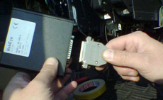
Figure1.Displaymodules thatare installedin a vehicle

- IMPACTOF THE ROAD MARKSONROAD SAFETY
Although theroadmarkson the pavementcanbe made according tovarious criteria,the basic divisionis derived from theiruse, androadwaymarkingsare divided into:
- longitudinal markingson the pavement
- transversemarkings onthe pavement
- other markson the pavementand objectsat the roadside.
In addition to this basic division, markings on the pavement can still be divided with respect to:
- their durability
- retro-reflectivecharacteristics
- The typeof appliedmaterials
- the manner of theirapplication
- coefficient offriction, etc.

Today there are several types of materials for making marks on the pavement, which differ according to the method of application, longevity, cost, and structural features.
The materialsfor makingmarkson the pavementshall notincrease theslipperypavement, and they areintheorderaddedelementsthat increase thesurfaceroughness of thepavement.
Currently,thepavementmarkingsare madein the following waysas:
- painted markings
- labels ofplasticmaterial
- ready-madelabels
- raisedmarkings
- illuminatedraisedmarkings

Each of the above ways of marking and materials has its specific advantages and disadvantages in the application.
To increase the visibility of the markings on the pavement in poor visibility conditions, when they are most needed for the drivers, the retro-reflective elements (glass beads, beads) are added to the material for the pavement markings.
The quality of retro-reflection marks on the pavement depends on:
- The amount of glass beads per m2
- Allocation (distribution) of glass beads in/by mark the material (thermoplastic, cold plastic ...)
- The relationship between the size of glass beads and the thickness of marks
- Level of injection of glass beads
- The viscosity (stickiness) of material marks
- environmental conditions (weather, condition of the road ...)

- APPLICATION OFA DYNAMIC METHODWITH AN OPTIMIZATION PROPOSALACCORDING TOLOGISTICS CONCEPT

The ZDR 6020 Dynamic Retroreflectometer RL is installed on a vehicle in order to measure the RL-values of road markings during the movement of that vehicle at normal traffic speed. The ZDR 6020 can be used for longer road distances than portable devices as well as in safety in particular on motorways when ZDR 6020 gives continuous measurements. The measuring head can be installed either on the left or right side.
Figure 3.Displayof measurementprincipleof nightvisibility

Measures the retro-reflection (night visibility) of a road marking true to scale. The observation angle of 2.29° corresponds to the viewing distance of a motor car driver of 30 m under normal conditions. The illumination angle is 1.24°.
The measuring vehicle is fitted with systems for monitoring, management and routing of vehicles to maximize the distance traveled during the retro-reflection measurement markings on the pavement.In this way, the vehicle routing and itinerary (a plan under which he will visit some of the road in a given county or several)are implied, to which the vehicle will be routed to the more optimized traveled distance.
GeoTrag is made on the characteristic vector GIS Cloud technology based on Adobe Flash platform.Vector technology is unique because it provides a superior customer experience with an Internet browser.
Overall, it improves usability, visual appearance and maintains a high level of user experience compared to other technologies for the display of map data (raster technology).Support for numerous vector and raster data and databases that allow GIS Cloud technology is used in solutions such as a system for Fleet Management (Fleet Management).
GeoTrag is simple web application enables you to effectively manage mobile assets, workforce and use business data to improve your services.
GeoTrag easily supports various GPS devices. Depending on a solution you need we can adapt fleet management system in no time to easily work with any device you are currently using. GeoTrag helps to proactively coordinate resources to accomplish workload in time improving customer service. Also provides better services to customers meeting agreed deadlines, serve more customers in less time, provide customers of details information on their delivery, increase responsiveness to customer demands and follow business rules.
GeoTrag supports GPS device integration. Integrated with Garmin, GeoTrag becomes interactive cost efficient solution where dispatchers and fleet managers can establish two way communications with a driver. Message from dispatch center delivered to GPS device provides driver with all necessary information and automatically instructs Garmin to route vehicle to its destination.
GeoTrag supports GPS device integration. Integrated with Garmin, GeoTrag becomes interactive cost efficient solution where dispatchers and fleet managers can establish two way communications with a driver. Message from dispatch center delivered to GPS device provides driver with all necessary information and automatically instructs Garmin to route vehicle to its destination. .
At intervals of 15 seconds you can see exactly where the vehicle is started, when it came to the point of sleep, how much time is spent there and how many miles crossed from the departure.Extremely important function of Fleet Management On-line software is on-line presentation of the vehicle, which allows control of the vehicle in real-time applications with the map (AVL-G).Also it is possible to get sound alarms recorded in the log of changes preset value sensor for displaying status.Immediately can be noticed the deviation from the specified route, leaving an area or coming to the area. In case of realization of the conditions specified by the client (such as opening the door, leaving the area, exceeding the temperature) can be set up the visual and sound basis alerting, which can be instantly react to the given event.
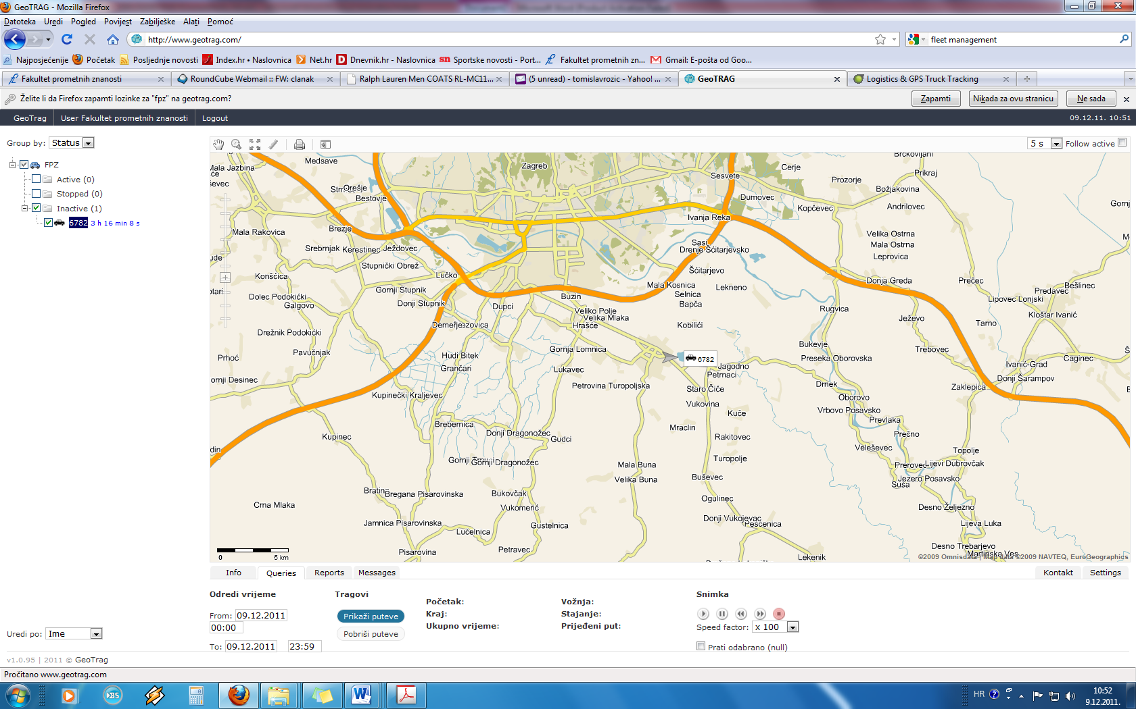
Figure4.Displaymapwith theposition of the vehicleon the computer

- CONCLUSION

Fleetmanagementsystem was developedto help usersperform theirtaskseffectivelyandcontribute forbetter organizationand effectiveness of themeasuring vehicle, which increases overall performanceand optimizecosts. Ithelpsin planning, controlling and managingthe businessthrough the computer.Withfleetmanagementit is possible tocontrolthe measurementof the vehicle andall of the defaultparameters as well asdirectmeasurementvehicleproducingan optimal plantripsandvisits tothe defaultlocation.
Based on thisapproachand previous experience inthe first yearaftercompletion oftests, it is accessed to finding theoptimalapproach totheitineraryas well asadditional improvementstothe implementationof dynamictestsof retro-reflectionmarkson the pavementjustusingthe previously describedlogisticconceptbasedon ITsupport.Dynamictesting ofthepavementmarking isan importantshiftinmaintenanceplanningandexecutionof longitudinalmarkings on thepavement, and the responsible personcan objectivelydeterminethedynamics of the construction, locations, and sharesthatareprioritiesforimplementationmarkson the pavementand on technologyperformanceindicator.
The obtained resultsallowthe analysisandoptimization ofmaintenance planto ensure high qualitymarkson the pavement, which contributes to increasingroad traffic safetyonstate roadsin Croatia.Based on thisapproach, theresult of the analysisshould be able tofind the optimalitineraryto conduct testsin 2012.year, which wouldconfirm theusefulness ofthe application oflogisticsconceptsfordynamictestsof retro-reflectionmarkson the pavement.

LITERATURE
- Ivaković Č., Stanković R., Šafran M.: Špedicija i logistički procesi, Fakultet prometnih znanosti, Zagreb 2010.
- Ščukanec A.: Primjena retroreflektirajućih materijala u funkciji cestovnoprometne sigurnosti, Doktorska disertacija, Zagreb 2003.
- Ščukanec, A., Šafran, M., Babić, D.: "In-Vehicle Safety System Performance Depending on the Quality of Road Markings", Časopis PROMET, TRAFFIC&TRANSPORTATION, Volume 19, No 1., Zagreb, 2007., str. 39-42.
- Zelenika, R.: Logistički sustavi, Ekonomski fakultet u Rijeci, Rijeka 2005.
- Hrvatske ceste d.o.o.: Smjernice i tehnički zahtjevi za izvođenje radova na obnavljanju oznaka na kolniku, Horizontalna signalizacija, Zagreb.
- Pravilnik o prometnim znakovima i opremi na cestama, Ministarstvo mora, turizma, prometa i razvitka, NN 33/2005.
- ZehntnerTesting Instruments: Instruction manual ZDR 6020 DynamicRetroreflectometer RL, Sissach, 2009.

Zelenika, R.: Ekonomika prometne industrije, Ekonomski fakultet u Rijeci, Rijeka 2010.,str. 261.
Zelenika, R.: Ekonomika prometne industrije, Ekonomski fakultet u Rijeci, Rijeka 2010.,str. 263.

