IMPACT OF HEAVY VEHICLE VISIBILITY ON TRAFFIC SAFETY

Darko Babić Ph.D., Mario Fiolić mag.ing.traff.,
Faculty of Traffic and Transport Science
Vukelićeva 4, 10000 Zagreb, Croatia
Petr Prusa Ph.D.
University of Pardubice,
Jan Perner Transport Faculty
Studentská 95, 53210 Pardubice, Czech Republic

ABSTRACT
One of the essential elements of safety is a good marking and thus the visibility of vehicles in traffic. In order to better visibility of long, heavy vehicles and their trailers, etc., these vehicles have to be marked with edge marking. This marking (contour marking) has to be from highly reflective materials which can guarantee better visibility during night and poor weather conditions. This paper focuses on heavy vehicle safety and aims to demonstrate how innovative reflective technologies can prevent truck crashes and fatalities by increasing their visibility. Over the last 10 years the road toll has shown a declining trend in all vehicle categories, including heavy vehicles despite the facts that the number of vehicles and the kilometers travelled on the roads have significantly increased. It is important that the downward trend remains and simple, low cost conspicuity measures support and accelerate the declining tendency.

KEY WORDS: heavy vehicle safety, innovative reflective technologies, contour marking
1. INTRODUCTION
On the roads of EU, some 50.000 people are killed, and more than 1, 6 million are injured per year. These numbers of killed and injured people constitute an enormous social and economic loss for the European Union. For this reason, the European Commission aims to reduce road casualties during the last 10 years and several large scale experiments were made on behalf of introducing a contour marking for trucks for better conspicuity. The results comparing the accident rates of marked and unmarked trucks always showed a reduction of the number of accidents. This was the reason for preparing a new ECE-Draft Regulation: Uniform provisions concerning the approval to retro-reflective marking of heavy and long vehicles and their trailers as an annex to the agreement: Concerning the adoption of uniform conditions of approval and reciprocal recognition of approval for motor vehicle equipment and parts. Within this Draft Regulation several requirements were made on behalf of:
- Geometrical dimensions
- Coefficients of retro-reflection
- Chromatic co-ordinates and others.
Large scale experiments were restricted to Germany and it was allowed by only special permission to equip trucks and trailers with logos, graphics, letters, and characters of different material types and colors. The geometrical data and the coefficients of retro-reflection of the marking of trucks and trailers were measured during the procedure of giving the special permission for installation of the markings. This paper is focused on regulations related to the vehicle marking and innovative reflective technologies that can prevent heavy vehicle crashes and fatalities by increasing visibility.

2. GENERALLY ABOUT MARKING VEHICLES
The Department for Transport (DfT) has committed to implementing European legislation on the fitment of conspicuity markings to large goods vehicles. These markings effectively illuminate the outline of a vehicle at night by reflection from the headlights of vehicles following behind. These requirements were intended to be transposed into the Road Vehicles Lighting Regulations and enter into force on 10 October 2009. However, in September 2009, the Secretary of State for Transport announced that the requirement for heavy goods vehicles to be fitted with conspicuity markings had been postponed and was introduced from 10 July 2011.
Currently, the Road Vehicles Lighting Regulations 1989 (RVLR) require certain motor vehicles with a gross vehicle weight exceeding 7.5 tones to be fitted with retro-reflective rear marker plates approved to the European Regulation, UNECE Regulation 70.00. (The latest version of this regulation is known as Regulation 70.01; however the UK still permits the use of Regulation 70.00 marker plates.) These plates are fitted in addition to rear lights and reflectors and are intended to make the vehicle more conspicuous to other drivers so they are aware of the presence of a large, potentially slow moving vehicle.
Some vehicle operators also fit conspicuity markings to their vehicles. These are vertical and horizontal lines of retro-reflective material which emphasize the length and shape of the vehicle and also warn other drivers of their presence. UNECE Regulation 104 (R104) provides a technical specification for these conspicuity markings and their use on vehicles in the UK is optional at present under the Road Vehicles Lighting Regulations. UNECE Regulation 48 (R48) is a European regulation that sets out harmonized installation requirements for vehicle lights and reflectors. It is broadly equivalent to the RVLR and the UK cannot refuse registration of vehicles approved to this regulation on the grounds of their lighting. Recently R48 was amended to mandate R104 specification conspicuity markings on certain new heavy vehicles and trailers.

3. RETROREFLECTIVE MATERIALS FOR VEHICLE MARKING
Conspicuity marking legislation requires a full contour marking on the vehicle’s rear, i.e. horizontal and vertical markings to outline the shape of the vehicle, and partial contour markings on the side. Partial contour markings consist of a horizontal line showing the length of the vehicle and ‘tick’ marks showing the upper corners of the vehicle. However, where the shape, structure, design or operational requirements make it impossible to install the mandatory contour marking, a line marking is acceptable.
UNECE Regulation 48 requires that the location designated for installing the markings shall allow for marking material at least 60mm in width. The actual width of the marking materials specified in UNECE Regulation 104, which states the width should be 50mm (+10 -0). So provided the vehicle will accept markings of 60mm it is acceptable to fit any marking material approved to Regulation 104. The certification approval process for conspicuity products is done to ensure that they meet requirements for color, reflectivity and durability set out in Regulation ECE104. The E marking, as shown in Figure 1, is a proof that the product has been tested, certified and meets all the requirements of ECE 104. Without the E-mark, the product is not compliant with the regulation.
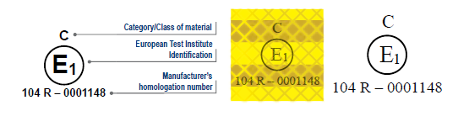
Figure 1 show obligatory requirements for contour marking material (class of material, European test institute identification and homologation number)
Source: FTA compliance guide: Conspicuity marking requirements on goods vehicles
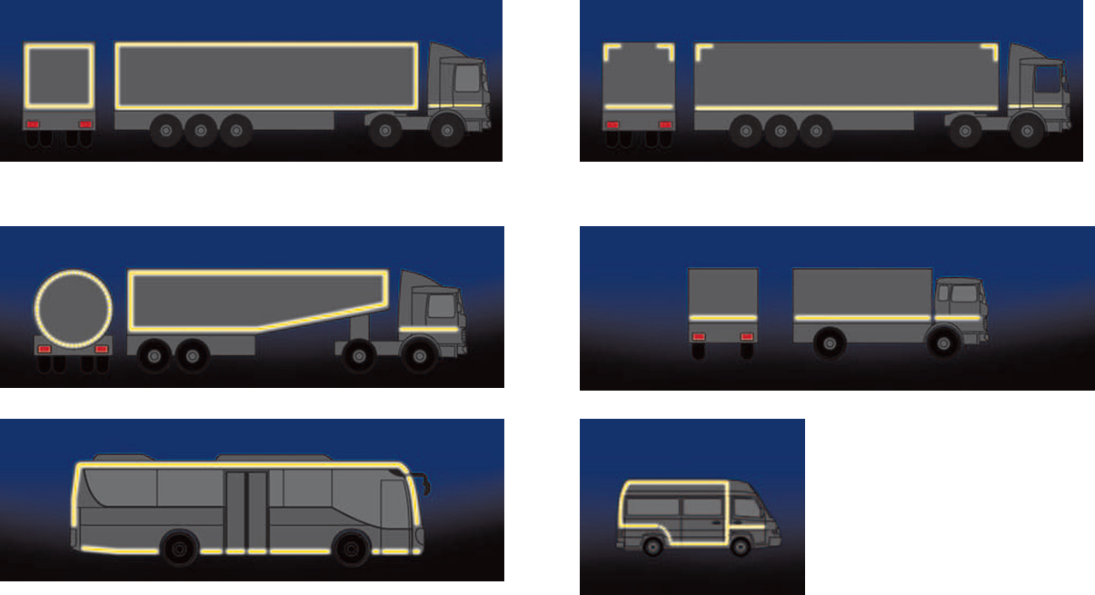
Figure 2 show some possible ways of vehicle contour marking appliance
Source: Vehicle contour marking - 3M
Figure 3 show different visibility of two vehicle – one vehicle is with contour marking and the other is without contour marking
Source: Faculty of Transport and Traffic Sciences
Table 1 shows the minimum values of the coefficient of retro-reflection R’ (ECE - Regulation 104) are drawn up. The requirements for the “red” material were added later into the Regulation.
Table 1 shows minimum values for the Coefficient of Retro-Reflection
Minimum values for the Coefficient of Retro-Reflection R’ /
(cd*m⁻²*lx⁻¹)
Entrance angle | β = 5° | β = 20° | β = 30° | β = 40° | β = 60°
Color
White | 450 |  | 200 | 90 | 16
Yellow | 300 |  | 130 | 75 | 10
Red | 120 | 60 | 30 | 10
Source: Conspicuity of Heavy Goods Vehicles - Final Report
Retro-reflective material in conformity with UN/ECE-R 104 is sold by the three manufacturers at approximately the same price. Material prices of roughly € 33 / per square meter (3M foil) were indicated. The manufacturers could not give any concrete details about the costs of installation. The retro-reflective material is normally installed by companies which have been accordingly trained by the manufacturers. The manufacturers stated that the retro-reflective material is very durable and resistant even to high strains while cleaning the heavy good vehicle, e.g. with steam-jet cleaners. Retro-reflective material installed at fixed bodies of HGV is given a warranty of seven years. A three-year-warranty is given by the manufacturers for retro-reflective material attached to new canvas covers. The retro-reflective material for canvass covers differs from that for fixed bodies insofar as it has to be flexible. Such retro-reflective material is offered by the manufacturers Reflexite and 3M. The mentioned manufacturers offer their own products for contour-markings of HGV independently of each other (See table 2). The products meet the requirements of UN/ECE-R 104. Product specimens are attached in Annex F. The products differ e.g. in the set-up of the material or by the different arrangement of reflective structures.
Table 2 shows specifications for contour-marking material
 | Product / Colors
 | White | Yellow | Red
Avery Dennison | V-6700 | V-6701 | V-6708
Reflexite UK Limited  rigid structure  canvass | VC104 white  rigid grade  curtain grade | VC104 yellow  rigid grade  curtain grade | VC104 red  rigid grade  curtain grade
3M Deutschland GmbH  rigid structure  canvass | Series 983-10 white  Series 987-10 white | Series 983-71 yellow  Series 987-71 yellow | Series 983-72 red  Series 987-72 red
Source: Conspicuity of Heavy Goods Vehicles - Final Report
4. LEGISLATION RELATED TO THE VEHICLE MARKING
In 1958 an Agreement was signed, formally titled "Agreement concerning the adoption of uniform technical prescriptions for wheeled vehicles, equipment and parts which can be fitted and/or be used on wheeled vehicles and the conditions for reciprocal recognition of approvals granted on the basis of these prescriptions". All participating countries agree on a common set of ECE regulations for type approval of vehicles and components and their reciprocal recognition.
The UNECE has overseen the harmonization of vehicle regulations related to heavy vehicle visibility: UN Reg. 48 - The Installation of Lighting and Light Signaling Devices and UN Reg. 104 the Uniform Provisions concerning the Approval of retro-reflective markings. UN Reg. 48 regulates the requirements on the installation on lighting and light-signaling devices. It governs the visibility requirements of the rear and the side of a heavy vehicle and applies to categories like M, N and trailers equal to category O. The regulation prescribes the colors to be used; white or yellow to the side and red and yellow to the rear. It provides detailed guidance on full, partial or line contour markings and how these should be applied. Table 3 presents a brief summary of the categories administered by UN Reg. 48. optional and mandatory conspicuity markings.
Table 3 shows optional and mandatory conspicuity markings for vehicle categories according to UN Reg. 48
SCOPE | PROHIBITED | International categories:  M1  O1 | Passenger cars  Trailers less than 750 kgs
 | OPTIONAL | International categories:  N1  N2<7.5 tons  O2 | N1: Vehicles used for the carriage of goods with a maximum mass not exceeding 3.5 tones  N2:<7.5 tons Vehicle used for the carriage of goods with a maximum mass exceeding 3.5 tones but not exceeding 7.5 tones  O2: Trailers with a maximum mass exceeding 0.750 tones but not exceeding 3.5 tones
 | MANDATORY | International categories:  N2>7.5 tons  N3  O3  O4 | N2>7.5 tons  Vehicle used for the carriage of goods with a maximum mass exceeding 7.5 tones but not exceeding 12 tones and above 6 m in length and 2.1 m in width  N3: Vehicle used for the carriage of goods with a maximum mass exceeding 12 tones and above 6m in length and 2.1 m in width  O3: Trailers with a minimum mass exceeding 3.5 tones  O4: Trailers with a minimum mass exceeding 10 tones
Source: Improving road safety by increased truck visibility

The provisions of UN ECE Regulation 104 apply to the approval of retro-reflective markings designed to increase the visibility and recognition for heavy and long vehicles and their trailers explaining the performance requirements. Contour markings are classified as type “C” and the intention of placing retro-reflective tapes on the side and at the rear of the vehicle is to make its shape and dimensions fully visible for other road users.
Retro-reflective tapes used on heavy vehicles and their trailers shall meet the strict requirements defined in UN ECE Reg. 104 which include photometric and colorimetric specifications, dimensional properties and physical and chemical testing expectations. Contour marking materials tested and approved according to UN ECE Reg. 104 shall have the approval mark printed on the surface of the tape showing classification ‘C’, country where the approval was granted and the approval number. This regulation also offers guidance for the marking shape and mounting requirements.
In Europe, governments tried to minimize the negative impacts of heavy vehicle accidents by introducing a national legislation, but as new technologies and borderless trade evolved there was a crucial need to harmonize the international requirements which led to a new European Directive 2007/35/CE, effective from July 2008. The European Union has decided to implement mandatory conspicuity markings for heavy goods vehicles and trailers in all member states from July 2011. The technical, application and performance requirements follow UN Regulations 48 and 104. This is an excellent example of how the adoption of the high performance retro-reflective sheeting for usage in vehicle marking has resulted in another safety improvement for many road users.

5. IMPACT OF HEAVY VEHICLE VISIBILITY ON TRAFFIC SAFETY
Numerous reports are available about the effectiveness of visibility markings aiming at reducing rear and lateral collisions. Visual perception is limited at night which results in relevant information not being received and more attention being required of the motorist. In this situation, trucks, which normally move relatively slowly, represent a potentially dangerous obstacle, especially since the fatality rates for drivers of passenger cars involved in accidents with them are very high on account of the high mass of the trucks. About 40% of road accidents take place at night, dawn or dusk in spite of the fact that not more than a third of the traffic is on the roads (compared to day-time driving). It can be concluded that driving at night is at least twice as dangerous as during the day. (Schmidt - Clausen 2000).
The National Highway Traffic Safety Administration USA (NHTSA) has studied the effectiveness of retro-reflective conspicuity tape on heavy trailers. (Morgan 2001) In an effort to quantify the effectiveness of the retro-reflective tape requirement on heavy trailers, NHTSA made arrangements with the Florida Highway Patrol and the Pennsylvania State Police to collect data and compile statistics on whether or not retro-reflective tape was installed on heavy trailers involved in crashes. Data was collected on 10,959 cases in these two states. The study concluded that the usage of retro-reflective tapes on trucks was effective and significant reductions could be achieved in side and rear impacts. In dark conditions defined as dark: not lighted, dark: lighted, dusk and dawn periods, the use of retro-reflective tape reduced overall side and rear impacts into heavy trailers by 29 percent. In dark-not-lighted conditions the use of retro-reflective tape reduced side and rear impacts by 41 percent. The study also declared that severe crashes were decreased by 44% and that the use of reflective tapes was especially effective in rain and fog conditions.
The German technical University of Darmstadt had also conducted an examination of night time and day time accidents between a test group comprising 1000 vehicles equipped with contour markings and a control group of 1000 vehicles without such measures. After 2 years of the installations the conclusion was drawn that 95% of night time collisions could have been avoided if trucks of the control group would have had retro-reflective visibility markings. The results of increased truck visibility demonstrated that 41% reduction of rear end crashes and 37% decrease of side impacts could be achieved by applying reflective, outline markings on heavy vehicles. The data analysis had also confirmed that the risk of an accident between truck and car was 30 times greater without conspicuity markings. (Schmidt - Clausen 2000).
Studies have shown that contour-marking of HGV (Heavy goods vehicle) provides the highest degree of conspicuity and significantly reduces the reaction time of car-drivers. For an optimal marking of HGV, it is recommended to equip the side and rear with a contour-marking. At least 80% of each side should be marked. In cases where contour-marking is impossible, a marking with a line/double line is recommended. In specific cases, a marking with a flexible cable is advisable. It is recommended to perform the contour-marking according to the examples given in UN/ECE-R 104. With colored material, the effectiveness substantially decreases, with yellow by 40% and with red by 80%.
Equipping a truck and a semi-trailer with retro-reflective tapes would cost approximately €1,500 which is a low cost intervention. Investing into making trucks safer would save more on economic costs than the money charged for the material and application, and would definitely have a positive impact on saving more lives on our roads. Expected results of the mandatory application of contour marking in Croatia are shown in table 4 (table show quantity of accidents and their possibility of avoiding by using contour markings on heavy good vehicles).
Table 4 show statistics of accidents with commercial vehicles and to avoid the same
Statistics of accidents with commercial vehicles and to avoid the same
For EU-15 | Accidents | The possibility of avoiding
Accidents | 4531
Died | 402 | 165 | 41%
Heavier injured | 2159 | 857 | 40%
Easier injured | 4904 | 1838 | 37%

Source: Vehicle contour marking - 3M

6. CONCLUSION
The readily available vehicle and road markings technologies should be leveraged to improve road safety for all road users. The adoption of the high performance, UN ECE 104 certified retro-reflective tapes for usage in vehicle visibility marking is another safety improvement for both heavy vehicle drivers and other road users. A review of the relevant ADR standards needs to be undertaken to take into consideration the latest technology and the global best practice to evaluate the mandatory introduction of visibility markings for heavy vehicles. Croatia is also a signer of the International Convention on traffic safety, and also committed to accepting of international standards. Based on these commitments the Republic of Croatia has issued an Order of the retro-reflective homologation mark for heavy and long vehicles and their trailers (NN 99/00). On the basis of the European statistics on traffic accidents, it was observed that the long and heavy vehicles and their trailers, buses and other motor vehicles are very dangerous traffic participants. Therefore, the international community is working hard to increase safety, and to have standard forms to increase visibility of vehicles in traffic, has developed new systems of protection contour marking, all in order to increase traffic safety. In Croatia all newly registered Heavy goods vehicle and their trailers and also long vehicles and their trailers must be marked from (01.10.2011.) with Contour marking. This is ensured by modifying Article 39 Regulations on the technical requirements of vehicles and supplementing Ordinance of technical tastings of the vehicles. Contour marking with retro-reflective materials is a means of conspicuity of the vehicle silhouette respect the vehicle type. Studies have shown that contour-marking of heavy good vehicles provides the highest degree of conspicuity and significantly reduces the reaction time of car-drivers.

Acknowledgement
The Ministry of Education, Youth and Sports of the Czech Republic, Project POSTDOK, CZ.1.07/2.3.00/30.0021 “Enhancement of R&D Pools of Excellence at the University of Pardubice“, financially supported this work.

7. LITERATURE
[1] Berces, A.: Improving road safety by increased truck visibility
[2] TUV Final Report 2004: Conspicuity of heavy goods vehicles, Contract Number: SER- B27020B-E3-2003-Conspicuity-S07.28185
[3] Regulation No. 48 (2008) “Uniform provisions concerning the approval of vehicles with regard to the installation of lighting and light-signaling devices” Rev.1/Add.47/Rev.5 United Nations
[4] Regulation No. 104 (1998) “Uniform provisions concerning the approval of retro-reflective markings for heavy and long vehicles and their trailers” Rev.2/Add.103, United Nations
[5] RTA QA Specification 3400 (2009) Manufacture and delivery of road signs, Edition 7 Revision 1

Conspicuity of Heavy Goods Vehicles; Contract Number: SER-B27020B-E3-2003-Conspicuity-S07.28185 FINAL REPORT, 22 December 2004.
ECE TR-NslWP.29R.773 - Proposal for a Draft Regulation: Uniform provisions concerning the approval of retro-reflective markings for heavy and long vehicles and their trailers, 12- 1996.

