Data acquisition within T-AI DSS
Tamara Ivelja, Ivan Racetin¹, Andrija Krtalic¹
Abstract

The module of T-AI DSS for data acquisition should provide the stability and reliability of (aerial) data acquisition on each platform. Subsystems (system configurations are different for different platforms) for aerial data acquisition will be examined on multiple platforms (Mi-8, blimp, Bell-206) and should have stable operation, without cancellation, on every platform. A new system for aerial hyperspectral survey: TIRAMISU light hyperspectral imaging system (T-LHSIS), was conceptualized by CTDT, designed, constructed and manufactured by FGUNIZ. T-LHSIS was tested on two platforms: blimp and Bell-206 helicopter by CTDT and FGUNIZ. The features of the system shown in the following text. T-LHSIS is a new tool, which can be used as stand alone equipment or in T-AIDSS. The helicopter Bell-206 is a new platform which can be used within T-AI DSS. The continuous and stable electricity supply for the aerial acquisition multisensor subsystem is re-designed, developed and built up in T-AI DSS. It is necessary to provide the independence of the power supply for the aerial acquisition system of AI DSS. This module is used for the collection of additional data from the depths of SHA. The requirements (general and specific) for the collection of additional data on SHA-in are the result of work in the module for the analytical assessment of the data in MIS.

1. Introduction

The aerial acquisition multisensor subsystem of existing AI DSS (before TIRAMISU) consists of:
      - matrix cameras: Nikon D90 (collects information in the visible part of the spectrum), DuncanTech MS410 (collects information in the visible and infrared part of the spectrum, 0.4 – 1 µm) and Photon 320 (collects information in the thermal part of the spectrum, 8-14 µm),
      - hyperspectral linear scanner (ImSpector V9, collects information in the visible and infrared part of the spectrum, 0.43 – 0.9 µm),
      - system for power supply (batteries, system to retrieve the current from the Mi-8 platform),
      - navigation devices (inertial measurement unit (IMU) - iMAR, GPS devices),
      - desktop computer, laptops (for navigation and iMAR management), monitor.

The current sub-system of AI DSS, module for aerial multisensor data acquisition, has been re-designed and used in military helicopters Mi-8 and Bell-206 (from 2008 to 2011) (Fiedler et al., 2008), (ITF, 2010 and ITF, 2011). But, the military helicopter Mi-8 has limited availability, the flight cost is high (in Croatia) and in some mine-affected countries it is unavailable. Bell-206 is more accessible and less expensive platform but much smaller payload (only one operator for all function modules for aerial data acquisition). The dependence of the variety of electrical power sources used in the helicopter decreases the operational availability of the system. On board of the helicopter Mi-8, the following sources of the electric power were used:
- own batteries (batteries, one weighing 75 kg (210 Ah), and one smaller about 10 kg (45 Ah), 12 V DC,
- 28-30 V DC from the helicopter's spare generator,
- inverters from 28-30 V DC to 220 V AC 50 Hz.

Before TIRAMISU project, the flying platforms used for aerial data acquisition (within AI DSS) were helicopters. During the series of tests and airborne missions, several technical disadvantages of this flying platform were detected. This included the issues related to the stability of platform (minimum speed for safe flight, the critical speed) and vibrations they caused during the flight. These disadvantages influenced the quality of the collected data (images, GPS data, flight parameters: roll, pitch and yow). These requirements are largely related to survey with the hyperspectral line-scanner and to pre-processing of hyperspectral images (parametric geocoding).

To achieve the images with good quality, the following requirements for platform and sensor have been defined:
- It needs to be able to operate at low speed.
- It needs to be able to operate at low heights.
- Platform swinging and vibrations must be minimal.
- Platform need to be controllable and it need to have possibility for navigation during a flight, respectively GPS tracking during the flight (flying according to the given routes and controlling the coverage area with images).
By analyzing these requirements and available platforms, remote controlled blimp has been chosen as the most acceptable platform. The selection of a blimp for the platform set up an additional technical requirement for the system:
- System needs to be lightweight.

2. Re-development of T-AI DSS configuration

Two batteries (210 Ah, 75 kg each) and two industrial controllers (24 V DC) have been purchased and implemented in AI DSS. The independence of energy supply was ensured in this way. Previous practice has shown certain problems when connecting to the electrical system of the helicopter. It is therefore essential to ensure the independence of the system power supply from the platform’s power supply. The new electric power system is centralized and easier to be handled. The autonomy and reliability of the T-AI DSS is increased by this new power supply.

2.1 Battery supply and security distribution

Distribution power supply with automatic circuit breakers / switches for switching individual groups of equipment is located in a separate box (the "rack", with the dimensions of W = 440, H = 60, D = 200 mm). Power supply from its own sources (batteries) without external converters for measuring equipment and monitors has been provided. The new configuration of the system for aerial data acquisition of T-AI DSS (after changes to the power supply system) for the Mi-8 platform was used for recording destroyed ammunitions depot Pađene and mine polygons in Benkovac in 2012. In this configuration, there was still a desktop computer used.

2.2 TIRAMISU light hyperspectral imaging system

To tackle mentioned requirements, a new system: TIRAMISU light hyperspectral imaging system (T-LHSIS) for aerial hyperspectral data survey has been conceptualized by CTDT, designed (figure 1 and 2), constructed and manufactured by FGUNIZ (the end of 2012, the first half of 2013). T-LHSIS was initially designed according to the technical requirements of the blimp which we had at our disposal. The limiting factor for this blimp were the payload of approximately 4 kg, but this is unique aerial platform which could be lighter than air and its application is not restricted by law.
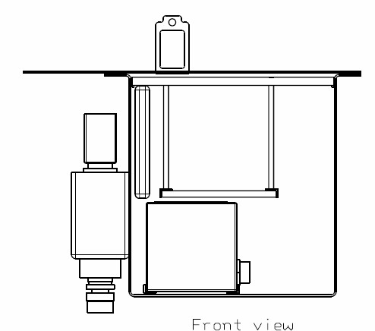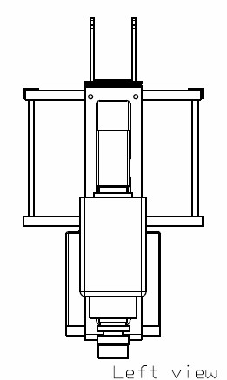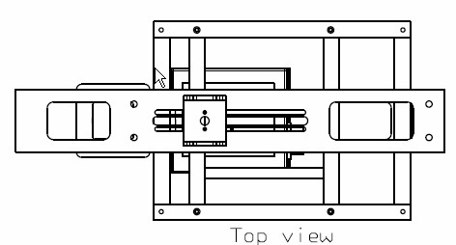
a b c
Figure 1. Technical drawings of the structure of T-LHSIS. a) front view, b) left view, c) top view.

The surface of one sample of hyperspectral sensors V9 is calculated by multiplying 33.3% of altitude (along the line sensor) and 2.8 per thousand of altitude (width of line sensors). Hyperspectral sensor V9 installed on platforms collects hyperspectral data of strip area W x L. The evaluation of the ground surface that is recorded can be calculated as: W = 0.333 x H (W = width of the recorded areas, L = length of the recorded areas, H = height above terrain, L = vT, v = velocity, T = endurance (the time in which the sensor collects useful data)).

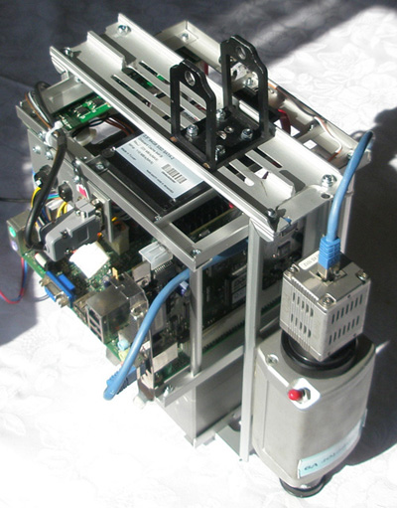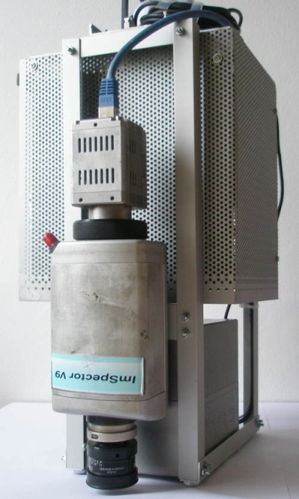
Figure 2. Two versions of the construction of T-LHSIS.

2.3 Platforms

The surveying with T-LHSIS was made with two platforms: blimp and Bell-206 helicopter. Due to the fact that it previously used the Bell-206 helicopter (during the development of the AI ​​DSS before TIRAMISU), this platform was used for hyperspectral surveying of exploded ammunitions depot in Padjane.

2.3.1 Blimp

Operability of T-LHSIS has been tested on blimp (Figure 3) in relation to the given requirements. Controllability of a blimp has been tested, as well as the quality of collected hyperspectral images during these flights. T-LHSIS is controlled wirelessly from the ground.

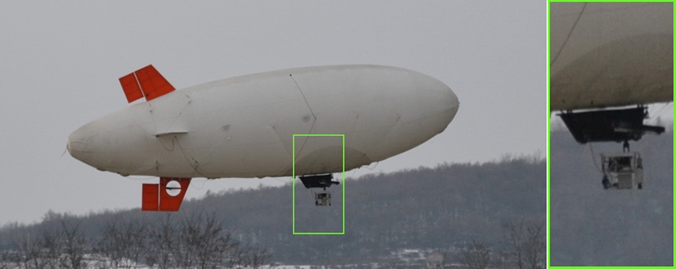
Figure 3. Blimp with T-LHSIS (in two green rectangles).

The declared favourable flight parameters (characteristics) of this particular blimp are: low speed flight (about 4-5 m/s), low altitude flight (less than 30 m) and insignificant swinging and vibrations, The main restrictions of this particular blimp (before testing) are: the maximum bearing weight (payload, 3,8 kg), pilot must have visual contact with the aircraft during the entire flight, the system is powered with battery of 12 V DC (2200 mAh/12V), resulting in short duration of the flight (about 30 min with payload of 3,8 kg (weight of T-LHSIS, Table 1).

Declared flight parameters were not confirmed during the testing in the operating conditions. The declared minimal flight altitude (less than 30 m) and speed (about 4-5 m/s) for the platform for hyperspectral survey were different after testing in operating conditions. Furthermore, the test results showed that the greatest limitation of this blimp was associated with the flight parameters: roll (rotation of blimp around the axis of the direction of flight) and pitch (rotation of blimp around an axis perpendicular to the direction of flight). The combination of the impact of the these parameters caused unacceptable deformation of hyperspectral images. The results depend primarily on the specific atmospheric conditions in the moment of surveying and the combined influence of pitch and roll parameters. On the platform and on T-LHSIS, certain changes were made (in attempt to reduce the influence of these phenomena) that resulted in reducing the phenomenon (pitch has decreased to about 2° and roll to about 6°). But still, the range of roll parameter remained high (over 6°) and it was very difficult to control. The distortion was still present to great extent.

2.3.2 Bell-206 helicopter

Bell-206 helicopter was re-entered in the focus of interest as a platform for aerial data acquisition sub-system of T-AI DSS after the production of T-LHSIS and after unfavourable results of testing the system on blimp. This platform (figure 4) is more easily accessible and much cheaper (about 6 times per hour) than the Mi-8 helicopters.

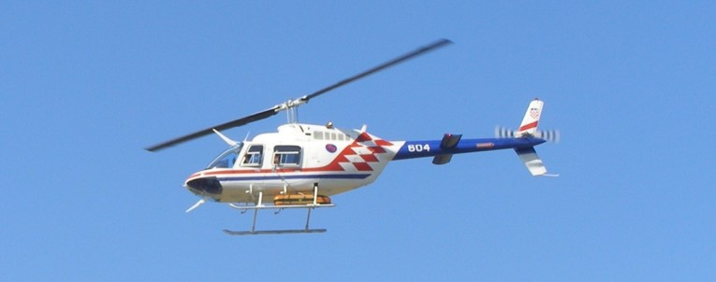
Figure 4. Helicopter Bell-206 with the T-LHSIS in the orange-black container installed under the helicopter.

The declared flight parameters (characteristics) of Bell-206 helicopter are: minimum steady flight speed is about 70 km/h, minimum height of stable flight with minimum flight speed is about 200 m (above ground), and the endurance is about 2:15 h. Compared to the blimp, Bell-206 helicopter can carry a higher burden, there are fewer problems with roll and pitch parameters, but the vibrations are higher. Furthermore, the minimum speed and height for hyperspectral recording are much higher. Vibrations, minimum speed and flight altitude are lower (more favourable) than with Mi-8 helicopter, but the capacity is smaller, there is no power supply from the helicopter and only one operator can go with the system.

After defining and eliminating some technical problems with T-LHSIS, the confirmed endurance during testing and surveying was not less than 2h, and the performance was mostly stable. The recorded data and flight parameters were very much satisfactory. Low value of oscillation of the flight parameters led to high quality of parametric geocoded hyperspectral images.

3. Conclusion

This module should ensure the stability and reliability of (aerial) data acquisition for non-technical survey of SHA on each platform. The new power supply system for module for aerial data acquisition (for Mi-8 platform) which is re-designed, developed and built up for T-AI DSS improve the robustness and stability of the system. These changes have resulted in changes in the configuration of the system for aerial data collection.

Subsystem (system configurations are different for different platforms) for (aerial) data acquisition was examined on multiple platforms (Mi-8, blimp, Bell-206) and can operate in stable manner, without cancellation, on Mi-8 and Bell-206 platforms (helicopters).

A new system, T-LHSIS, for aerial hyperspectral data survey has been produced. Technical stability and robustness of the T-LHSIS was confirmed by testing and evaluation (based on the behaviour of the system during the data collection over the test areas) of the systems on different platforms and operational missions in Croatia in the period from June 2012 to July 2013. Blimp can fly with T-LHSIS but it is difficult to be managed, and the parameters of the conducted flight do not provide a satisfactory quality of hyperspectral images. So, the testing of the blimp as a platform for T-LHSIS (line scanner for hyperspectral survey) disqualified it for further testing. A similar platform will be tested for a matrix cameras of T-AI DSS. Flight parameters of Bell-206 helicopter as a platform for T-LHSIS provide a satisfactory quality of hyperspectral images. T-LHSIS is a new tool, which can be used as stand alone equipment or within T-AIDSS.

4. Acknowledgement
These are people who have participated in these activities on a project TIRAMISU (for CTDT or FGUNIZ, in alphabetical order): Milan Bajic, Hrvoje Gold, Tamara Ivelja, Tihomir Kicimbaci, Marko Krajnovic, Andrija Krtalic, Josipa Nikolac, Ivan Racetin, Luka Valozic, Dejan Vuletic.The research leading to these results has received funding from the European Community's Seventh Framework Programme (FP7/2012-2013) under grant agreement n° 284747, project TIRAMISU.

5. References

[Fiedler et al., 2008] Fiedler, T., Bajic, M., Gajski, D., Gold, H., Pavkovic, N., and Milosevic, D.I. (2008) System for the Multisensor Airborne Reconnaissance and Surveillance in the Crises Situations Deliverable D220.1- v6, Page 90 of 94, and the Protection of Environment, Faculty of Geodesy University of Zagreb, Technology project TP-006/0007-01, supported by the Ministry of Science, Education and Sports of the Republic of Croatia, Zagreb, 2007-08 (Document in Croatian).
[ITF, 2010] ITF, CTDT (2010) Deployment of the Decision Support System for Mine Suspected Area Reduction Final Report 2009, V2.0.0, International Trust Fund for Demining and Mine Victims Assistance, Ig, Slovenia, HCR Center for Testing, Development and Training, Ltd., Zagreb, Croatia
[ITF, 2011] ITF, CTDT, BH MAC (2011) Determination of Mine - Suspected Area near Bihać, Mostar, Trebinje by Advanced Intelligence Decision Support System, Final report V1.0.0, of the project Deployment of the Decision Support System for Mine Suspected Area Reduction in Bosnia and Herzegovina. Zagreb, Croatia

Faculty of Geodesy University of Zagreb, Croatia, tamara.ivelja@gmail.com, ivan.racetin@gmail.com, kandrija@gmail.com

