The concept of method for semi-automatic interpretation within T-AI DSS
Ivan Racetin, Andrija Krtalic¹, Zlatko Candjar¹
Abstract

Computer-assisted image processing for extracting of IMP on the basis of object oriented analysis (using images segmentation) was carried out (by means of factor and cluster analysis) within the interactive interpretation of images. The final evaluation will be conducted by experienced interpreter and it will be also carried out on the basis of NIIRS and IQM parameters. The one aim of this research is to establish a methodology and guidelines for interactive semi-automatic interpretation of digital images in humanitarian demining for the purpose of detection and extraction of (strong) indicators of mine presence and absence which can be seen on the images. The experience gathered in working with AI DSS in undertaken projects led to the conclusion that a man (the human eye and contextual view on the scene) as interpreter (of mine scene) can hardly be replaced by automatic methods of digital image processing. However, some methods of digital image processing (implemented in certain ways) may help the interpreter in the identification of certain anomalies in the scene and easier detection of indicators. The basic idea of interactive methods of semi-automatic interpretation of digital images of SHA is to provide assistance to the interpreter in the interpretation of digital images rather than to replace him. The objective of this method is to be sensor independent and independent of object of research. The concept of this method was defined and initial research carried out in 2013.

1. Introduction

The one aim of this research is to establish a methodology and guidelines for interactive semi-automatic interpretation of digital images in humanitarian demining for the purpose of detection and extraction of (strong) indicators of mine presence and absence which can be seen on the images. The experience gathered in working with AI DSS in undertaken projects led to the conclusion that a man (the human eye and contextual view on the scene) as interpreter (of mine scene) can hardly be replaced by automatic methods of digital image processing. However, some methods of digital image processing (implemented in certain ways) may help the interpreter in the identification of certain anomalies in the scene and easier detection of indicators. The basic idea of interactive methods of semi-automatic interpretation of digital images of SHA is to provide assistance to the interpreter in the interpretation of digital images rather than to replace him. The objective of this method is to be sensor independent and independent of object of research.

2. Method for semi-automatic interpretation within module of T-AI DSS

The method consists of the following procedures (figure 1):
- Pretreatment of images and transformation into other forms of display – PCA, ICA, CIELAB,
- Segmentation,
- Statistical analysis of the parameters of segments - finding of isolated parameters,
- Using of common methods of images processing - according to isolated parameters,
- The combination of the results of image processing - to enhancement objects.

2.1 Pre-treatment of images and transform into other forms of display

Image enhancements (PCA, ICA), processing (TVI, NDVI,…) and transformation in different color space (CIELAB) have aim to rearrange information in order to obtain independent entities for further processing. The accent will be focused much more on the benefits of chosen enhancement or transformation to another colour space than the actual mathematical and scientific background.

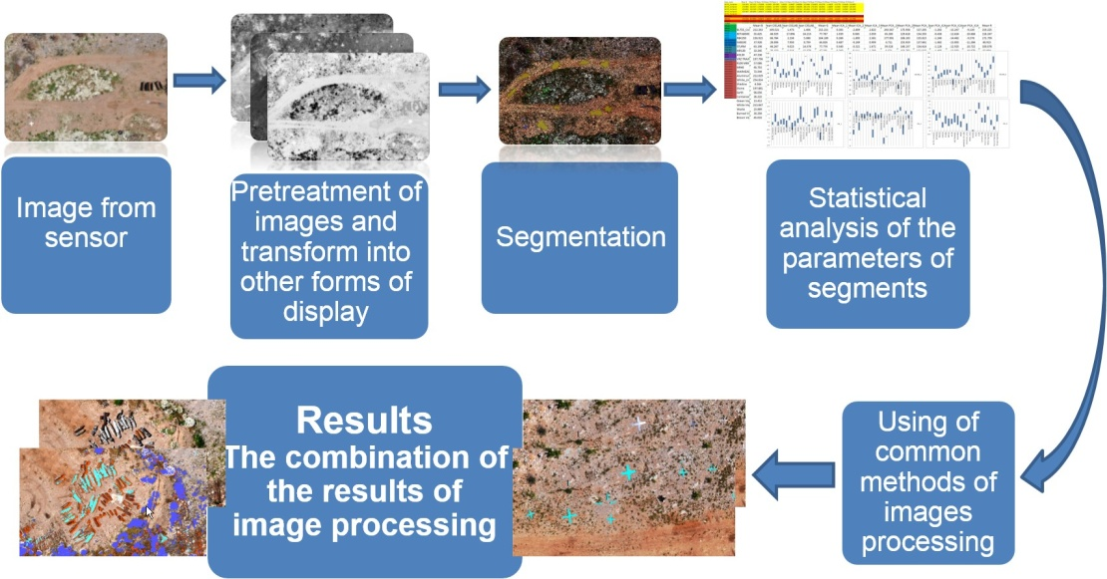
Figure 1. Schematic representation of Method for semi-automatic interpretation within module for T-AI DSS.

2.2 Segmentation

For the purpose of feature analysis of each indicator (object) on the digital image, it is necessary to determine the pixels that form the object in the image. Image segmentation is used for this procedure within the T-AI DSS. Statistical methods like factor and cluster analysis are used for radiometric and geometric analysis of these newly created segments.

The segmentation of digital images is a process of decomposition of digital images into smaller parts (segments) that have common characteristics (features). For this research, multiresolution segmentation (Figure 24b) is performed within the software package Definiens Professional 5.0 (DEFINIENS, 2006). Multiresolution segmentation algorithm is an optimized heuristic procedure that minimizes locally averaged heterogeneity of objects within the image resolution images, and is based on five criteria: scale parameter, colour, shape, smoothness and compactness (DEFINIENS, 2006).

Related parameters as colour and shape, and smoothness and compactness. The sum of the coefficients of their impact is always 1, and the condition is that the colour parameter can never be 0. Segmentation is performed on a set of images of different resolutions and it is therefore possible to weight the images according to the needs of analysis and resolution of images. All these segmentation parameters depend on the scale of images (pixel size and resolution) and the size of the object.

2.3 Statistical analysis of the parameters of segments

The segments represent the observed indicator and the objects that surround it (for analysis of the degree of discrimination of targeted objects from the environment) in the best possible way. Statistical analysis of radiometric and geometric parameters is performed in order to identify parameters which will enable discrimination of targeted objects from the environment. That can be distinguished according to their feature values. If it can’t be done directly, with one processing, then a combination of processing is looked for which can extract the desired object (an indicator or some percentage of its surface) on the resulting image.
The inputs for statistical analysis are digital numbers of pixels and statistical parameters of the segments (radiometric (figure 2) and geometric) which are incurred in the process of segmentation. Radiometric parameters that were used in research are: mean, standard deviation and coefficient of variability.

Cluster analysis indicates classification of segments according to their characteristics. First, the clusters (categories, classes) of entities were formed according to some common characteristics, and then the relationships between them defined. The specificity of this approach relates primarily to the use of cluster hierarchical clustering methods by which it is possible to homogenize the group in some set in objective manner.

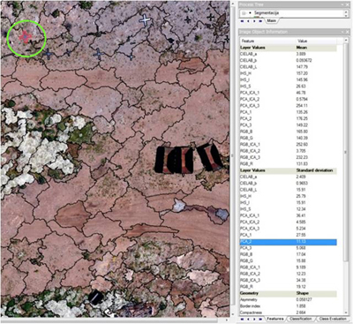
Figure 2. Segmented image (aluminium cross in green circle) and statistical parameters of one segment (right table).

Research for the semi-automatic methods of interpretation was carried out with the indicators of mine presence (on images from previous projects) and UXO (area exploded munitions depot Padjene). In this paper are shown only analysis of UXO.

3. Analysis of UXO

The object of interest, in this case are unexploded ordnances (UXO), but this method is possible to apply to any other object of research which can be seen on the digital images. The data used for this research are visible (by Nikon D90 matrix camera, Figure 4a) and near infrared (by DuncanTech MS4100 matrix camera, Figure 4b) aerial images of exploded ammunition depot located in Padjene, Croatia. The unplanned explosion, caused by extensive forest fire, happened on 13 September 2011, and the airborne multisensor mission, covering the area of interest was executed from 11 to 15 June 2012. The consequence of the explosion were spatially scattered UXOs. The aim of this study is to examine the possibilities of enhancement or extraction of UXO’s using known techniques of digital image processing, or combinations of these results.

This kind of data analysis, as already said, is independent of the sensor used. The only difference can be in the image processing which is possible for given sensor data. Aerial images of the area where explosive materials are located (controlled by the military) that can be found in the area of interest and marked with aluminium crosses (for better detecting of explosive devices in the figures) were selected for initial analysis (Figure 4).

The first step needed to do is to execute the series of various image processings which will help the photo interpreter in his work. In this special case, transformation in CIELAB colour space has been used. Apart from that, Principal Component Analysis (PCA) and Independent Component Analysis (ICA) have also been applied, and for the sensor with data from near infrared spectrum, vegetation indexes have also been calculated. The second step is to perform multiresolution segmentation (Figure 3).

After the preferred image processing had been performed, all this newly created data was imported into software supporting the object oriented analysis (Definiens Professional 5.0). This data can be seen as new channels or layers which are added to original image. By segmenting the image and obtaining the adequate image objects (segments), it is possible to acquire and export extensive data sets about radiometric and geometric parameters of objects of interest.

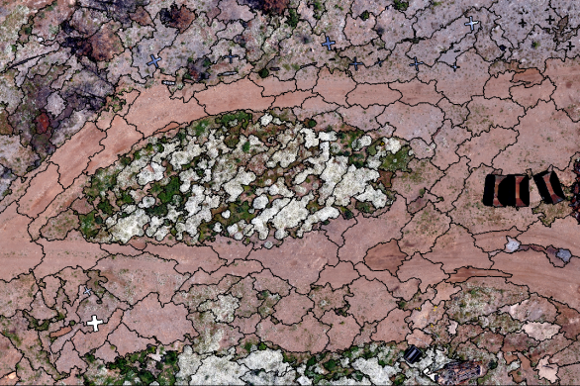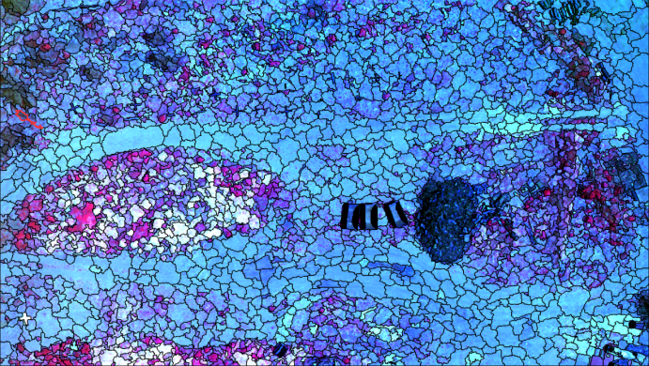
a b
Figure 3. a) The segmented colour image captured by the Nikon D90 camera. b) The segmented infrared colour image captured by the DuncanTech MS4100 camera.

The next step of computer supported interpretation is further analysis of statistical parameters with the aim of finding regularities in a set of images (thresholds, raster calculator) by which the desired objects can be extracted. By setting a threshold for a particular feature (mainly radiometric), it is possible to highlight certain binary objects of interest. Furthermore, these binary images are suitable for raster calculation with the aim of highlighting or marking certain objects in the pictures.

Access to the selection of the threshold parameters can be twofold. The first approach involves the selection of such thresholds, which will directly extract only the object of interest or more of them. Another approach involves capturing objects that are not of importance, such images are used as a mask to input images. In cooperation with photo interpreter, it is possible to make conclusion about capabilities of interpretation of targeted objects. It is a kind of internal evaluation of the method. The goal is to determine which objects are and which cannot be interpreted on given images or their processing.

3.1 Preliminary results

The best response is from targeted objects which are made of polished aluminium, and not corroded, this includes following UXOs: Training missile VRZ 57mm P1, some pieces of Artillery shells 130TF for M46, Air cluster bomb RBK – 250 and Cluster bomb BL-755, container for cluster bomb. It must not be forgotten that airborne mission was executed nine months after the accident, and most of UXOs were already rusty in the time of the mission.

a
Figure 4. a) The main (binary) result of established method in the research carried out so far. The positions of two types of explosive ordnance: air cluster bomb RBK (green ellipse) and VRZ training missiles (red ellipse) and polished aluminium crosses (black crosses) are clearly separated from the environment.

Statistical samples were the basis for determination of threshold values and for the selection of channels in order to achieve the desired results. In the pictures that are shown above, a part of the original image (figure 4) can be seen, as well as the results of applying the thresholds and raster calculation of the images and their processing.

4. Conclusion

Defined concept of Interactive semi-automatic interpretation of digital images in humanitarian demining for the purpose of detection and extraction of UXOs (strong) or indicators of mine presence and absence which can be seen on the images it showed some potential in practice. The research by means of the method for semi-automatic interpretation will continue in 2014. It is necessary to direct research towards integrating the analysis of radiometric and geometric parameters of the segments, and to exploit all the advantages given by one and the other. Furthermore, if possible, it is necessary to find the legality of the parameter values of the same object in different images and terrains. This would be a way to write guidelines for the implementation of processing to extract specific objects of interest in digital images.

5. Acknowledgement
The research leading to these results has received funding from the European Community's Seventh Framework Programme (FP7/2012-2013) under grant agreement n° 284747, project TIRAMISU.

6. References

[DEFINIENS, 2006] DEFINIENS (2006): Definiens Professional 5, Reference Book, Definiens AG, München, Germany

Faculty of Geodesy University of Zagreb, Croatia, ivan.racetin@gmail.com, kandrija@gmail.com, zcandjar@gmail.com

