**THE ROLE OFTRAFFIC SIGNALIZATIONON REDUCTION OF**

**ACCIDENTSON THE CROATIAN ROADS**

DarkoBabić Ph.D1., Mario Fiolić mag.ing.traff.1

Faculty of Traffic and Transport Science1

Vukelićeva 4, 10000 Zagreb, Croatia

E-mail: darko.babic@fpz.hr, mario.fiolic@fpz.hr

***Abstract:****Safety of all road users on the roads is one of the fundamental social objectives. Measures for improvement or remediation of dangerous sites (black spots) in Croatia are carried out in several phases, from planning the envisaged measures, valuation measures, the implementation of measures to observation and assessment derived measures. Certain dangerous places are repaired only by changing traffic signalization and those sites and measures are described in this paper. In last eight years on the roads in Croatia, 215 dangerous places were repaired and partial restoration was carried on the 46 dangerous places. The success of provided measures, expressed through an analysis of the number and consequences of accidents on dangerous places for three years before and three years after restoration, shows the drastic reduction in traffic accidents on this places. The conclusions and solutions of these measures are presented in this paper.*

*KEYWORDS: BLACK SPOTS, TRAFFIC SIGNALIZATION, RETROREFLECTION, MEASUREMENTS*

# Introduction

*The national program of road safety in Croatian was first planned and implemented in 1994.Since then, it has been conducted the four NPSCP's, and the latest, fifth, is in force since April 2011. (Period 2011-2020).Considering the positive experience in the implementation of certain of these programs, which haveresulted decreasing fatal casualties and decreasing injuries in traffic accidents, it has continued with the adoption of the program, with addition to tracking the latest trends in increasing road safety and compliance with best practice in European countries, which recorded the best results. In determining the cause of the accident or wrong behavior of participants that started the accident event is of crucial importance.Is it for wrong behavior that caused the accident responsible only the subjective factor, i.e. direct participant in traffic or to the incorrect behavior that caused the accident occurred in some form of interaction between subjective factors and objective factors.*

# Defining black spots in Croatia

*There are several definitions of “black spots“ and two of them are most commonly used: 1. „Black spot is a place, location in the road network (point or road section), or the streets network where is more likely thatan accident will happen, depends on the other network elements.*

*2. In accordance with the methodology of traffic safety, the "black spot" can be called an intersection or road segment lengths up to 300 m, or "dangerous section" can be called a part of the road length of 300 m to 1000 m, with conditions that they have to comply in following criteria:*

*• If at the critical location in the last three years occurred 12 or more accidents with injuries,*

*• If at the monitoring location in the previous three years recorded 15 or more accidents, no matter the consequences,*

*• If at the critical location in the previous three years happened three or more identical traffic accidents, with the same group of participants, same direction of movement, on the same conflict areas etc.*

*Since 2001 it was detected 220 black spots (95 remediation is completed or is in progress). 2012 was detected 45 new black spots, mostly in the Splitsko-dalmatinska (16) and Krapinsko-zagorska (7) county.*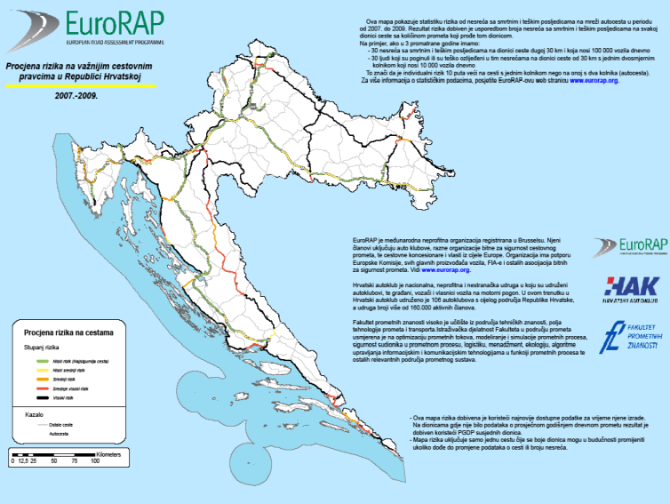

Figure1Risk assessment on the major roads in Croatia

Source: http://www.hak.hr/vijest/176/eurorap-mapa-rizika-za-3400-kilometara-nasih-cesta

# Elimination of black spots

## 3.1. Methodological approach

*Determination of dangerous places "black spots" on the roads is an important aspect of managing traffic at places that represent a potential threat. Situation analysis of traffic safety on all roads was carried out in three phases:*

*1. The general analysis of the situation and tendency of traffic safety has enabled the understanding the size of the problem, international comparisons, review the structure of accidents, the time distribution of accidents, trends and other general characteristics of the condition.*

*Quality information base for the analysis and identification of critical points in the transport system requires the following information:*

*• Types of accidents (according to the consequences, type of collision, vehicles participants, etc.)*

*• Type of location (rural / urban, road, street type and class, crossing / not crossing etc.),*

*• Time (day time, day in week, date)*

*• Environment (physical conditions, light, visibility, wind, temperature, rain, snow, etc.),*

*• Participantscharacteristics (age, ability, experience, behavior, status, influence of alcohol, drugs, etc.)*

*• Vehicle characteristics (type, age, technical requirements, etc.)*

*• Roadcharacteristics (the precise location, geometry, visibility, surface quality and condition, equipment, clarity, etc.)*

*• Traffic characteristics (intensity and structure of the flow, average speed, etc.)*

*• Expert opinion (factors that have contributed to the accident, estimated speed, position and behavior of participants)...*

*2. Situation analysis on the traffic sections and risk mapping by sections enabled the betterunderstand the spatial distribution of traffic accidents and specificity of certain road sections in terms such as risk of accidents, risk of injury, the most common types of accidents, the categories of participants, the most common mistakes etc.Thus, the conducted analysis allows the definition of the most dangerous sections or "black spots".For the detection of critical points on the road network it is used different types of criteria:*

*• Number of accidents during a certain period that is higher than certain norms,*

*• Weight of accidents during a certain period,*

*• Combination of the number and severity of accidents during a given period,*

*• Number of accidents at the point that we observe in relation to other points along the road,*

*• Opportunities for reducing accidents*

*• Accidents costs during a given period,*

*• Danger indicators method*

*• Rating according to characteristics of place, not byhistoryof accidents,*

*• Current annual cost of accidents that occur at this point, based on the average cost of accident and by type of accident.*

*3. Situation analysis by the road kilometer and determination of “dangerous kilometers”. Based on a detailed analysis of accuracy, condition and quality of data on accidents it was observed the precision of the location of the accident.In the accidents analysis there are two phases:*

*• Phase when the driver detects a situation that leads to accidents • Phase when the driver is trying to avoid.*

*These phases are related with the appropriate categories of measures that seek to improve safety. One group consists of active safety measures. These are measures that help to stop the occurrence of accidents, to help the driver to avoid them or to put him to know that there is a situation of increased risk and the possibility of accidents (information about the risk, improving of visibility, controlled direction, etc.).Another group,measures of passive safety, are those measures which are becomingan indicator during the accident.They prevent the serious consequences of accidents (road safe environment without hard solid objects or trees, the equipment on the road that will cause serious injury, etc.).Identifying method of "black spots" on the roads is based on a previous analysis of data on traffic accidents, road and traffic.The aim ofimplementation method is to highlight the meaning and importance of establishing "black spots" on the roads and stimulate further theoretical and practical work on the consideration of these issues.Interventions at places of accumulation of traffic accidents are considered one of the most effective approaches in prevention of traffic accidents on the roads.Considering the scientific literature there has been a series of attempts to find and define the most effective method, which would enable the measurement of the security of certain road sections and identify the most vulnerable and dangerous place, or "hot spots" of traffic on the roads.*

## 3.2. Traffic signalization

*Croatian roads ltd. continually since 1998 in cooperation with the competent police directorates of the Ministry of Interior, collects data on the number and consequences of accidents on the micro locations of state roads where is noticed certain grouping of traffic accidents.The collected and processed data basically contains information about weight, casualties, and micro-location where the traffic accidents occurred.Besides there are collected and processed data on traffic density, road and its surroundings, equipment and road signaling, etc.Data on the road and its surroundings include geometric characteristics of the road alignment (horizontal and vertical), construction elements (longitudinal and transverse slopes, type of paving, drainage), paving condition (cracks, potholes, the state of the macro and micro texture), road equipment (fences, poles, street signs Retro-reflection), visibility, road marking and lighting, etc.Prometni znakovi osnovna su sredstva komunikacije između nadležnih za ceste i sudionika u prometu. Factors that help to identify the sign in his understanding are:*

*• Size of sign*

*• Simplicity of symbols or used text*

*• Color of the sign*

*• Retroreflection.*

*One of the most important properties of the retroreflective foil for drafting traffic signs except the clarity is ability to restore lights, i.e. reflectivity.There are several principles of classification retroreflective foil depending about the institution which it specifies, but the most common and used by CEN are:*

*• Class I (closed glass ball, at the present time and microprisms)*

*• Class II (embeddedglass ball, at the present time and microprisms)*

*• Class III (prizma).*

*Materials class I are retroreflective sheeting’s made of a durable material with the bounded glass micro beads or prisms. Retroreflection of materials class I with glass micro beads is about 70 cd•lx-1•m-2 and because of its low retroreflection it is in most cases used in areas with low-speed and calmer traffic flow. Materials class I that have bounded micro prims have significantly higher retroreflection (around 200 cd•lx-1•m-2) than materials with glass micro beads.*

*Materials class II are retroreflective sheeting’s that contains encapsulated glass micro beads or prims that are three times brighter than materials class I. The signs made from materials class II are clearly visible, even from a wide viewing angle, and the lighted environment, effectively warning drivers of approaching danger on the roads. Retroreflection of materials class II with glass micro beads is around 250 cd•lx-1•m-2 and 500 cd•lx-1•m-2 for materials with micro prisms.*

*Materials class III are retroreflective sheeting’s that are made of highly effective micro prisms that enables retroreflection around 700 cd•lx-1•m-2. Therefore, they provide the drivers with adequate visibility in all day and night and adverse weather conditions. The prerequisite for safe driving at night is a sufficient level of visibility for the driver which is consistent with the permitted speed.The different qualities of materials enable certain traffic signs to adjust on higher or lower levels of luminance.Some materials are designed to maximize the durability of the traffic signs, while another intended for short-term use.The different quality of materials for traffic signs, different sign production processes and selection of materials for the surface of the sign will have an impact on the ultimate lifetime of traffic signs.By being placed on the open road signs are exposed to the impact of unfavorable atmospheric conditions; their unfavorable factors such as the influence of ultraviolet rays in sunlight, humidity, and large differences between day and night temperatures.Such negative effect of weathering at the end reduces transparency, color and integrity of the materials used in retro-reflective road signs and thereby reduces their visibility at night.*

*The dynamics of remediation was conducted in a way that in 2001 was remediated 4 dangerous places, during the 2002 remediated 15 dangerous places, 2003 remediated 36 dangerous places, 200451 dangerous places, 2005 26dangerous places, 2006 13 dangerous places, 2007 remediated 12 dangerous places, 2008 remediated 19 dangerous places, 2009 remediated 15 dangerous places, 2010 8 dangerous places, and the 2011 was remediated 16 dangerous places.The most common causes of traffic accidents that occur on the roads and must be taken into consideration in the selection of measures that should be applied are:*

*• The conflictlevel in traffic regime,*

*• Clarity of the road,*

*• Inappropriate speed (poor conditions that contribute to driver defective estimating of safe speed)*

*• Conditions imposed by the environment (visibility, slippery, lighting, etc.).*

*Measures for short-term and long-term remediation of dangerous places can be systematically divided according to time and place of origin and the manner of elimination. With regard to the duration may be temporal or permanent.*

*I. Class measures (temporary measures, mostly traffic-technical properties) - those that result from occasional or periodic condition at a specific location (ice, driving traffic, temporary blockages, etc.) or a result of various of other causes (the inevitability of taking action, additional land acquisition , lack of resources, etc.). Traffic signals on the road must meet the following conditions:*

*• alert the driver to any unusual and non-standard solution,*

*• inform drivers about road conditions that a driver must be considered at time, and they must adapt,*

*• guide the driver through an unusual situation (it clearly focus on appropriate behavior)*

*• direct its movement in zones of conflict and at other road surfaces,*

*• compensate for certain errors and behavior by drivers with elements that mitigate the effects and help to avoid accidents.*

*This class (I) measures undertaken at those locations where they are not needed construction works, and where are already adequate road signs (better class to create traffic signs, new traffic signs, maintenance ...) sufficient to achieve a higher level of safety in road traffic. Examples of such repairs are shown in Table 1 under regular maintenance program (Karlovac D3, Čibaća, Velika Mučna...), which includes the maintenance or replacement of existing traffic signs. Picture 2 gives an example of taking measures for the rehabilitation of a first-class dangerous place where the existing signs are replaced and supplemented with new traffic signs and road markings.*

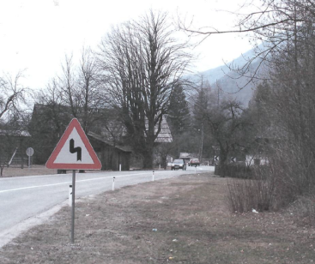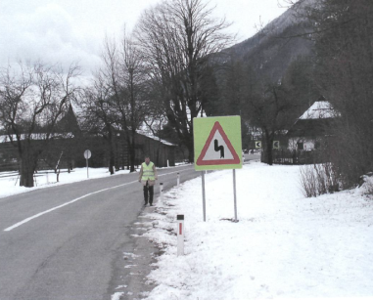

Picture . Displaying dangerous place before and after the implementation of measures of class I

Source: http://www.skyscrapercity.com

*II. Class (permanent measures) - measures that should completely eliminate the condensation of traffic accidents. This class includes construction-technical measures and adequate traffic signs and represents the most expensive but also the best solution for the remediation of hazardous places. Building technical measures include:*

*• Extension of the roadway,*

*• Correction of cross slope,*

*• Creation of visibility in curves,*

*• Construction of the rotor,*

*• Setting of additional protective fence,*

*• Changing the roadway with new asphalt layer*

*• Milling of asphalt surfaces to increase friction road surface during the summer rains and winter ice...*

*In Croatia, this type of measures is usually implemented through programs Betterment and national road safety program (Table 1). The national program of road safety of Croatian basic document and a platform to raise the level of road safety in our country to a higher, more acceptable level than current, while the Betterment Program (a program of increased maintenance and project specific rehabilitation) is the rehabilitation of the road network, and is funded partly of loan funds from the European Investment Bank, and partly from its own resources Croatian Roads ltd. Picture 3 gives examples of taking action II. Class that include building technical measures and traffic-technical characteristics (Betterment Program).*

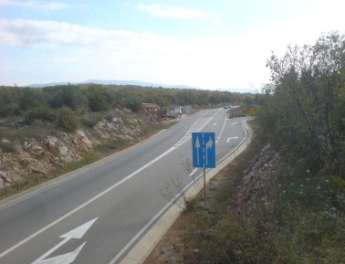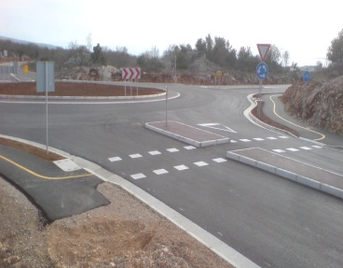

Picture 3. Displaying dangerous place before and after the implementation of measures of class I

Source: http://www.skyscrapercity.com

*On the basis of these measures in the short-term and long-term remediation of hazardous places can be concluded that based on the basis of:*

*1. Established conflicting events observing traffic on that place;*

*2. Mentioned traffic technical deficiencies and irregularities of the road, affecting traffic safety;*

*3. Justification of the basis of the valuation methodology (cost - benefit) established traffic technical irregularities of the road, and considering the dangerous behavior of road users.*

Table 1 provides data of traffic accidents and the consequences of these accidents (number of minor and serious injuries, and the number of fatal accidents and easier injuries) for the period from the last 3 years (data for the 2012 and 2013 year are processed completely) which include information on traffic accidents three years ago and three years after the measures implemented. Under the program, there are maintain the measures which were taken at each dangerous section. On some sections it was enough to existing traffic lights, replace with adequate traffic signs (regular maintenance program), and in this way reduce the number of fatally injured persons, while individual stocks require more remediation and construction-technical measures and also adequate traffic signs.

Table 1. List of hazardous places remediated by the year rehabilitation (Source: Croatian Roads ltd.)



# Conclusion

*Safety of all road users on the roads is one of the fundamental social objectives. Traffic accidents related to area are due to unfavorable interactions between subjective and objective "factors - the road" to "dangerous place", meaning that the road some of its characteristics have a significant effect on driver behavior, and that such behavior would result in a traffic accident. The road and its effects are not the only or the biggest factor in road accidents. Often, that is the most common cause of the human factor, but eliminating possible causes of the events of traffic accidents due to road conditions, appropriate amendments to traffic signs and road equipment quickest and most efficient may affect the reduction in the number and consequences of accidents at critical locations. Determination of "black spots" on the roads on the basis of registered safety indicators (number of traffic accidents, the number of deaths, and the number of minor and injured people on certain sections of the road) is the first step to be taken in order to later be determined and implemented preventive and repressive measures to increase traffic safety. A job improvement of road safety is a continuous job, resolving and alleviating one problem, there is a second, in new circumstances, appears the new priority, along with new problems to solve and improving safety.*

*Measures for improvement or remediation of hazardous spots in Croatia are carried out in several phases, from planning the envisaged measures, valuation measures, the implementation of measures to observation and assessment derived measures. In the previous period, Croatian Roads, through various programs, have spent to complete the rehabilitation of 215 dangerous spots and partial rehabilitation of 46 dangerous spots around 179.5 million Kuna, while for the same purpose from the funds of the National program of road safety of Croatian allocated 5.5 million Kuna, which makes a total of 185 million spent for remediation of hazardous spots on state roads of Croatia. The success of the rescue operation carried, expressed through an analysis of the number and consequences of accidents on retrofit dangerous places for three years before and three years after remediation, is evident through a drastic reduction in traffic accidents on dangerous rehabilitated*

*(the period since 2001. until 2011.) places from 6326 to 1568 (75.2%) accidents. The number of deaths on retrofit dangerous places was reduced from 131 to 12 (90.8%), serious injuries from 548 to 141 (74.2%) and the number of light injuries decreased from 1,980 to 555 people (71.9%).*

# Literature

1. *Gledec, M.: Why on the roads are "black spots" , Zagreb 2009.*
2. *Ščukanec, A.: Application of retroreflective materials as a function of road-traffic safety, Doctoral dissertation, Zagreb 2003.*
3. *Ščukanec, A., Babić, D.: Test methods retroreflection of traffic signs and road markings, Zagreb 2013.*
4. *Zovak, G., Šarić, Ž.: Traffic safety and technical expertise (teaching materials), Zagreb, 2011.*
5. *Bulletin of road safety, the Republic of Croatia, Ministry of Interior, Zagreb 2012.*
6. *Rulebook on trafficsignsandequipment on theroads, theMinistryofSea, Tourism, Transport andDevelopment, NN 33 / 2005.*
7. *Croatian Roads - Data on rehabilitation "dangerous places" on state roads of Croatia.*