1. Luka, MUDRONJA, Faculty of Maritime Studies, University of Split, Zrinsko-Frankopanska 38 Split, luka.mudronja@pfst.hr, phone: +385913807083, corresponding author
2. Marko, KATALINIĆ, Faculty of Maritime Studies, University of Split, Zrinsko-Frankopanska 38 Split, marko.katalinic@pfst.hr
3. Pero, VIDAN, Faculty of Maritime Studies, University of Split, Zrinsko-Frankopanska 38 Split, pero.vidan@pfst.hr
4. Joško, PARUNOV, Faculty of Mechanical Engineering and Naval Architecture, University of Zagreb, Ivana Lučića 5 Zagreb, jparunov@fsb.hr
ROUTE PLANNING BASED ON SHIP ROLL IN NUMERICALLY MODELLED HEAVY SEAS
Abstract
Challenges in navigation route planning for seafarers are ship safety, travelling comfort and reasonable voyage duration time. Various routing models available to shipping companies aim to partially or fully avoid bad weather and heavy seas. The presented study analyses the situation when heavy weather cannot be avoided and the ship passes through a storm having the seafarers making immediate decisions about course and advance speed. Possible routes were evaluated for an existing shipping line across the Adriatic Sea during strong south-east wind that occurs several times per year. Heavy sea, resulting from strong winds, was calculated by a spectral wind-wave model SWAN. Ship response was computed by a combination of analytical expressions and spectral analysis. Ship roll was chosen as the seakeeping criteria for route planning.

Key words: route planning, ship roll, heavy seas, SWAN numerical wave model.
PLANIRANJE RUTE PLOVIDBE S KRITERIJEM LJULJANJA BRODA NA NUMERIČKI MODELIRANIM VALOVIMA
Sažetak
Odabir rute plovidbe broda predstavlja izazov pomorcima kako sa stajališta sigurnosti i udobnosti tako i brzine plovidbe te pravovremenog dolaska u luku. Mnogi modeli planiranja rute plovidbe savjetuju kako izbjeći nevrijeme i valovito more. Ovaj rad se bavi problemom prolaska broda kroz oluju i nemogućnosti izbjegavanja valovitog mora. U takvom slučaju pomorac mora odlučiti kako postaviti brod na valove i kojom brzinom napredovati. Odabrana je postojeća brodska linija na Jadranskom moru te su analizirane moguće plovidbene rute u uvjetima jakog jugoistočnog vjetra. Uz poznavanje brzine i smjera vjetra, spektralnim numeričkim modelom SWAN dobiveni su vjetrovni valovi . Odziv broda na valovima je izračunat kombinacijom analitičkih izraza i spektralne analize. Ljuljanje broda je uzeto kao kriterij pomorstvenosti broda na željenoj ruti.
Ključne riječ: planiranje rute plovidbe, ljuljanje broda, olujno more, SWAN numerički model valova

Introduction
Route planning is an interesting and responsible task for seafarers, usually done by 2nd officer
onboard merchant and passenger ships or by the master on smaller ships. It includes the selection of the voyage route based on parameters such as speed, voyage duration, passenger comfort, fuel consumption, etc. Avoiding bad weather and heavy seas is imposed as a logical conclusion and numbers of software supports have been developed to that aim [1]. Sometimes it is impossible to avoid bad weather and heavy seas, especially in areas such as the Adriatic Sea where its size disables avoiding bad weather [2]. In such cases route planning includes ship maneuvering in heavy seas which means voluntary speed reduction and course change. Results should be satisfactory in terms of ship response for events such as slamming, accelerations, rolling, etc. Questionnaires were done handed out and processes about seafarers’ reactions considering ship maneuvering and interesting papers were published [3, 4] with explanations how seafarers recognize bad weather and which maneuvers are usually undertaken. All ship maneuvering procedures can be considered as decision making processes based on a deterministic [5] or a probabilistic [6, 7] approach.
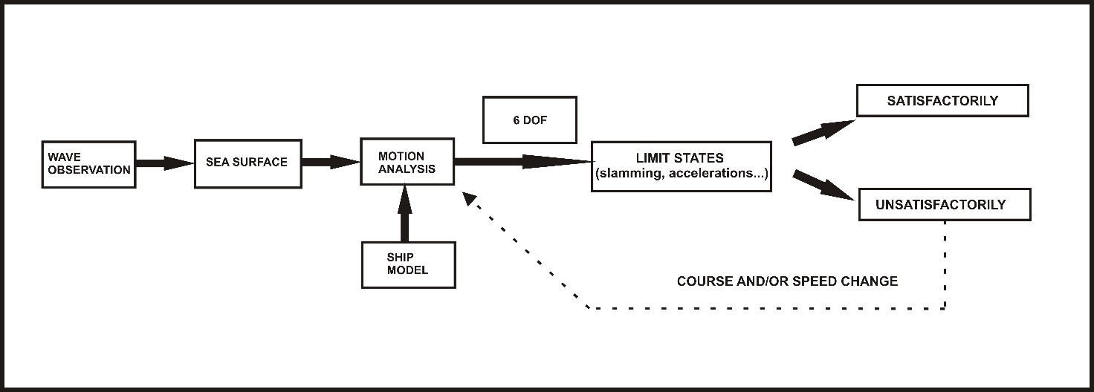

Fig. 1 Procedure for ship maneuvering on heavy seas
Slika 1 Opis postupka upravljanja brodom na valovitom moru

Figure 1 shows standard procedure for ship maneuvering (i.e. relevant decision making) derived from literature [5, 6, 7]. The motion analysis is based on a sea state model and a ship model with varying different speeds and courses calculating responses for six degrees of freedom (6 DOF). Limit states for certain ship responses (slamming, accelerations, rolling, etc.) can be introduced as deterministic [5] or probabilistic [6, 7] values.
This paper gives the authors’ proposal for route planning and safe navigation trough a storm. The concept is shown on passenger ship in the Adriatic Sea navigating during strong south-east wind and waves. A numerical model SWAN was used as a tool for wave modelling. The ship was modelled and motions were analyzed using closed-form expressions [8]. Ship rolling was used for seakeeping evaluation and limiting values were chosen to determine whether the response for a given speed and course is satisfactory or not.

Model for route planning based on rolling response of the ship
Presented route planning model is based on model derived from literature and presented in Figure 1. As it is shown in Figure 2, the model is a combination of ship motion analysis and limit states of the seakeeping criteria. Response spectral analysis is essential for ship motion analysis:
(1)
where S_{R} and S_{ζ} represent the response and wave spectrum, respectively, and ω_{E} is the encounter frequency. RAO (abb. Response Amplitude Operator) is obtained as a square of the transfer function [9]. Closed-form expressions derived by Jensen [8], as a semi-analytical method for ship modelling and transfer function calculations, where applied for calculating RAO in this model.
Encounter frequency is given by the equation:
(2)
where ω_{E} is the encounter frequency between the vessel and the wave, ω is the wave circular frequency, g is the gravity force acceleration, V is vessel speed and β is wave heading (180º means bow heading).
For the presented model, the SWAN model is provided as a tool for wave modelling and obtaining the wave spectrum.

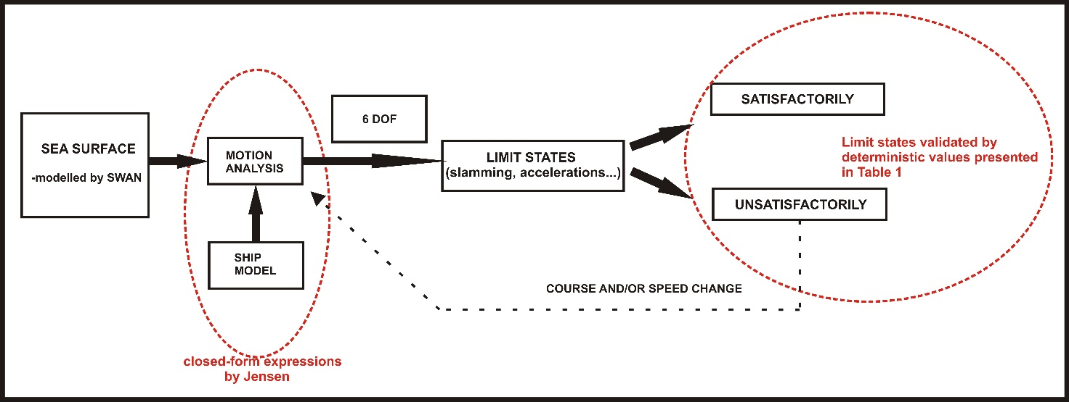
Fig. 2 Conception of the routing model
Slika 2 Koncept modela za određivanje plovidbene rute
Evaluation of ship motion is possible with seakeeping criteria and their limit states for some of them as presented in Table 1 [10, 11]. Limit states are given as deterministic values for large ships.

Sea surface modelling
For the purpose of sea state modelling, to provide input into the seakeeping analysis, a numerical wave model SWAN (abb. Simulating Waves Near-Shore) was applied. SWAN is a state-of-the-art, third generation spectral wave model [12]. It essentially resolves the spectral action density equation including the following effects: wind generation of waves, temporal and spatial wave propagation, refraction due to depth and currents, frequency shift due to non-stationary depth, tri- and quad-wave interaction, wave breaking, energy dissipation, obstacle reflection and diffraction.

Ship model
Closed-form semi-analytical expressions [8] are provided for transfer function calculations. Therefore, the ship does not have to be modelled, and the following parameters: length, breadth, draught, block coefficient, water plane area coefficient, heading and speed are a sufficient description. The validity of these expressions has been demonstrated by comparisons with experimental data and strip theory calculations by their authors Jensen, Mansour and Olsen. Because of their suitability and simplicity, these expressions were chosen for the approach described in this paper.

Motion analysis
Response spectra calculation is given by Equation 1. Transfer functions are to be calculated for corresponding motions and, in combination with wave spectrum, the response spectrum can be obtained. Expressions can be applied to calculate heave, pitch, vertical accelerations and roll responses. One of the results of the spectral analysis is the zero spectral moment which represents the variance of process. Significant amplitude of the response may be determined as:
$R_{S}=2∙\sqrt{m_{0}}$ (3)
where $R_{S}$ is significant amplitude of the response and $m_{0}$ is zero spectral moment. Significant amplitude of the response is calculated for each combination of RAO and ship speed.

Limit states of the seakeeping criteria
Seakeeping criteria are also known as operational criteria and have been used for evaluation of motions on waves. Results of the spectral analysis are used as an input for limit states calculations. Limit states chosen for the presented route planning model are shown in Table 1. These limit states are derived for large ships [11].
Table 1 Seakeeping criteria and limit states
Tablica 1 Kriteriji pomorstvenosti s pripadajućim graničnim vrijednostima
Limiting probability of slamming | 0.01
Limiting probability of deck wetness | 0.05
Limiting RMS of vertical accelerations at bridge | 0.15g
Limiting RMS of lateral accelerations at bridge | 0.12g
Limiting RMS of roll | 4 deg

Expressions for probability and root mean square calculations can be found in literature [11, 13].

Route planning
The aim of route planning calculations is to find a satisfactory route for ship navigation. Satisfactory route is where none of the limit states are exceeded and the ship can navigate safely. If the criteria is not satisfied, appropriate changes must be implemented, such as speed and/or course change. In relatively small seas basins, such as the Adriatic Sea, where storms cannot be avoided, usually route changing means only adjusting the ship-to-wave heading, not avoiding heavy seas completely as could be considered with weather routing.

Case study for the Adriatic Sea
The route planning model is presented for a voyage between ports Ancona and Split in the Adriatic Sea (Figures 4). A passenger ship, operating daily on that route, was chosen as a case study example and the main characteristics of the ship are presented in Table 2. The seakeeping characteristic of the chosen vessel were evaluated on a typical crossing course, from west (Ancona) to east (Split) coast, during a south-east (SE) storm wind (jugo) event. SE winds reach relatively high speeds and, due to long fetch along the basin, develop high seas (with a maximum recorded wave height of 10,8 meters [14]). Based on average storm wind speed during jugo wind, the sea states were modelled with the SWAN model using the actual bathymetry of the Adriatic and computational grid of 1 x 1 deg latidute/longitude. The model was forced by stationary 20 m/s wind, direction 135 deg in nautical coordinates. One-directional wave spectrum was then obtained at three defined locations for the expected, wind-wave frequency range. Defined locations are shown on Figure 3 with related positions defined in Table 3.

Table 2 Main characteristics of the ship
Tablica 2 Značajke broda
Length over all | 127,50m
Length between perpendiculars | 115,00m
Breadth | 19,60m
Draught | 5,50m
Block coefficient | 0,58
Water line coefficient | 0,80
Maximum speed | 16kn

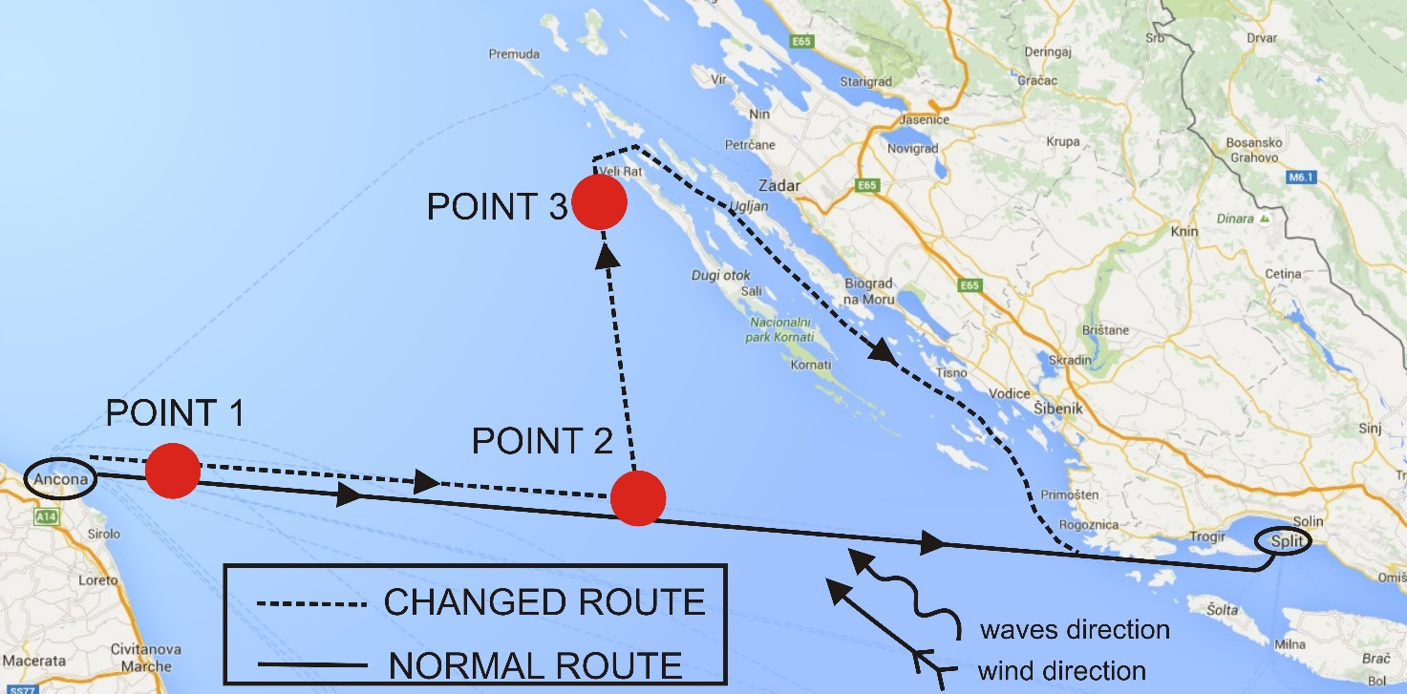
Fig. 3 Three defined points on the Adriatic Sea
Slika 3 Tri pozicije na Jadranskom moru koje su razmatrane u proračunu

Table 3 Locations of three defined points
Tablica 3 Geografske lokacija tri pozicije na Jadranskom moru
Point on the Adriatic Sea | Latitude [º] | Longitude [º] | Significant wave height [m]
Point 1 | 43,70 | 13,75 | 5,65
Point 2 | 43,60 | 15,00 | 5,66
Point 3 | 43,99 | 14,76 | 5,79

Table 3 also includes calculated significant wave heights for 20m/s SE wind (jugo). Points 1 and 2 are on the usual navigation route between ports Ancona and Split. Point 3 is on an alternate route that ensures better ship seakeeping performance during the described sea conditions.
The point of special interest is Point 2 because it represents the location where the route was changed. Thus, in the text bellow the results at that location are examined and discussed. Among available seakeeping criteria (Table 1), ship roll was singled out as being most representative based on questionnaires results obtained amongst seafarers [4] which had been made on the Faculty of Maritime Studies in Split during 2014., 2015. and 2016. Respondents were 18 nautical officers working on passenger ships and they have been asked to select which seakeeping criterion is (in their opinion) the most important for a passenger ships. Answers are shown in Figure 4. Eleven answers (61%) had been that rolling is the most important criterion.
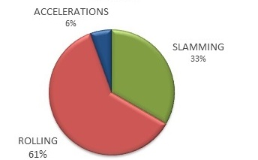

Fig. 4 Results of the questionnaire for interesting seakeeping criteria - passenger ships
Slika 4 Rezultati upitnika zanimljivih kriterija pomorstvenosti za putničke brodove

Response Amplitude Operators (RAOs) were calculated at Point 2 for two cases:
- 135 deg heading sea - normal route (Figure 3)
- 35 deg heading sea - changed route (Figure 3)
(180 deg represents bow heading sea).
It was necessary to change speed and heading of the ship in a way not to exceed limiting values of the seakeeping criterion for roll (Table 1).

Closed-form semi-analytical expressions [8] for roll were used in calculations:
(3)
where:
-is function for roll RAO calculation
-is the encounter frequency,
-is the amplitude of the excitation moment,
-is the natural period for roll,
-is the roll restoring moment coefficient,
-is the roll damping coefficient for the ship.

SWAN numerical model was used for sea state modelling and it was used to derive the wave spectrum for further calculation. Significant wave height of the wave spectrum at Point 3 was 5,79 meters as shown in Table 3.
Response spectrum for 35 deg and 135 deg heading is shown in Figure 5. Maximum allowable ship speed, not to exceed the limiting roll value of the 4 deg, is 5 knots (for the better of the two headings). Both spectra are made for the same speed of 5 kn. Response spectrum for 135 deg heading has very high peak value at encounter frequency of 0,7 rad/s because of the resonance effect which occurs when the natural and excitation frequency are about the same. The natural response frequency for roll, as function of beam and metacentric height [9], is constant for the vessel while the wave excitation frequency, which varies with speed and course, approaches the natural frequency at about 0,7 rad/s giving the highest response.

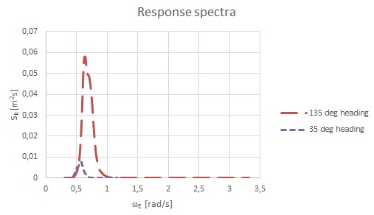
Fig. 5 Response spectra of the ship with speed of 5 knots and sea state with significant wave height of 5,79m-Point 2.
Slika 5 Spektar odziva broda koji plovi brzinom 5 čv na stanju mora značajne valne visine 5,79m-pozicija u točki 2

Equation 3 was used to calculate the ship significant roll response. Limiting value, according to Table 1, is 4 deg. Normal route (Figure 3), where relative ship-to-wave heading is 135 deg, exceeds the limit value of 4 deg roll several times, so route change is necessary. Ship-to-wave heading of 35 deg and speed of 5 knots meets the defined limiting value (Table 4).

Table 4 Significant roll angle for 5kn speed in the Point 3
Tablica 4 Značajni kut ljuljanja broda koji plovi brzinom 5čv u točki 3
 | NORMAL ROUTE | CHANGED ROUTE
Speed of the ship | 5 kn | 5 kn
Ship-to-wave heading | 135 deg | 35 deg
Significant roll angle | 12,3 deg | 3,7 deg

Discussion and conclusion
During navigation when it is not possible to avoid heavy seas, it could be useful to include a seakeeping evaluation in the decision-making process. A possible model for decision-making is presented in this paper with a case study of a passenger ship navigating through a storm in the Adriatic Sea. A passenger liner in reality operates on a daily basis between two ports on each sides of the Adriatic Sea. Seakeeping criterion for roll was used for evaluation as questionnaires results amongst nautical officers on passenger ships suggested it is most appropriate. SWAN numerical model was used for sea state modelling and the waves were generated and propagated for 20m/s SE wind speed which empirically causes heavy sea states. Three point in the Adriatic Sea where chosen for calculation and the seakeeping response evaluation was elaborated at location representing the point of a probable route change in the foreseen scenario. The results confirm that during described weather conditions, and for common course and speed, the ship would experience unacceptable roll behavior. If the route was changed to modify the effective wave direction on a ship from beam/quarter-bow to stern-quarter, along with the speed reduced, ship roll would mitigate to an acceptable value. These kind of maneuvering is empirically known among seafarers and the work done in this papers confirms the effects and quantifies the values of interest. If these information would be made available to the nautical officer in charge it could be of assistance to make the correct decisions in terms of comfort and safety.
Only one criterion was used for seakeeping evaluation and for the future work other criteria could be included as well to gain better and more realistic results. A comparison of the wave spectrum obtained by SWAN and the Tabain’s wave spectrum would be interesting to review the numerical approach option with the traditional and well established Tabain’s formulation derived specifically for the Adriatic basin. Advantage of SWAN modelling is the ability to determine sea state based only on wind speed data, with a spatial and temporal resolution and to derive two-dimensional spectra for a point of interest while the Tabain’s model provides less information but is much easier to apply. Usage of close form expressions has proved to be a fast and straightforward tool for RAOs calculations and including other methods (3D panel and strip) is planned for the future work.

ACKNOWLEDGEMENT
This work has been supported in part by Croatian Science Foundation under the project 8658.

Reference
- DAM NIELSEN, U. et al.: “A step towards risk-based decision support for ships-Evaluation of limit states using parallel system analysis”, Marine Structures 22 (2009), p.209-224.
- MUDRONJA, L. et al. 2014. : “Operability guidelines for product tanker in heavy weather in the Adriatic Sea “, Navsup 2014, Gdynia, Poland, 2014.
- PRPIĆ-ORŠIĆ, J. et al.: “Operation of ULCS-real life”, International Journal of Naval Architecture and Ocean Engineering 6 (2014), p.1014.1023.
- MUDRONJA, L. et al. 2015. : “Seafarers´ approach for manoeuvring in heavy seas “, ICTS 2015, Portorož, Slovenia, 2015.
- RUSU, L., SOARES, C.G..: “Forecasting fishing vessel responses in coastal areas”, Journal of Marine Science and Technology 19 (2014), p.215-227.
- SPANOS, D. et al. 2008. : “Risk-based on board guidance to the master for avoiding dangerous seaways”, 6th Colloquium on Seakeeping and Stability of Ships, Osaka, Japan 2008.
- BITNER-GREGERSEN, E. M., SKJONG, R.: “Concept for a risk-based Navigation Decision Assistant”, Marine Structures (2008), p.1-12.
- JENSEN, J.J., MANSOUR, A.E., OLSEN A.S.: “Estimation of ship motions using closed-form expressions”, Ocean Engineering 31 (2004), p.61-85.
- PRPIĆ-ORŠIĆ, J. & ČORIĆ V.: ”Seakeeping”, Rijeka: University of Rijeka, Croatia, 2006.
- MOAN, T. et al.: ”Comparative reliability Analysis of ships-considering different ship types and the effect of ship operations on loads”, Transactions Society of Naval Architects and Marine Engineers, SNAME 114 (2006), p.16-54.
- JOURNÉE, J. M. J. & MASSIE, W. W.: “Offshore Hydromechanics”, Delft: Delft University of Technology, Netherland, 2001.
- RIS R.C. et al.: “A third-generation wave model for coastal regions. Part II Verification”, Journal for Geophysical Research, 104 (1999), p.7667-7681.
- JOURNÉE, J. M. J.: “Prediction of speed and behavior of a ship in a seaway”, Rapport 0427-P, Delft, 1976.
- LEDER, N., SMIRČIĆ, A., VILIBIĆ, I.: “Extreme values of surface wave heights in the Northern Adriatic”, Geofizika 15 (1998), p.1–13.

