University Students´Attitudes towards the Use of Anglicisms in Ict- Implications For Policy And Practice

Ester Vidović, Jasminka Mezak
Faculty of Teacher Education Rijeka, Croatia

Abstract: Adopting terms from the area of Information and Communication Technology (ICT) has become a common practice in many countries around the world, as have the efforts to replace them with words from the linguistic corpus of national languages. Via a questionnaire, which was administered to the first year students of teacher education and early and preschool education at the Faculty of Teacher Education in Rijeka, we tried to research the students’ attitudes to the use of foreign words and their equivalents in Croatian within the ICT area. With this research we strived to indicate to the need of systematisation of terminology within the ICT, and to motivate our students, the future primary school teachers and early and preschool educators, to gradually adopt Croatian equivalents for the English terms in ICT, thereby helping them to promote native words amongst the population they will be educating upon the termination of their tertiary study.
Keywords: anglicisms, ICT, written expression, spoken expression, native words.

- Introduction
During the last few decades, the Croatian standard language has adopted numerous words from English. New vocabulary from areas as diverse as medicine, music, electrical engineering and many others has entered the corpus of Croatian. However, the biggest influx of new terminology has been noted within the area of information and communication technology (ICT) and these words have significantly influenced the standard Croatian language (Škifić and Mustapić, 2012). This comes as no surprise since it is estimated that as many as 1000 new words are created within the ICT field every year (Munday, 2005).
Borrowing vocabulary from English has also been a trend in other European countries and wider. Thus in many European languages a trend of forming a hybrid language has been noted. In that manner we speak of franglais, spanglish, itang´liano and svenglish, the hybrids of French, Spanish, Italian and Swedish on one, and English on the other side. Hrenglish is, points out the Croatian linguist Nives Opačić, another such hybrid and the result of adding Croatian inflections to English word roots (Opačić, 2012). In Branka Drljača´s opinion, the phenomena of lexical borrowing from English is closely linked to globalisation and the media, which are the biggest sources of "imported" anglicisms (Drljača, 2006).
The reasons for borrowing from other languages are numerous. Marko Samaržija distinguishes four main reasons for borrowing into Croatian: 1) political, cultural, economic and technical-scientific relations between speakers of two or more languages, 2) direct geographical contacts between linguistic regions, 3) terms from other languages which fill the gap in a lexical system of a particular language, 4) contribution to the clarity of sematic borders within the Croatian linguistic system (Samaržija, 1995).

  - Attitudes to borrowing from English in Croatia
When talking about attitudes to borrowing from other languages, we should stress that these are mainly a reflection of a language policy of a particular society. The Croatian linguist Dubravko Škiljan understands language policy as a collection of rational and institutionalised procedures through which a certain society influences the linguistic forms of public communication and the forming of the consciousness of its participants of these forms (Škiljan, 1988). Language policy determines linguistic purism, which we can define as "a form of language ideology aimed at closing a language to foreign influences" (Škifić- Mustapić, 2012). Krešimir Mićanović (2006) emphasises the link between the process of standardisation of a particular language and puristic incentives, aimed at preserving the language.
Linguistic purism does not target solely foreign elements, as Škifić and Mustapić (2012) point out, but as well the elements from the native word stock which do not comply to the accepted standard norms.
In Croatia redefining attitudes to elements from foreign languages were in particular prominent in the 1990s. This is understanding since Croatia was undergoing turbulent changes during this period in its history, the most important being establishing an independent country in war conditions as well as establishing the Croatian standard language (also by name). Unselective borrowing from English was strongly criticised in the 1990s, while at the beginning of the 21the century this trend was somewhat softened (Vidović and Reljac Fajs, 2015). In order to continue the discussion on various modes of treating anglicisms in the standard Croatian language, as well as on the continuing efforts to find replacements for linguistic elements borrowed from English, one has to define anglicisms.
There is a discrepancy amongst Croatian linguists on what anglicisms in fact are. In that manner Lelija Sočanac (2010) understands anglicisms as all the words borrowed from English linguistic area, whereas Nives Opačić (2012) and Rudolf Filipović (1990) consider that anglicisms are the terms which have, to a bigger or smaller extent, undergone various adaptations into Croatian. Škifić and Mustapić (2012) point out that older English terms have mainly adapted into Croatian on two levels, orthographical (ex. hardware into hardver, software into softver) and morphological (application into application, address into adresa), whereas words that have recently entered Croatian word stock, such as download, desktop, firewall) tend to stay in their original forms and are called foreign words. Attitudes to anglicisms vary depending on the type of borrowing. Thus foreign words, such as download, firewall, chip are least tolerated, whereas stands to the words that have undergone orthographical or morphological adaptations are acceptable (Mihaljević, 2006). The author as well states about a dozen principles for the application of ICT principles onto ICT terminology. We state the principles that are relevant for our study. These include: 1) native term has priority over a foreign term (thus računalo should be used instead of computer), 2) the foreign term which does not fit into Croatian because of a specific combination of sounds that should be avoided (čip is favoured over chip) because it is not natural in Croatian, 3) shorter terms have priority over longer ones (the foreign word software has priority over the native descriptive term programska računalna podrška), and others (Mihaljević, 2006).

- Overview
Pupils formally encounter ICT terminology as early as primary school, although many children possess a substantial word stock already at the early and preschool age. Informatics is taught in Croatia in the first form of primary school as an optional subject, while pupils have an opportunity to continue learning it throughout primary school and, subsequently, during their secondary education, also as an optional subject. In that manner children come across a large number of English words related to the ICT field from an early age. Moreover, it has to be admitted that computers have become an integral part of our lives and they seem to be indispensable in our everyday communication (Marković and Rajović, 2016). Thus, it comes as no surprise that an increasing number of children have established contact with ICT before school- attending age (Škifić and Mustapić, 2012).
On the other hand, for more than ten years English has been an obligatory subject from the first form of primary school throughout secondary school and up to graduation. It should be noted that this exposure to both ICT and English has resulted in the phenomena that very young children are tackling with words that their parents encountered at an adult age.
One of the biggest challenges in the systematization of ICT terms has been the issue of synonymy. Thus Škifić and Mustapić (2012) state as many as four equivalents of the English term internet in the standard Croatian language. The question that raises during the discussion is which terms are preferred by the younger generation, the English ones or the Croatian ones? Research conducted amongst the population of students attending a Technical college in Serbia and the survey undertaken in higher forms of a primary school in Croatia suggest that students opt for anglicisms mainly if the Serbian/Croatian equivalents consist of a multi-word phrase (Marković and Rajović, 2016; Škifić and Mustapić, 2012).
Our primary motivation in finding out about the attitudes of our students to anglicisms was to detemine whether anglicisms or words from the domestic word stock prevail in their written and spoken communication. Taken into consideration the fact that our students will be the ones who will soon be educating children of an early and preschool age and children in lower forms of primary school respectively, we considered feedback from our students would be beneficial in the context of motivating them to assist their future students to reflect upon the complex problem of unselective borrowing of ICT terminology into Croatian.

- Research
The aim of this study was to investigate which terms our students - future teachers and educators, found the most appropriate in their written and spoken expression. Our expectations were that the students would favour native words over foreign words in their written expression and orthographically and morphologically adapted words in their oral expression.

  - Methodology
The research was conducted via a questionnaire that consisted of three parts. In the first part the respondents were required to provide their biodata, while in the second and the third part of the questionnaire they were asked to select the terms they found most appropriate in their written and spoken expression. The respondents were asked to complete a questionnaire in paper form, which was anonymous and based on voluntary basis. The study included 75 respondents - first year students of Faculty of Teacher Education in Rijeka. The participants were 36 students of the Integrated Teacher Training Studies (48%) and 39 students of the undergraduate study of Early and Preschool Education (52%). All of the collected questionnaires were properly completed. The sample consisted of a group of students who have finished grammar school (46.3% of future primary school teachers (US) and 53.7% of future educators (RPOO)), while other students completed a vocational school (Figure 1).
Figure 1. Study groups and the high school completed by respondents

The survey was conducted in December 2016 at the Faculty of Teacher Education in Rijeka in the context of the subject “English Language”.
As mentioned earlier in the text, in the first part of the questionnaire the students were asked to provide their biodata, as well as the data on their previous education in the areas of the English language and ICT. The second part consisted of provided terms, where students selected those they found the most appropriate in their written expression. Each term included two kinds of anglicisms, i.e. a foreign word and a word orthographically and/or morphologically adapted to the Croatian standard language, as well as a word from the native word stock. Students were also asked to state appropriate situations for using anglicisms and their opinion about using these. In the third part the students were asked to choose between foreign and native words in spoken expression between 30 most frequently used terms in the ICT area. A descriptive analysis was conducted, which revealed significant differences between the two study groups in terms of the use of foreign and native words.

  - Results and discussion
The average of formal and informal education in English is about 11 years for future primary school teachers (US), although individual values range from 0 (2 students) to 20. Future educators (RPOO) stated that their formal education in English lasted on average for 12 years, while the informal education was going on for almost 8 years on average. Individual values for future educators range from 8 to 16 years for formal education and 0 to 19 for informal education in the English language. IT courses for both groups of students were mainly conducted only in the 1st form of high school education, so the average duration of Informatics as a compulsory subject is 2 years and a little shorter for Informatics as an optional subject in high school. (Figure 2).
Figure 2. Previous education in English and Informatics

It should be pointed out that there were two students of the undergraduate study of Early and Preschool Education who had no IT courses in high school at all.
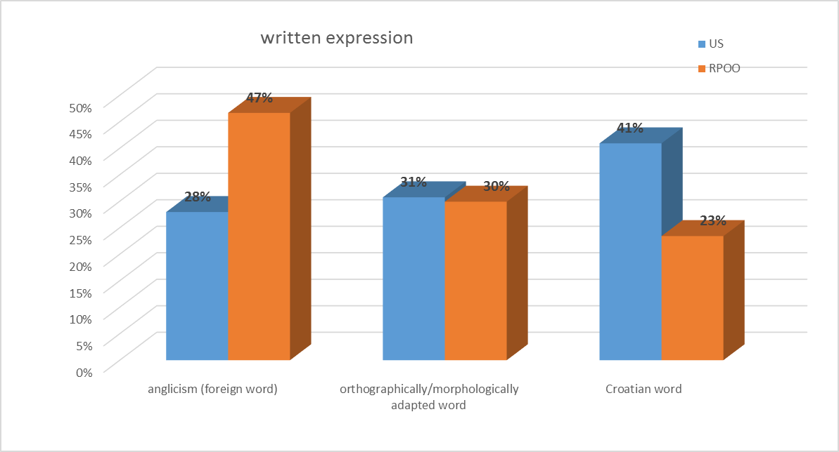
The second part of the questionnaire, where students expressed their preferences in using terms in written expression, showed differences between the two study groups (Figure 3.)
Figure 3. Terms selected for written expression

The results show that future primary school teachers (US), are fond of Croatian words for specified terms rather than anglicisms, while future educators (RPOO) prefer foreign words.
Answering the question in what situations they will use the anglicisms, students of both study groups answered that they use anglicisms in informal situations, although there was a difference in the answer “formal situation”, where no one from the future primary school teachers answered affirmatively, while 15% of future educators stated that they would use anglicisms in formal situations (Figure 4).
Figure 4. Situations of using anglicisms

When asked about the suitability of using anglicisms in written expression, both student groups tended to view them as rather inadequate (Figure 5).
Figure 5. Suitability of using anglicisms in written expression

Such results were expected, since the majority of students stated they use anglicisms in informal situations.
The third part describes how students orally express themselves. They were asked to choose between foreign and native words in spoken expression for 30 most frequently used expressions in the ICT area (Figure 6).
The results indicate that the students of both study groups preferred English words over native expressions.
Figure 6. Terms selected for oral expression

The study also analyses the frequency of the use of the offered terms for written and oral expression. The results show there are some words that are exclusively used as anglicisms in written and oral expression. Such words include chip and processor in written expression and joystick, USB stick, chip and processor in oral expression.
The inspection of mean values indicated that the students prefer to use orthographically and morphologically adapted words in their oral expression, as we predicted in our initial hypothesis. However, our expectations that the students would favour native words over anglicisms in their written expression proved to be partly correct, due to a great diversity in responses between the study groups.

- Conclusion
Our students (59%), generally do not consider anglicisms unsuitable for the use in written expression, with most students using anglicisms in oral expression (62% of the words). For some terms students often use an anglicism because there are several Croatian equivalents that are not widely accepted. Also, there are some multi-word native terms that describe the concept, however in these cases a shorter term (anglicism) takes precedence over the longer one (Mihaljevic, 2006). In cases where Croatian terms do not contain several words or an English word is ambiguously translated, the more common use of native expressions is observed.
The presence and use of anglicisms in the Croatian language has been extensively studied. In addition, research has mainly been focused on determining the presence of anglicisms, the degree of their adaptation to the structure of the Croatian language, but also on the attempts to find the most appropriate native words that would replace anglicisms (Škifić, Mustapić, 2012).
To conclude, we can assert there is a need of systematisation of the ICT terminology. Our attempts have been oriented to encouraging our students, to adopt Croatian terms rather than instantly resort to the use of anglicisms in ICT. In this way we can assist our students to promote words from the native word stock amongst the population they will be educating.

References
- Drljača, B. (2006). Anglizmi u ekonomskome nazivlju hrvatskoga jezikai standardnojezična norma. Fluminensia 18 (1), 65-85.
- Filipović, R. (1990). Anglicizmi u hrvatskom ili srpskom jeziku: porijeklo-razvoj-značenje. Zagreb. Jugoslavenska akademija znanosti i umjetnosti.
- Marković, N., Rajović, J. (2016). Utjecaj engleskog jezika na srpski u kontekstu računarske terminologije.Technics and Informatics in Education, 6th International Conference,eds.?Čačak: Faculty of Technical Science.
- Mićanović, K. 2006). Hrvatski s naglaskom. Standard i jezični varijeteti. Zagreb: Disput.
- Mihaljević, M. (2006). Hrvatsko i englesko raučnalno nazivlje. Jezik. Časopis za kulturu hrvatskoga književnog jezika 53.2: 41–50. Retrieved on 18.01.2017. from http://hrcak.srce.hr/file/25194
- Munday, J.(2005). E-mail, Emilio or Mensaje de Correo Electrónico.The Spanish Language Fight for Purity in the New Technologies. ur. Anderman, Gunilla, Margaret Rogers. In and Out English: For Better, For Worse? Clevedon-Buffalo-Toronto: Multilingual Matters, 57-70.
- Opačić, N. (2012). Hrvatski (ni) u zagradama. Zagreb: Hrvatska sveučilišna naklada.
- Samaržija. M. (1995). Leksikologija s poviješću hrvatskoga jezika. Zagreb: Školska knjiga.
- Sočanac, L. (2010). Studije o višejezičnosti. Zagreb: Zakladni zavod Globus.
- Škifić, S., Mustapić, E. (2012). Anglizmi i hrvatsko računalno nazivlje kroz prizmu jezičnoga konflikta i jezične ideologije. Jezikoslovlje, 13(3), 809-839. Retrieved on 18.01.2017. from http://hrcak.srce.hr/file/140138
- Škiljan, D. (1988). Jezična politika. Zagreb: Naprijed.
- Vidović, E, Reljac Fajs, E. (2015). Usvajanje anglizama i njihova adaptacija u hrvatski jezični sustav. Language, Culture and Literature in the Modern World. eds.Turza Bogdan et al. Zagreb: Učiteljski fakultt Sveučilišta u Zagrebu.

About the authors
VIDOVIĆ, Ester has a Ph.D. in Philology and is the senior lecturer at the Faculty of Teacher Education in Rijeka
Contact: ester.vidovic@uniri.hr
MEZAK, Jasminka has a Ph.D. in Information and Communication Sciences and is the Assistant Professor at the Faculty of Teacher Education in Rijeka
Contact: jasminka.mezak@uniri.hr

