PARAMETERS ASSESSMENT OF THE FMEA
METHOD BY MEANS OF FUZZY LOGIC

Jasminka, Bonato, Faculty of Maritime Studies in Rijeka, Studentska 2, 51000 Rijeka,
bonato@pfri.hr
Julijan, Dobrinić, Faculty of Engineering, Vukovarska 58, 51000 Rijeka,
cinirbo@gmail.com
Martina, Badurina, Faculty of Maritime Studies in Rijeka, Studentska 2, 51000 Rijeka,
badurina@pfri.hr

ABSTRACT:

The paper aims at presenting the FMEA method based on the fuzzy technique, representing a new approach to the failure analysis and its effects on the observed system. The FMEA (Failure Mode and Effect Analysis) method has assigned the risks a coefficient i.e. a numerical indicator that very clearly defines the degree of risk. The risk is calculated as a mathematical function of RPN which depends on the effects S, probability O that some case will lead to a failure and to a probability that a failure D can not be detected before its effects are realized. RPN = S O D. The FMEA method, based on the fuzzy logic, makes a more reliable evaluation of the observed system failures possible.

Key words: FMEA, fuzzy logic, RPN

1.Introduction

FME (Failure Modes and Effect Analysis) is a method by means of which the way in which every single failure appears is examined as well as the effects of every single failure of the analysed system. It can also be used in analysing the reliability engineering and system safety.
The American army developed the method in the nineteen fifties in order to increase the reliability of their equipments and processes. Moreover, the method was used by some government institutions, like the NASA, but was very soon adopted for civil use as well. One of its first users was Ford, who adopted the method when in 1987 he was forced to take the Ford Pinto car model off the market due to a failure in the design of the fuel tank. Today, the method has become an integral part of many companies and institutions, including industries engaged in airplane, motor-car,, nuclear, electronic, chemical, mechanical and medical technologies, yearning for a greater reliability of their products $\left[1\right],$ $\left[2\right]$, $\left[3\right]$.
The main characteristic of th method is the attempt to prevent potential failures and their elimination $\left[4\right]$. It could be said that the main goal of this method is to minimize the probability of failure occurence and to increase the safety. In the traditional FMEA method, the risk is calculated as a mathematical funcion RPN (Risk Priority Number) as against the following terms:
RPN = O S D, where O is the failure occurence probability, S is the failure severity and D is the the failure not detection probability.
The RPN value defines very clearly the degree of the risk on the basis of which particular safety and preventive measures are introduced. The traditional FMEA uses the scale from 1 to 10 when measuring, for example, the failure severity [5, 6]. The greater the RPN value is, the more important is the risk and will thus obtain priority over.
In an attempt to preventing system failures, regardless of its simplicity, we can not predict all the events, as well as the exact frequency of occurrence of certain events within the system. Control algorithms are usually in line with the experience of experts and decisions form IF-THEN. This kind of management is applied in everyday life.Fuzzy logic provides the necessary methodology for implementing expert knowledge and experience in the FMEA method$\left[7\right]$,$\left[8\right]$,$\left[9\right]$. Advantages of application are, moreover, flexibility and broad application, tolerance to imprecise data, as well as the use of language concepts in fuzzy approach that allows the improvement of the applicability of FMEA methods. The paper aims at presenting that the FMEA method based on the fuzzy logic is suitable for a safety parameters values assessment of the FMEA method $\left[10\right],$ $\left[11\right]$,$\left[12\right]$, [13]. This method is used in the shipbuilding industry [14], engine systems [15], and nuclear power plants [16].

2.Fuzzy FMEA

  - FuzzyLogic

In 1965, Lotfi Zadeh introduced the concept of fuzzy sets [17], where more degrees of membership are allowed some element of a set.
The degree of membership within a set is marked with numbers from among 0 and 1, i.e. with some numbers out of the interval $\left[0,1\right]$. As the interval $\left[0,1\right]$ comprises infinite numbers, infinite degrees of memberships are possible. Fuzzy logic is based on the fuzzy sets theory that can be understood as a generalization of the classic sets theory.

  - Fuzzy Algorithm
Fuzzy algorithm developed by means of the Matlab programme package. One of the possible fuzzy logic algorithm is the Mamdani model. As a model for the characteristic assessment, it is used when there is a “relative small“ number of input data sets.The fuzzy inference system – FIS, can be described in four phases: fuzzification, inference, aggregation, defuzzification.

    - Fuzzification

In this paper, five fuzzy sets (remote, low, moderate, high, very high) are defined for the input variables O, S and D (Fig.1) while for the output variable RPN five fuzzy sets (very low, low, moderate, high, very high) are also defined (Fig. 2) $\left[6\right],$[15]$.$ The possible numerical values are called universal set. For each fuzzy set, a value that defines the linguistic meaning of the set best is determined.
Besides the number of fuzzy sets, it is necessary to determine their form by means of the membership function. Based on the expert knowledge and the quality of information available, the paper deals with the selected membership function of the trimf form with five linguistic variable values allocated.
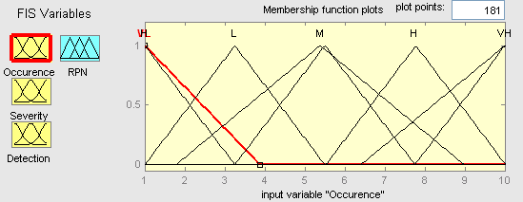
Figure. 1: Input Variable Occurence Membership Function Plot (overlapping of fuzzy sets within the universal set) [18]

Fuzzy sets membership function can overlap within the universal set (Fig.1). A membership degree μ = 1 is allocated to the typical fuzzy set of the joined input and output variables occurence. The triangular membership function trimf is defined by parameters [a b c], where a represents the left-side function section with the membership a = 0, b is the central peak or the typcal value with the membership μ = 1, while c is the right-hand function section with the membership μ = 0. Based on the scale of 1 to 10, for measuring the severity of the fault by using the traditional FMEA for each membership function is determined domains, and the shape of membership functions of the output variables is given in Figure 2,

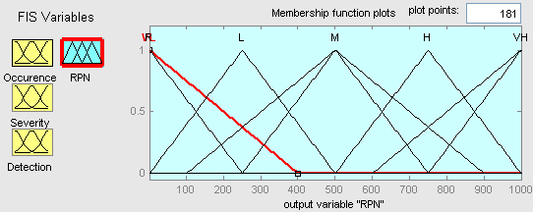
Figure. 2: Output Variable RPN Membership Function Plot

Table 1: Description of Marks Used in Defining Rules within the Fuzzy Inference Mechanism
Mark | Description | Mark
9-10 | Very High | VH
7-10 | High | H
4-8 | Moderate | M
2-5 | Low | L
1-3 | Very Low | VL

    - .Inference

The fuzzy inference structure of the input variables O, S and D and of the output variable RPN is shown on Fig. 3:
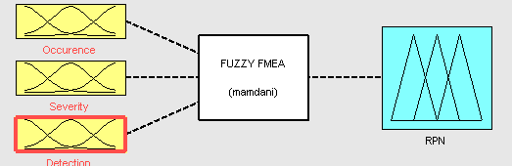
Figure.3: Fuzzy Inference Structure [18]

    - .Aggregation

FIS rules for the output parameter values assessment are defined (Fig. 4)

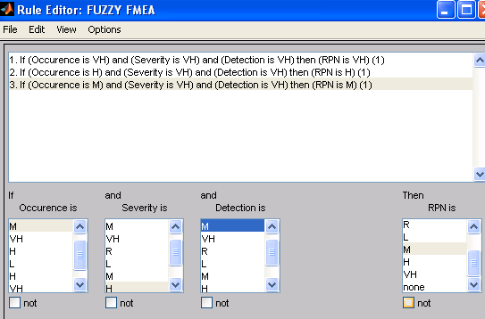
Figure. 4: FIS Rules [17]

    - Defuzzification

Defuzzification is the process of transforming linguistic results from the rule basis into numerical values. The defuzzification method is a continuous one if an infinitesimal change of the input variable does not cause a sudden change of any output variable. Therefore, the Center area method has been chosen, where the areas beyond the membership coefficient for each single linguistic set are superimposed in a new fuzzy set (shading area) and the center of mass is calculted. The linguistic output variable numerical value calculation is shown on Fig. 5, describing the model inference diagram [18].

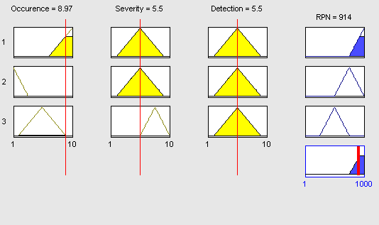
Figure.5: Inference Diagram [18]
Fig.6 shows the 3 D responding function of the RPN index value assessment depending on the input parameters O and D.

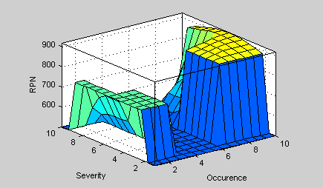
Figure. 6: 3 D responding function of the Input Parameters O, D Influence Assessment on the RPN Output Parameter Value [18]
- Results
The RPN index assessment has been carried out by means of the fuzzy logic. Three input variables have been defined, each of by the triangular function (Fig. 1) , and the output variable as well. Out of Table 1, linguistic values and their reactions can be seen on the scale varying from 1 to 10. The 3 D responding function and the FIS rules have resulted in the RPN index value assessment depending on the input parameters S, O and D.

- Discussion
Analyzing the RPN results obtained by means of the FMEA method and the fuzzy logic obtained values, enables a much better assessment of risks connected with the failure type in the functioning of the systm. Possible consequences of faults have been allocated to the causes that the faults are the cause of. The advantages of the fuzzy inference system, included in the FMEA method, are numerous. The introduction of a professional knowledge and experience [16,17], indefiniteness [18] and of a nonlinear relation between the RPN index and the S, O and D parameters [19] .has been acceptable.

- Conclusion
During the functioning of the system, particular faults, describable in words, can appear causing difficulties in its operation. After having identified faults that can be the cause of undesirable risks, a particular number of fuzzy sets can be attributed to them as well as some numerical values. Therefore, the fuzzy logic algorithm is important in describing the system behaviour.
A fuzzy conclusion does not allow the appearance of identical RPN values for different risk factor sets and, based on the results, it is possible to establish priorities in ranking different faults and their influence on particular corrective measures taken.
As to further researches, it is important to find a method based on fuzzy logic that can make the testing of parameters integrated in the fuzzy decision-making mechanism possible, in order to estimate and rank risks connected with the type of fault that could appear in the functioning of the system. Fuzzy logic is an appropriate tool in the analysis of priorities when particular FMEA corrective measures methods are taken, thus having an influence on the reliability system as well.
- Acknowledgements
The present work was supported by the Ministry of Science, Education and Sports of the Republic of Croatia (Research Project Information communication technologies in intelligent marine systems112-1121722-3314).

- References

$\left[1\right]$CHANG, C. L., WEI, C. C., & LEE, Y. H. (1999). Failure mode and effects analysis using fuzzy method and grey theory. Kybernetes, 28(9), 1072-1080.
$\left[2\right]$ CHANG, C. L., LIU, P. H., & WEI, C. C. (2001). Failure mode and effects analysis using grey theory. Integrated Manufacturing Systems, 12(3), 211-216.
$\left[3\right]$CHIN, K. S., CHAN, A., & YANG, J. B. (2008). Development of a fuzzy FMEA based product design system. The International Journal of Advanced Manufacturing Technology, 36(7-8), 633-649.
$\left[4\right]$SANKAR, N. R., & PRABHU, B. S. (2001). Modified approach for prioritization of failures in a system failure mode and effects analysis. International Journal of Quality & Reliability Management, 18(3), 324-336
$\left[5\right]$http://www.growingscience.com/dsl/Vol3/dsl_2014_3.pdf
$\left[6\right]$http://www.isr-publications.com/jmcs/71/download-fuzzy-fmea-analysis-for-identification-and-control-of-failure-preferences-in-erp-implementation-
$\left[7\right]$ https://www.scribd.com/document/337936011/Vol1-Iss4-366-376-Fuzzy-FMEA-Analysis-for-Identification-and-Control-of-Failure-Preferences-in-ERP-Implementation-1

[8] BOWLES, J.B., PELAEZ, C.E, "Fuzzy logic prioritization of failures in a system failure mode, effect and criticality analysis", Reliab. Eng. Syst. Safe. 50, 203-213 (1995).
[9] PILLAY, A., WANG, J," Modified failure mode and effects analysis using approximate reasoning", Reliab. Eng. Syst. Safe. 79, 69-85 (2003).

$\left[10\right]$https://camo.ici.ro/journal/vol16/v16a16.pdf
[11] MESUT KUMRU, PINAR YILDIZ KUMRU, Fuzzy FMEA application to improve purchasing process in a public hospital, Applied Soft Computing, Volume 13, Issue 1, January 2013, Pages 721-733, ISSN 1568-4946, 10.1016/j.asoc.2012.08.007.
[12] https://www.researchgate.net/profile/Tihomir_Latinovic/publication/281550866_Analysis_a_failures_in_industrial_systems_with_FMEA_analysis_and_fuzzy_logic/links/55ed66b608ae21d099c74f9e/Analysis-a-failures-in-industrial-systems-with-FMEA-analysis-and-fuzzy-logic.pdf?origin=publication_detail
[13] https://www.researchgate.net/publication/259602209_Failure_Mode_and_Effects_Analysis_on_Control_Equipment_Using_Fuzzy_Theory
[14] J. WANG A. PILLAY, "Modified failure mode and effects analysis using approximate reasoning", Reliability Engineering and System Safety, (79):69–85, 2003.
[15] M. XIE S.L. HO M. L. ZHU K. XU, L.C. TANG.," Fuzzy assessment of FMEA for engine systems", Reliability Engineering and System Safety, (75):17–29, 2002.
[16] C.M.F. LAPA A.C.F. GUIMARES, " Fuzzy FMEA applied to power chemical and volume control system", Progress in Nuclear Energy, (44(3)):191–213, 2004.
[17] LOTFI A. ZADEH, Fuzzy Sets Information and Control 8, 338-353, 1965.
[18] Matlab central. Retrieved from http://www.mathworks.com/matlabcentral/fileexchange/21383-rmse
[19] TAY, K.M., LIM, C.P., "Fuzzy FMEA with a guided rules reduction system for prioritization of failures", Int. J. Qual. Reliab. Manag. 23, 1047 – 1066 (2006).

