

Application of microsimulation in analysis of the traffic load of the bridge

Irena Ištoka Otković1,Damir Varevac1,

1 University of Osijek, Faculty of Civil Engineering Osijek, Croatia

Abstract

For the last decade, the EU countries has been working intensively on creation developmental and sustainable transport strategies at the national and international level, which requires, besides analysing economical and ecological implications, implications on traffic-regulations, and also the analyzing the impact of different transport strategies on transport infrastructure.

It is realistic to expect that in the near future, both the carrying capacity of road vehicles and the density of traffic will increase.

This fact imposes to the traffic infrastructure increasing demands in terms of capacity and bearing capacity. Particularly critical points of the transport infrastructure are bridges, especially those built several decades ago because they are designed according to different traffic requirements and applicable standards at the time.

Having in mind the fact that traffic is stochastic, and that experimentation on the real systems is not justified by safety and functional criteria, application of traffic microsimulation modeling is a logical choice. In this paper, the possibility of using microsimulation of traffic in the analysis of the traffic load of the selected bridge is examined through the generation of various potentially critical traffic scenarios within the existing but also for the future assumed traffic load. This paper does not include an analysis of accidental traffic situations or scenarios where sudden braking of the vehicle occurs, as well as traffic accidents and vehicle collision with another vehicle or bridge elements. The application of this method is shown in the example of the road bridge "Dr. Franjo Tuđman "across the river Drava in Osijek, built in 1995.

*Keywords: traffic load, bridge, microsimulations, VISSIM*

1. Introduction

Mobility is the basic prerequisite for the development of human society. Growth in population and economic activities generate increasing traffic demand. The Federal Highway Administration estimates an increase of more than 65% in the volume of US freight traffic from the beginning of the century to 2020 [1]. The increase in traffic demand triggers and motivates better traffic “supply”, not dominantly by building a new infrastructure, but by increasing the utilization of the existing [2], raising the level of serviceability of the road transport infrastructure as a whole rather than fragmentary [3] and selection of optimal transport strategies [4]. This ought to be based on timely and realistic data of the current state of the existing traffic infrastructure [5] when available, or on secondary data if not [6]. The process of choosing an optimal model for people and cargo transportation is a very complex process and depends on a large number of factors [7] in which price and reliability of transport are only a few of the relevant parameters. The administration, all stakeholders in the transport process [8] and the public [9] are deeply involved in this process. According to the European Commission document [2], the implementation of new transport strategies and technologies [10] [11] is a prerequisite for the sustainable development of road infrastructure. The applicability of new strategies and technologies depends on the applicability at critical points of the road transport infrastructure, which are intersections (based on the flow criterion) and the bridges (according to the criteria of flow and bearing capacity). The question of the reliability of existing bridges in such new conditions of use is extremely important, not only from the point of view of safety and reliability, but also from an economic point of view. Accurate and timely assessment of bridges and decision when they have to be repaired or removed is a critical decision that can save lives and significant financial resources.

1. Assessment of existing bridges

Many existing bridges were designed and constructed according to the then applicable regulations, which were based on different assumptions, different calculation procedures and, most importantly, significantly lower prescribed loads (mainly traffic load and earthquake). The best example is the bridge Rječina on the Rijeka bypass. The north bridge Rječina was designed in 1975 according to DIN standards, and the south bridge was designed in 2007 according to the EN 199x standard. They are placed next to each other at an axial distance of 18 m. The new bridge has slightly larger spans (about 10%), and the immediate vicinity of the older bridge demanded the same appearance. In addition to the higher applied material quality, the thickness of the elements has increased by approximately 25%, and in the middle of the span thickness of the webs of the prestressed box girder is larger for 60% [12]. The authors, Z. Šavor and others, in the same article state: “The request to increase the dimensions of structural elements in relation to the original project of the southern bridge of Rječina is attributed to increased design load, in particular the traffic load, wind and earthquake effects, but also to the applied technology…”. It is important to emphasize that not only the design loads have been changed but also the actual traffic load has increased due to the development of new heavy vehicles and changes in road transport volume. When deterioration of the structure due to exposure to weather, aggressive conditions and accidental effects for a number of years is taken into account, the reliability assessment becomes a very complex problem. If current regulations were applied to existing bridges, many would not meet the basic requirements, even if they were in relatively good condition. Therefore, each existing bridge must have a unique approach.

According to [13], a detailed assessment of the level of safety of an existing bridge includes updating of actions with the respect to the actual and expected traffic load and may be based on different reference periods, depending on remaining working time. The same document states that *“… values (of the actions) to be used may also be derived from actual use, taking the backgrounds of the standardized values into account.”*. Whether Verifications based on partial factors (assessment value of actions, *F*act for partial factor format and *Qk,act*Q*k,act* for global resistance format*)* is applied or Verifications based on probabilistic format (random value of the actions based on the actual condition and use of the bridge) [13], microsimulation may offer valuable load data, taking into account present character of the traffic or even projected increase in traffic load.

1. Application of microsimulation in analysis of the traffic load of the bridge

Traffic models are an analytical tool intended for various traffic analysis at macro and micro level of planning. The application of simulation models is an integral part of the process of selection and evaluation of national transport strategies [14] [15]. The chosen micro simulation tool for this research is VISSIM - a stochastic, discrete, micro simulation model that begins to develop in the 70s of the last century in Germany at the Karlsruhe University. The calibration of the model for all types of detailed analysis is a prerequisite for the reality of modelling results [16] [17].

Within this paper, VISSIM was used to analyse the different traffic load scenarios for the road bridge over the river Drava in Osijek, for existing and predicted traffic loads. The model is made for a two-lane road bridge, in the first iteration without stopping the traffic on the bridge, and in the second iteration with stopping the traffic, simulating the traffic jam or a standstill due to accident. One hour of traffic across the bridge was modelled, and, for the purpose of calibration of the model, the collection of real-time traffic flow data was done in the morning peak (7.30h-8.30h) in the period from 14th to16th December 2017.

Because of the stochastic nature of the traffic flow, for the same input data, in each simulation 3 potential traffic scenarios of the vehicle arrival in the observed hour was analysed, with the step of random number generator 10 (Random Seed Increment). The initial value of the random number generator is the default value of 42.

For all sets of input data, the same values of random number generator were used, which allows comparability of the micrscenarios and mean values of traffic indicators.

* 1. Analysis of different traffic scenarios

Different traffic scenarios of the existing traffic flow and the potential future increase in traffic load for 10%, 20% and 30% were analysed. Having in mind that freight vehicles are critical for bridge load analysis, particular attention is paid to the share of freight vehicles in the traffic flow. The share of freight vehicles in the traffic flow structure was varied. The existing share on this particular bridge is 10% and 12% in one and the other direction, while simulated shares were 20%, 30% and 40% of freight vehicles in the traffic flow structure for both directions. This simulated increase may cover the innovative technologies and trends of cargo transportation (smart vehicles, wireless connection etc.). Two incoming vehicle speeds were analysed - 50 km/h and 30 km/h.

In the terms of traffic flow, none of the traffic scenarios analysed is problematic because traffic on the open road section is conducted without interruption in the first iteration of the analysis, and for larger traffic loads a higher share of freight vehicles and lower speed occasionally produce jams but without significant time losses (Figure 1). The functional indicators analysed in this paper, the driving time and the length of the vehicle queue, are output results of the traffic simulation. Driving time across the bridge is measured between two fixed points, which are, in this case, pedestrian stairs to access the bridge on both sides of the bridge. The vehicle is in the queue, according to the settings of this model, if the clearance between the vehicles is less than 10m, and the distance 10-20 m is considered the queue access zone for the already formed queue. The dependence of driving time between the fixed points (Figure 2) and dependence of the vehicle queue (Figure 3) on traffic load and share of HGV (Heavy Goods Vehicle) is shown, both for access speed of 30 km/h. Both images show diagrams of simulation results for more traffic loaded north-south direction.

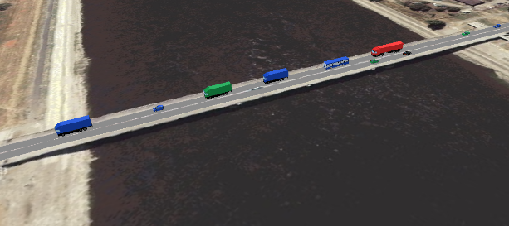 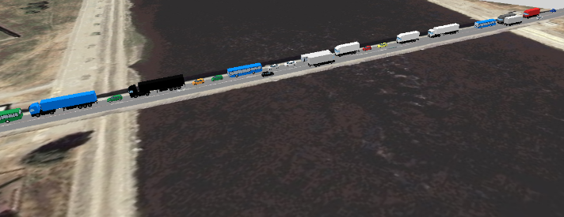

1. Existing traffic load (left) and increase of traffic by 30% (right)



1. The driving time between the fixed points for a speed of 30 km/h



1. Vehicle queue on the observed bridge for a speed of 30 km/h
   1. The stopped queue of vehicles on the bridge

The second traffic situation discussed in this study was stopped queue of the vehicles on the bridge. To ensure that the non-transforming queue does not block the simulation, the incoming vehicles were stopped in the simulation every other minute, and the lock lasted one minute. The aim of this simulation method was to find a potentially critical traffic load of the bridge rather than simulating one hour of the most common or usual traffic scenario.

In terms of traffic, such a situation is expected to be significantly different, both in terms of travel time criterion and in terms of vehicle queue length (Figure 4).

 

1. The driving time and vehicle queue for the speed of 30 km/h in the conditions of stopped queue
2. Potentially critical traffic loads

The result of the simulation that can be obtained with VISSIM is the output file in which, for every time step of the simulation, exact position of each vehicle is recorded, longitudinally in relation to the beginning of the link, laterally (driving lane) and the position in its own driving lane (right, left, center), distance from the leading vehicle in the queue, its time and space void relative to the vehicle in front, type of vehicle (personal, freight, bus ...) and a number of other traffic indicators, e.g. for each vehicle in the simulation, driving time in the queue relative to the total driving time (Table 1).

1. Example of VISSIM output file



Such a file type contains a large number of data that is proportional to the duration of the simulation, the traffic load and the structuring of the output file, or the chosen data that is recorded during the simulation. Each output file can be analyzed "manually" but there is an idea of a program code that could process a large number of such output files in a short time and identify potentially critical traffic loads (vehicle distribution, axle spacing and load, their clearance and other relevant data for analysis) according to the bridge capacity criteria. An example of the calculation of the bending moment, using influence line, for each time step of simulation is shown in Figure 5. Influence line is created for mid-point of middle span.

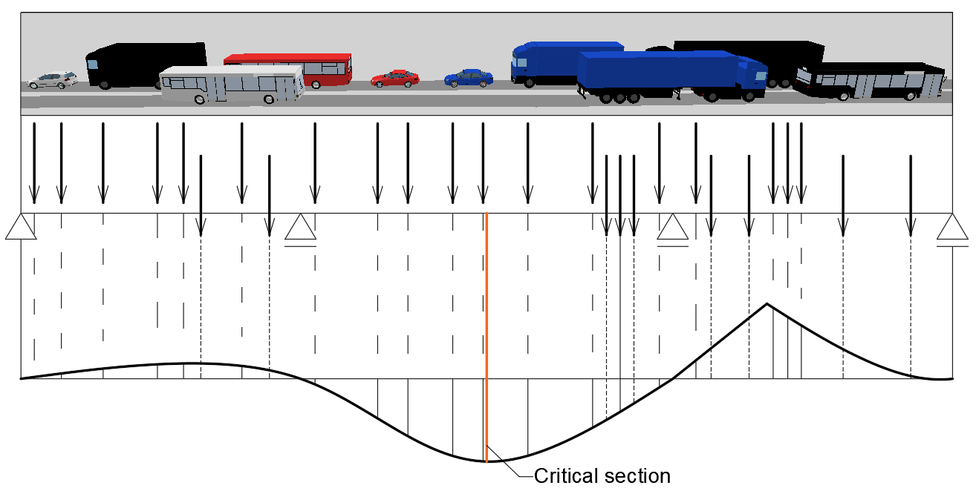

1. Influence line for calculation of the bending moment at critical cross-section (for each time step of simulation)
2. Discussion

The accessibility of information on available transport infrastructure, data on capacity and traffic infrastructure status are the basic prerequisites for the selection of a transportation strategy at a local, national and integrated European level. Innovative technologies are prerequisites for effective use of the existing infrastructure. Automatic controlled freight vehicle queues represent a combination of two fast-growing trends - transporting larger quantities of goods in the convoys of high-capacity trucks and developing automated wireless-connected smart vehicles. The automatic controlled freight vehicle queue is defined as a queue of two or more trucks with a time clearance between a vehicle that is less than 1 second (equivalent to a spatial clearance of less than 22 m at a speed of 80 km/h) provided by wireless communication between vehicles which automatically aligns simultaneously the longitudinal and lateral movement of the entire queue and each vehicle in it [11].

Bearing in mind that this research is in the initial phase, this paper does not analyze the scenario of an auto-controlled column of freight vehicles, but to these issues in the ongoing research need to be given special attention. Within this paper, the manually driven freight vehicles were analyzed in the overall traffic flow.

1. Conclusion

Application of simulation models in all types of analysis of potential traffic flow and structure and what-if traffic scenarios, analysis of the consequences of innovative technologies in the existing traffic flow and infrastructure and analysis of different transport strategies is of unquestionable significance. The prerequisite of the concept of sustainable traffic development and the adoption of an optimal transport strategy is the existence of a relevant database of the existing transport infrastructure that forms a traffic offer in the dynamic relationship with traffic demand. Simulation models, as shown in this paper, have a significant role in analyzing the traffic and bearing capacity of the critical points of an existing transport infrastructure, such as bridges. This way, it is possible to significantly reduce the time required to estimate the actual load on the bridge, as it is possible to avoid long-term WIM weighing and reduce the uncertainty source for advanced assessment of existing bridges [18]. Based on results of microsimulation, it is very easy to create a realistic series of moving loads and analyze the potential effects on the internal forces that occur at critical points (bending moments in the fields and over the supports, transverse forces and torque moments where this is important). The next step in this study is to create a procedure for identifying potentially critical traffic loads that need to be further analyzed in detail, using VISSIM output files. The application of this methodology can be very useful in the analysis of the bearing capacity of existing bridges and the determination of allowed queue length and/or load capacity of individual freight vehicle for selected routes in the implementation of an automated column of freight vehicles in the traffic flow, which is expected in the near future.

References

1. Federal Highway Administration: Freight Analysis Framework Overview. Publication FHWA, FHWA-OP-03-006, 2002.
2. European Commission: Roadmap to a Singel European transport area—towards a competitive and resource efficient transport system (white paper) COM(2011) 144 final. European Commission, 2011.
3. Granger, R. J., Kosmider,T.:Towards a better European transport system, Transportation Research Procedia 14, pp.4080 – 4084, 2016. doi: 10.1016/j.trpro.2016.05.505
4. Chow, J.Y.J., Yang, C.H., Regan, A.C.: State-of-the art of freight forecast modeling: lessons learned and the road ahead,Transportation 37, pp. 1011-1030, 2010. doi:10.1007/s11116-010-9281-1
5. Meixell M. J., Norbis M. A review of the transportation mode choice and carrier selection literature. The International Journal of Logistics Management Vol. 19 No. 2, pp. 183-211, 2008. doi 10.1108/09574090810895951
6. Giuliano, G., Gordon, P., Pan, Q., Park, J.Y., Wang, L.L.: Estimating freight flows for metropolitan area highway networks using secondary data sources. Netw. Spatial Econ., Volume 10, [Issue 1](https://link.springer.com/journal/11067/10/1/page/1), pp 73–91, 2010. https://doi.org/10.1007/s11067-007-9024-9
7. de Jong, G., Gunn, H.F. and Walker, W.: National and international freight transport models: overview and ideas for further development. Transport Reviews., 24 (1). pp. 103-124, 2004. https://doi.org/10.1080/0144164032000080494
8. Haial, A., Berrado, A., Benabbou, L.: A Transport Strategy Developing Process Based on Stakeholder Engagement, Proceedings of the International Conference on Industrial Engineering and Operations Management Rabat, Morocco, 2017, pp.2408-2416
9. Ennio, C., Pagliara, F.: Public Engagement for Planning and Designing Transportation Systems, [Procedia - Social and Behavioral Sciences](https://www.sciencedirect.com/science/journal/18770428), Vol. 87, pp. 103-116, 2013. <https://doi.org/10.1016/j.sbspro.2013.10.597>
10. Jadaan, K., Zeater, S., Abukhalil, Y.: Connected Vehicles: an Innovative Transport Technology, Procedia Engineering 187, pp.641 – 648, 2017 doi: 10.1016/j.proeng.2017.04.425
11. van Maarseveen, S.: Impacts of Truck Platooning at Motorway On-ramps: Analysis of traffic performance and safety effects of different platooning strategies and platoon configurations using microscopic simulation, Master of science thesis, Delft University of Technology, Faculty of Civil Engineering and Geosciences, 2017
12. Šavor, Z., Gukov, I., Bleiziffer, J., Hrelja, G. Kalafatić, I., Franetović, M.: Rječina bridge on the southern pavement of the Rijeka Bypass. Građevinar 61; pp. 893-900, 2009
13. European Commission: JRC Science and Policy report – New European Technical Rules for the Assessment and retrofitting of Existing Structures. European Comission, 2015.
14. Jacyna, M.: Cargo flow distribution on the transportation network of the national logistic system, Int. J. Logistics Systems and Management , Vol. 15, Nos. 2/3, pp.197–218, 2013. <https://doi.org/10.1504/IJLSM.2013.053767>
15. Meixell M. J., Norbis M.:A review of the transportation mode choice and carrier selection literature. The International Journal of Logistics Management Vol. 19 No. 2, pp.183-211, 2008. doi 10.1108/09574090810895951
16. Ištoka Otković, I., Tollazzi, T., Šraml, M.: Calibration of microsimulation traffic model using neural network approach, Expert systems with applications. 40, No. 15; pp.5965-5974, 2013 <http://dx.doi.org/10.1016/j.eswa.2013.05.003>
17. Ištoka Otković, I.; Varevac, D.; Šraml, M.: [Analysis of neural network responses in calibration of microsimulation traffic model](http://bib.irb.hr/prikazi-rad?&lang=EN&rad=767924). The Electronic Journal of the Faculty of Civil Engineering Osijek e-GFOS. 10 (2015) ; 67-76 <http://dx.doi.org/10.13167/2015.10.8>
18. Šavor, Z., Šavor Novak, M.: Procedures for Reliability Assessment of Existing Bridges. Građevinar 67; pp. 557-572, 2015