IMPROVMENT OF CONTAINER TRANSPORT BY DEVELOPING EXTREMELY BIG CONTAINER SHIPS

Rino Bošnjak, D.sc.

Goran Belamarić, D.sc.

Andrea Russo, D.sc.

Maritime University in Split, Ruđera Boskovića 37, Split, Croatia, rino.bosnjak@pfst.hr

ABSTRACT

In the last decade, the container market is growing at about 8% a year. Studies show that the performance of Ultra Large Container Ships (ULCS) is not only feasible but may be necessary if this expansion on the market has to be placed in the most cost-effective framework. Conducted terminal capabilities, along with possible improvements in onshore and offshore design, it is obvious that the largest number of ports in the world can serve a ULCV capacity of more than 14,500 TEU, which corresponds to an approximate VLCC board size. Most container ports in Asia do not impose any restrictions on ULCS dimensions. Infrastructure constraints, height and / or limitations of the ship draft, the maximum limit of 400m today is imposed on several major ports of northern Europe (Antwerp, Bremerhaven, Hamburg, Le Havre, Valencia, and Zeebrugge). This is due to the fact that some of them are located in tidal waters at the mouth, or even many miles of upstream rivers. Furthermore, it is believed that ULCS of lengths up to 430 m which are specially equipped for efficient maneuvering and control (with sufficient power of bow thruster / stern thrusters or double propeller propulsion, strong tugs with sufficiently strong towing bits etc.) can be maneuvered in areas where the length of the boat is currently limited to 400 m.

Keywords: ULCS, container ports, container transport, equipment and limitations

1. INTRODUCTION

Containerizations refers to the process of packaging goods, stowing of cargoes in containers and transport by one or more forms of transport, principally from the place of embarkation from the internal areas of a country to the place of destination in the internal areas of another country. From the point of view of transport by containerization, the idea is to realize that a large number of individual commodities of different shapes, types, sizes and masses form or merge into a larger unit of cargo, which becomes a unique handling unit. The constant demand for transport of cargo in containers has caused a rise in container ships. Transport of containers is an event that marked the twentieth-century seamanship. It has made it easier and faster to handle the load and door to door service. Today, about 85-90% of cargo is transported in containers which are loaded to container ships, and approximately 26% of these containers originate from China. Since 2005, 18 million containers have made over 200 million journeys per year. Shipbuilding engineers are already constructing and are already in exploitation ships that can transport over 20000 TEUs. It is expected that container ships in the near future will be up to 450m long and up to 60m beam, and that even the passage of Malacca Strait will present a constraint. It is also anticipated that such a rise in containerization will lead to a large increase in the world fleet.

1. CLASSES OF CONTAINERS

Container ships are designed to maximize cargo optimization. Compare to a larger ships, smaller ships are equipped with their own cranes with a capacity up to 2900 TEU (*Feeder Container Ships*). These container ships are divided according to the type of loading the cargo on:

* container ships with vertical guides,
* container ships with horizontal loading,
* large ocean going container ships and
* small feeder ships for supply larger ships.

All container ships are open constructions and must be so constructed that their structure allows free loading / unloading of crane containers. In order to obtain unobstructed and rectangular storage facilities, they have a high degree of strength with regard to fully open decks, these ships are usually constructed with ˝Double Hull System˝. Container ships are developed in response to market demands, and in that context they increased their transport capacity in TEUs as well as their size (length x width x max. draft in meters) [1]. The development of container ships since 1956 is in accordance with their capacity in the TEUs and dimensions of the hull can be categorized as following (figure 1):

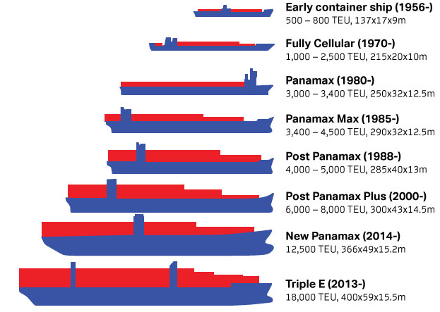

http://www.container-transportation.com/container-ships.html

Figure 1. Classes of container ships

1. EXTREMLY LARGE CONTAINER SHIPS

Under the term "*Extreme Large Container Ships*" is implied *Ultra Large Container Ship* (ULCS) or *Ultra Large Container Vessel* (ULCV) also known as *Megaboxer*, is the group of the largest container ships used in container transport. It seems that the width will increase to 24 rows, increasing the nominal capacity for about 1,000 TEUs while simultaneously keeping the fuel costs per TEU unchanged. By increasing the ULCS maximum 24-row width range of 16m to 17m, capacity can be increased by about 10% which increases fuel efficiency - especially for heavy containers. If greater nominal capacity is required than prolonging the ship for a single cargo hold (2 BAYs = 26 BAYs total), this would result in TEU entry of about 23,300, with fuel costs per TEU reduced by about 4.5%. By increasing the width to 25 rows and length up to 26 BAYs, ULCS capacity could reach 26,300 TEUs. Such a design would be limited to entry into numerous ports and could not go through the Suez Canal with its current limitations in fully loaded condition. This would also require a new concept of structural construction. That is why it is unlikely that such size of vessel will be ordered in the near future, even if it promises another 3.5% reduction in fuel costs by TEU [2] [3].

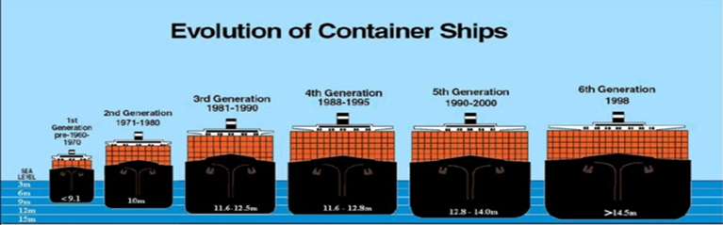

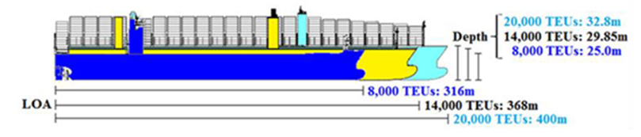

Figure 2. Evolution of container ships

* 1. Triple e class of extremely big container ships

Maersk Line has built a new "Triple-E" class of container ships of 15,500 TEUs. The first 10 ships were delivered in 2013 and 2014, and another 10 vessels in the period 2014 and 2015. The class of ships was named Triple-E class because has recognized three main purposes economical, energy efficiency and ecological improvement. These new container ships are setting new standards that outperform the current efficiency and CO2 emissions per container. The newest Triple-E is a 400-meter-long, 59m wide and 73m high, 14.5m draft, deadweight of 165,000 mt, 600 TEU Reefer Container, 23 knots maximum, with 18,000 TEUs capacity. Triple-E class produces 20 percent less CO2 per container, which is 50 percent less than the average of Asia and Europe's industry. This class consumes about 35% less fuel per container than ships of 13,100 TEUs delivered to other liner container carriers in the previous years, which also operates on the line of Asia-Europe. Triple-E ship is a significant step towards addressing the environmental challenges associated with cargo transportation around the world. Each ship costs 190 million dollars. In addition to the size that provides superior size compared to other vessels (more cargo means less CO2 per container), the efficiency of Triple-E class comes with its innovative design. Two slow running engines are running by two big propellers, and this combination is called the ‘’Twin Skeg’’. The reason to use this combination is derived from the Maersk Line study that showed that with two slow-motion engines which are running the two propellers, it results in an energy saving of a further 4 percent compared to a single engine propeller design. Especially optimizing the hull and bow shape makes it possible to achieve a maximum speed of 23 knots, compared to Emma Maersk whose max. speed is 25 knots. This small difference in maximum speed reduces the output power of the machine by 19 percent, allowing less engine speed and more economical (lower) fuel consumption. To reduce the environmental impact of ships beyond their lifecycle, Maersk Line has set new standards for vessels in terms of their recycling. All materials used to build the Triple-E Class will be documented and mapped on board as a Cradle-to-Cradle Passport. This means when a ship is sent to scrap yard, this document will ensure that all materials can be reused, recycled or disposed of in the safest and most efficient manner.

* 1. Transport efficiency for next generation of ulus/ulcv

The ship MOL Triumph from company Tokyo-Mitsui O.S.K. Lines, Ltd. (MOL) in March 27, 2017. was delivered by the Samsung Heavy Industries Co. This ship is first delivered in series of six vessels of 20,000 TEU class containers for this company. The ship is 400 m long and 58.8 m wide, with a capacity of 20,170 TEUs, and the first such ship of 20,000 TEU classes ever built [4].

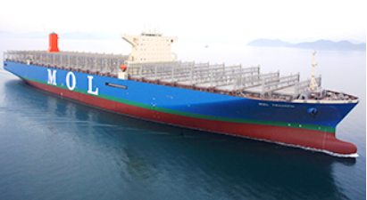

Figure 3. ULCV MOL Triumph 20,170 TEU Container vessel [5]

Ship particulars for ULCV MOL Triumph:

* LOA = 399,87m
* Breadth = 58,80m
* Depth = 32,50m
* Designed draft = 14,50m
* Deadweight approximately = 192672 MT
* Capacity of TEU's = 20170 TEU
* Builder: Samsung Heavy Industry

The ship is equipped with a variety of new technologies to ensure more efficient fuel economy and improved ecological efficiency. In accordance with MOL's policy and environmental standards, a new 20,000 TEU class container ship is equipped with a variety of high-tech energy saving technologies including underwater colour with very low resistance, high performance propulsion and steering wheel, Savour Stator Propulsion, and optimized fine hull shape which together further reduce fuel consumption and CO2 emissions per container by about 25-30% compared to 14,000 TEUs container ship. In addition, the ship was also designed with the possibility to switch over to LNG fuel, and in view of the rules set by IMO regulations to limit SOx emissions in marine fuels, which will come into force in 2020.

Also, in April 2017, another ULCV 20,568 TEUs, Madrid Maersk, was delivered to A.P. Moller-Maersk Group. Less than two months after MOL Triumph has won the world's largest container ship as the first ship to cross 20,000 TEUs on May 15, 2017. Samsung Heavy Industries in Geo, South Korea delivered a new ULCV for the Overseas Container Line (OOCL) in Hong Kong. With a capacity of 21,413 TEUs, OOCL Hong Kong has record of the world's largest ship with TEU capacity [5]. Ship particulars for OOCL Hong Kong:

* LOA = 399,87m
* Breadth = 58,80m
* Depth = 32,50m
* Designed draft = 14,50m
* Deadweight approximately = 191,317 MT
* Capacity of TEU's = 21413 TEU
* Builder: Samsung Heavy Industry

One of the major constraints for these types of ships is max. draft, which makes it difficult and restricts the passage through the Suez and Panama Canals. The Suez Canal imposes restrictions on the maximum main dimensions of ULCS with max. draft of 20.10m, width 59m (ULCS 18.000 TEUs). As for the New Panama Canal (neo-Panama Locks) after its expansion, the locks are 427m long, 55m wide. In accordance with Panama Canal Authority (Aug. 2016) it can service ships with max. Draft of 13.4m (44 ft.), 49m wide (ULCS 13.500 TEUs). The draft limitation is based on the current level of water in Gatun Lake and the weather forecast for the next few weeks. Another limitation is the infrastructure and the available land-based crane technology in commercial ports, with regard to the final outreach of the crane and the height of stowed deck containers, which can limit the number of containers that can be loaded on the deck of ULCS vessel. The most ports on the waterway Far East-North Europe in the meantime upgrade their gantry cranes so they can service ships up to 25 rows of containers. Nevertheless, in some ports, the height of the crane may still be a factor limiting the number of heights loaded containers on the deck, especially when considering the ULCS design with its depth of about 33 m.

1. BUILT CONTRUCTION OF EXTREMELY BIG CONTAINER SHIPS

The most important technical problem with extremely large container ships (ULCV) is of a structural nature. Conventional ships have a huge and strong deck that contributes to the rigidity of the ship, while in container vessels the cell type deck surface is limited only to narrow parts between the cell storage and the hull of the ship, so the cellular structure serves both stability and strength of the ship. Given the extreme dimensions of the latest generation of ULCV and especially in identifying structural problems Lloyd's Register has developed two conceptual designs associated with ships of this type and size [6]:

* Wide Skin Option (WSO)
* Narrow Skin Option (NSO)

With the Wide Skin Option concept, the lateral structure is designed to accommodate two rows (two widths) of deck containers on each side. Double side hull and double bottom tanks are used only for ballast. The basic characteristic of such ships is L x B x D = 381 x 57 x 29m. One of the major challenges for naval architect of container ship is the flexibility of the hull, especially for torsion. For this reason, containers stowed on deck are very sensitive and vulnerable to damage, especially to cross lashing and even possible to damage the containers. Containers mounted on lateral supports outside of the hatch cover are therefore even more vulnerable. This concept of hull allows up to 12,100 TEU [6].

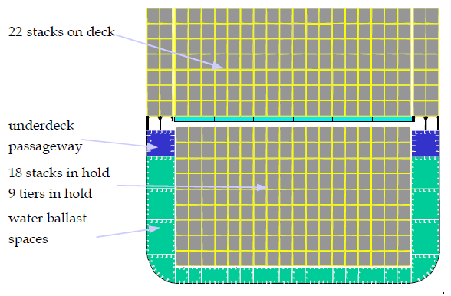

Figure 4. Conceptual design - *Wide Skin Option* [6]

A further design concept was developed with a narrow lateral structure, wide enough to accommodate only one row (width) of deck containers on each side. However, it is structurally much more demanding and difficult, and requires more careful consideration of structural aspects. This design has a capacity of 12,500 to 13,000 TEU containers [6].

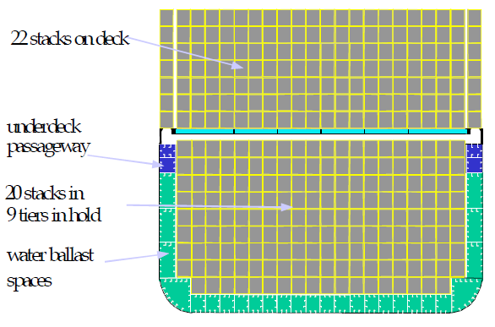

Figure 5. Conceptual design - *Narrow Skin Option* [6]

* 1. Ulcc construction characteristic

According to the SOLAS criteria of visibility from the navigational bridge, the maximum distance for the blind sector in front of the bow is determined by SOLAS chapter V. according to rule 22 (Navigation Bridge Visibility). Each vessel of 45 meters long or longer, built on September 7, 1990. or after that time, under load or ballast from the observation position on the command bridge may not have a blind sector in front of the bow, which is longer than two lengths of a ship or 500 meters, depending which size is smaller [7]. Because of their large ULCV length, their superstructure is located at approximately 1/3 of the length of the bow, to ensure visibility from the command bridge. Superstructure with a bridge over a conventional position above the engine room, with container vessels of capacity 12,000 TEU containers and above is no longer possible. No need for stern visibility.

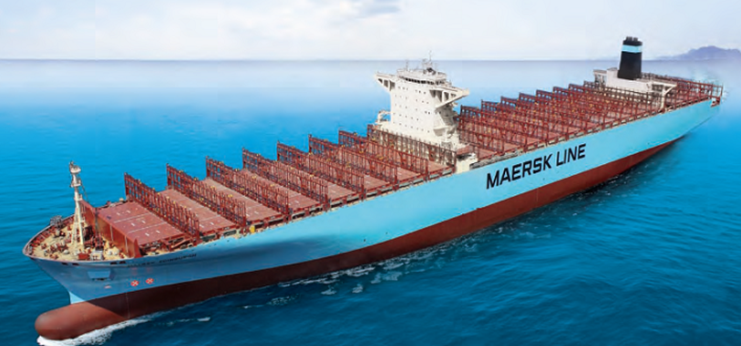

Figure 6. Fully Cellular Container Ship 13300 TEUs [8]

The engine room is located on the one third length of ship from stern with aim to reduce the propeller shaft length from the main propulsion to the propeller. This avoids large deflections of the propeller shaft as a result of its large length. Particular attention is paid to the hydro-dynamic properties of container ships because they are designed to achieve a high economic speed. The main decks are placed high and carry heavy loads. The high position of the deck can reduce the value of righting lever for uprighting the ships so tanks on these ships are very important. Large ballast tanks and powerful pumps are very important to trim the ship and to prevent hogging and sagging. Therefore, shipbuilders are trying to improve optimum regarding length, width, draft and other dimensions during building such a ships. Containers are stacked one above the other, with a weight of 20-foot containers up to 25 mt and 40-foot containers up to 30 mt. This has the resulting effect on the load of hatch covers and on the load of tank top fully through the four corner posts i.e. rest pads containers.

* 1. Holds characteristic for container ships

Inside the double bottom tank where are situated highly concentrated loads, should be ensured additional stiffeners. The size of the container to be transported greatly determines the construction performance. Vertical cell guides, shaped by the angular profiles, are the only additional structures in the storage space used for stacking the container when the ship rolling.

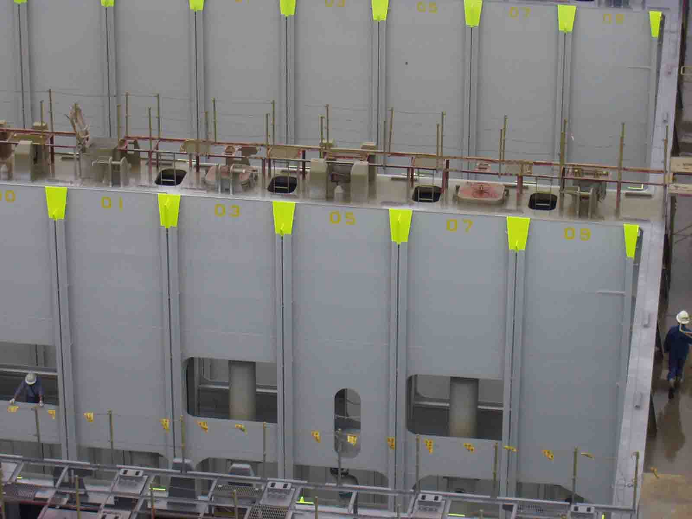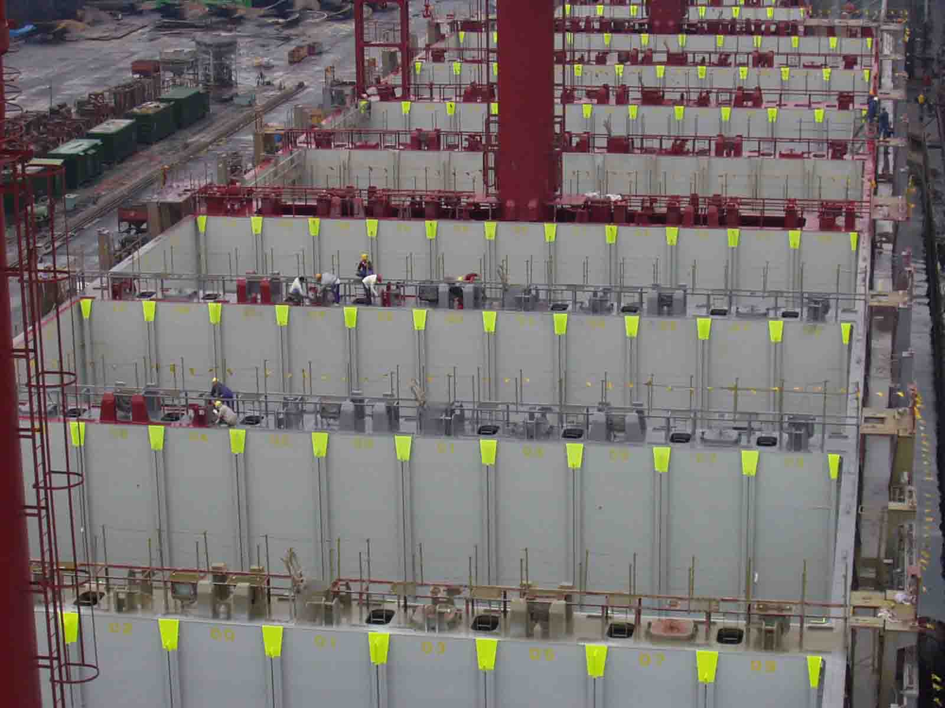

Figure 7. Cell guides in holds of container ship [9]

The hatch covers are heavy and big and present support to containers stowed on decks.

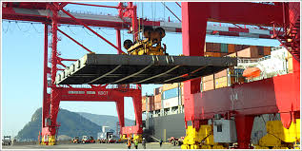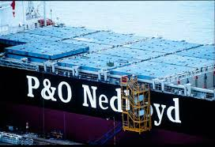

Figure 8. Hatch covers of container ship [9]

1. CONCLUSION

From all of the above, it is concluded that increasing draft improves the efficiency of transporting all variants for most homogeneous load conditions, increasing the widths for one or two rows, but maintaining the length only improves the efficiency of transport with a low homogeneous load condition. Further, it can be concluded that increasing the length for one ship's cargo hold (two BAYs), but holding the width of 23 rows improves transport efficiency for about 5% for all load conditions. Just increasing the width additionally increases the capacity, but does not have a positive effect on transport efficiency. The increase in length of ship for two holds (total of 28 BAYs) in relation with increasing the width to 25 rows would increase the transport efficiency by about 8% to 11%, depending on the average weight of the container. According to Maersk Line's, there is enough capacity in an existing merchant fleet to support a 3 percent annual growth in world trade over the next five years. Chinese carrier president and chief representative for North Asia said there is no need for new tonnage in the liner shipping industry. The existing fleet has 19 million TEUs (20-foot equivalent units), 2 million TEU in idle status, and a 3 million TEU order book has not yet been delivered. That's a total of 24 million TEUs. Until 2022, a million TEUs will be cancelled, leaving the world's fleet by 2022. of about 23 million TEUs. If world demand for goods increased by 3 percent per annum, from now on until 2022. a total of 22 million TEU would be needed.

REFERENCES

[1] Generacijska usporedba kontejnerskih brodova, 2016.

http://www.container-transportation.com/container-ships.html (25.09.2017.)

[2] DNV GL, Container ship update No.1/2014

[3] DNV GL, Container ship update No.1/2016

[4] NYK Line Maritime College, Singapore, 2010.

[5] Hyundai Heavy Industry; Full Celular Container Ship, 13300 TEUs, Shipbuilding 2011

[6] Jean-Paul Rodridge; Geography of Transport Systems, 2014.

[7] SOLAS poglavlja V. Pravilo 22: Navigation Bridge Visibility

[8] Hyundai Heavy Industry; Full Celular Container Ship, 13300 TEUs, Shipbuilding 2011

[9] Belamarić, G.: Privatna arhiva - praktični izvorni materijali i zbirka fotografija