CHARGING A CAR IN MOTION WIRELESSLY
BREZŽIČNO POLNJENJE AVTOMOBILOV V VOŽNJI
Dario Ležaić², Tihomir Mihalić ℜ, Andrej Predin³
Keywords: wireless on-the-road-charging, Dynamic charging, Li-Air, wireless tower, car body panels as energy storage system

Abstract
The concept is charging electric cars wirelessly, both stationary and in motion, via wireless modules prebuilt in roads or over energy towers that emit electrical energy through air. The wireless charging of electric cars means there is a completely new obstacle for engineers: one that competes with conventional battery charging. The conventional charging of high capacity batteries is simple, because current travels along a wire that is made of metal and is good current conductor. However, how is it possible to transfer great amounts of electricity wirelessly through the atmosphere?

Povzetek
V članku je predstavljena ideja polnjenja električnega avtomobila statično in v vožnji, preko brezžičnih modulov, nameščenih v cesti, ki se napajajo preko energijskih stolpov, ki emitirajo energijo skozi zrak. Brezžično polnjenje električnih avtomobilov predstavlja popolnoma nov inženirski pristop glede na konvencionalno polnjenje električnih baterij. Namreč konvencionalno polnjenje baterij zahteva kovinske vodnike, ki so dobri prevodniki, ne omogočajo pa polnitve v gibanju avtomobila. Izziv pa je, kako emitirati večje količine energije brezžično in to višjih moči?

1 INTRODUCTION
The Tesla company's conventional chargers can deliver about 120 kwh of energy and can charge a battery of 85kwh in approximately an hour. With new superchargers, it will be possible to deliver approximately 350kwh of energy; therefore, the speed of charging will triple and difference between charging electric cars (EC) and filling the tank of Internal Combustion Engines (ICE) cars and will be very little. What about wireless charging? Power levels of 120kwh for wireless technology presently are not possible because electric current that is running through metal conductors (made of metal with density of 8000 kg/m³) has enough particles on which to travel to the batteries. In contrast, air has 8000 times less density thus fewer particles on which the current can flow. This can be solved by using Tesla's coil for transforming high current of 500A and relatively low voltage of 120VDC and frequency into low current of just a few amps but very high voltage and frequency about 100kV and 50kHz; the specific parameters depend on the manufacturers and technologies used. That kind of current with high voltage and frequency travels faster through the air, carrying less “cargo” or less current; the current now can reach the batteries via the given amount of particles in air. The process of transforming voltage and current to the desired values and reversing it back again is fully automated and occurs beneath the car while parked over a charging station.
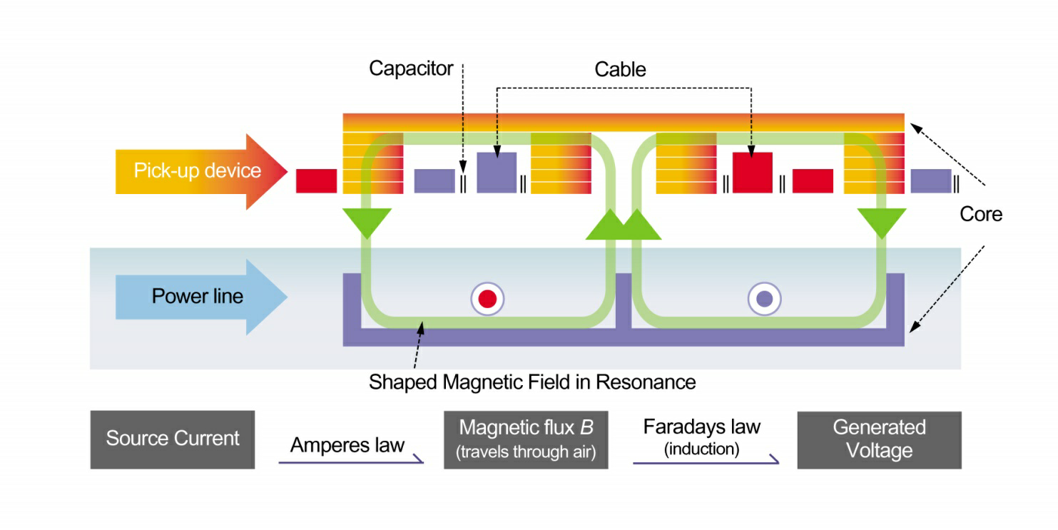
Figure 1: Wireless dynamic battery charging technology

2 WIRELESS BATERY CHARGING
This kind of energy transfer has great potential. The power of wireless charging varies in the range of 3.6 to 11 kWh depending of the manufacturer and the need of charging various battery types. With improvements of Qi (an open interface standard that defines wireless power transfer using inductive charging over distances) technology, somewhere between 22 to 25 kWh of energy is possible in the near future for the same battery capacity and device that is used now. An interesting idea for both static and dynamic battery charging is in a system of public transportation. Buses and trams have predetermined routes; therefore, installing wireless chargers in every station or every two stations can provide continuous battery charging and the overall battery capacity of used batteries can be reduced, which in the end reduces the high cost of manufacturing them. In this manner, wires hanging above the tramlines could be removed, but electrical charging for all public transportation would remain possible.
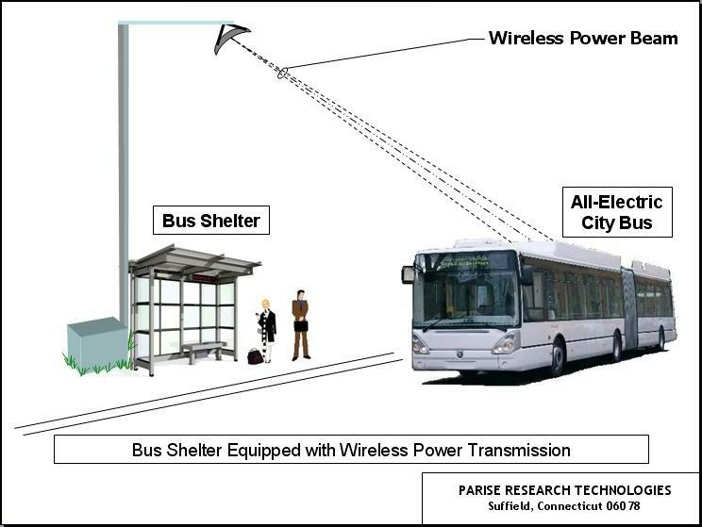
Figure 2: Diagram of using wireless charging technology in public transportation .
With the further development of solar panels, this number can be expanded, because every minute spent in sunlight means that the range is further extended; in combination with the wireless charging of cars in motion, market development and the buying of electric cars will be hastened. Furthermore, any excess energy that is produced could be sent back to the grid, thus reducing grid costs; it could also power nearby devices, such as mobile phones. This could provide added benefit to waiting passengers.
If we apply those ideas to cars we can discuss extending the ranges of Electric Cars.
In particular, with current technology, solar panels with installed power of 4 kWh could give a radius of driving about 40 kilometres, which is enough to commute from home to work or from work to the nearest charging station. If the battery was completely drained when a driver arrived at work in the morning, this 40 km can help without any extra cost or worries; if the battery was at 50%, this extra 40 km safely guarantees the drive back home or even another, unplanned ride.
The latest achievement on the market is CED (Continuous Electric Drive technology), which was introduced by the car manufacturer Volvo. It already has a prototype, which will introduce this new engineering achievement to the public and it can be implemented in new vehicles very soon. Figure 3 shows Volvo’s concept car with installed dynamic wireless charging technology.
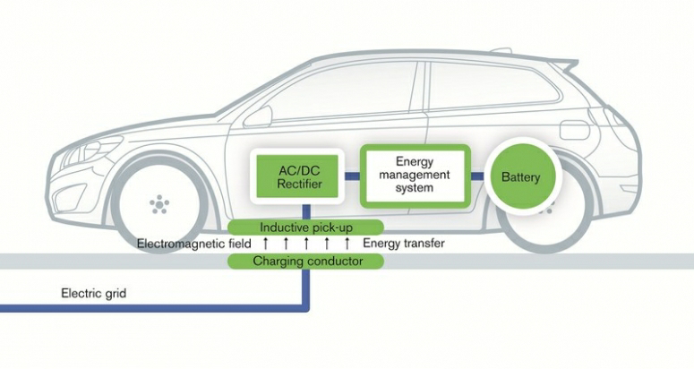
Figure Picture 3: Volvo’s concept car with installed dynamic wireless charging technology
Volvo has stated that its new prototype of electric car is ready for production and that it is fully adjusted for a dynamic wireless charging with a system called CED, which stands for Continuous Electric Drive. This technology is widely used in electric trams and railway systems in which a constant power supply to drive motors and batteries is used just to provide electric energy in emergency situations like gird failure or crashes; their capacity is just around a few kWh. However, with the CED system, engineers are adopting that idea just to power main motor for vehicle propulsion and to make it more efficient. Everything unnecessary will be removed and a smaller battery pack will be installed, which will be enough to power a car in non-charging areas; when it returns to the main grid, it will charge the battery fully and continue to use wireless power to move. By adopting this usage protocol, a car’s range will be practically unlimited. This technology is very expensive today because of the necessity of installing thousands of kilometres of cables under the roads; it is technologically feasible, but a better solution may be found elsewhere.
Another idea is to build a tower that could broadcast energy like a TV tower broadcasts signals. An electric car consumes about 11 to 15 kWh of energy to travel a distance of 100 kilometres. Wireless technology which can deliver 11 kWh of power, which would be enough to provide driving over 90% of a given ride and only 10% would be covered by energy from battery. This means that current electric cars with an average range of 150–160 kilometres could travel a distance of 1400 km with this new CED system. Of course, there is always a question of cost effectiveness for the previously mentioned system because this would require to completely reconstructing city roads to achieve this goal. With this in mind, perhaps building a one or few central towers to provide cars with electric energy would be a cheaper and better solution. Recent researches shows that electric towers can send 10 kWh of electric energy in radius of 500 meters; in this phase, a few towers to provide a whole city with enough power but in the future, range and power will grow so it will no longer be a problem.
The technology that is used in energy towers is based on microwaves. Microwaves, because of their ability to move through air at high frequencies, can deliver small amount of the energy in a given time but because of high frequency and the wider aspect of time when using more towers, greater amounts energy can be delivered.
Furthermore, another idea is to use the car’s body panels as batteries, which will significantly lower the weight of current EC caused by the additional weight of batteries.

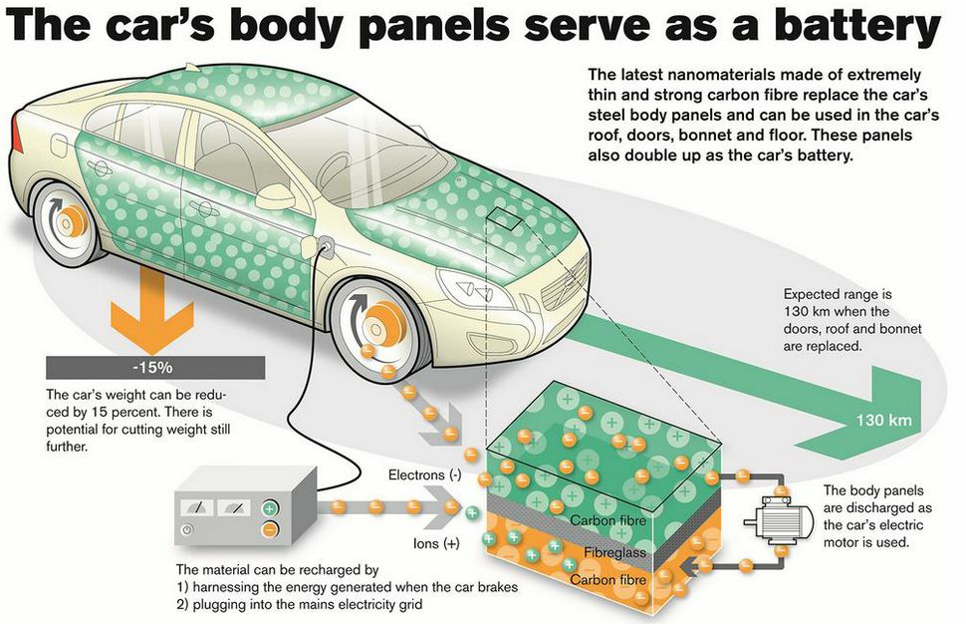
Figure 4: Volvo’s system to use car body panels to serve as energy storage.

3 FUTURE DEVELOPMENTS
The race for new technologies and development never stops. If VOLVO successfully implements its idea about using car body panels for energy storage, it would create a completely new perspective on how batteries look and how energy will be stored in future. Conventional battery packs will become obsolete because there would be no need to use the plastic housing for battery cells. With this, a car’s payload and usable volume will increase. The same thing happened with USB flash memory. At first USB flash drives had housing 10 times bigger than the USB connector, and now the USB connector is 4 times bigger that the rest of the device which can now store up to 10 times more data. The best solution for this system would be usage of Li-Air batteries with great capacity and also usage of dynamic wireless charging to make cars lighter and to increase the range above 1000 km, body panels to store energy, and CED technology.

5 CONCLUSION

The vehicle production industry undoubtedly goes forward with new technologies. Now more than ever before, it is essential to reduce emissions of CO₂ in every way possible. Electric cars are very helpful in this situation because conventional cars produce large amounts of pollution. With the development of CED technology and fast battery-charging, electric cars become very attractive to buyers. The mass production of electric cars will lower their price, which is currently a significant obstacle to overcome when buyers decide which car to buy.

References
[1] Schrack:, Jednostavni Li-Ionski Fotonaponski sustavi, 2015
[2] Wikipedia: Tesla coil

Nomenclature
ICE | Internal Combustion Engine
EC | Electric car
CED | Continuous Electric Drive

Corresponding author: Tihomir Mihalić, PhD., University of Applied Sciences, Karlovac, Tel.: +385 98 686 072, Mailing address: I.Meštrovića 10, Karlovac, Croatia E-mail address: tihomir.mihalic@vuka.hr

