DIGITALIZATION IN CONTAINER SHIPPING INDUSTRY

Vladimir Jerebić
Bukovačka Cesta 282a, Zagreb, Croatia

Summary
Due to late start, container shipping is now under the continuous imperative to develop and implement sustainable digital system that will increase operational efficiency. In order to seamlessly merge their shore and seaborne transporting operations within the global supply chains, the various measures, procedures, programs and plans are being developed and implemented by shipping companies. Modern shipping demands better operational visibility during the sea voyage, timely access to information with more focused customer orientation. Transparency in cargo management, complete tracking and tracing of shipments and full integration of their core processes within innovative integrated digital frame are key factor for ensuring the quality of service and market competitiveness. This process is known as a digitalization. The paper will present major trends, processes, demands and challenges facing the digitalization implementation into container shipping industry and as well as an overview to possible future developments.

- INTRODUCTION

The shipping industry is under considerable pressure to increase overall operational efficiency. Particularly because the period since 2008 crisis has been very difficult for the container shipping, causing overcapacities, low rates across all segments of industry, bankruptcies and need to conduct mergers and acquisitions in order to survive on the market [1].The industry has endured and the rates are now slowly picking up and consolidation of competitors are bringing stability to the market. The gradual rise of freight index could be seen on Figure 1:
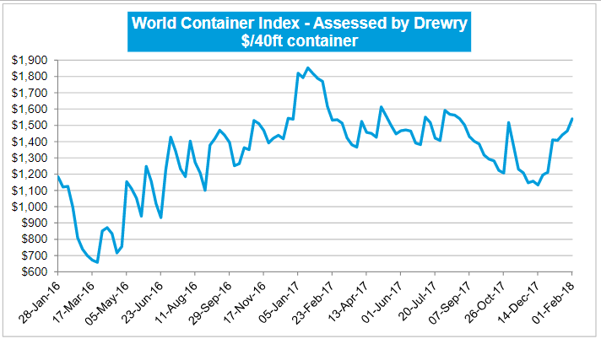
Fig. 1. Container Freight Index, Source [2]

However, the markets have become much more complex and shipping companies are facing the fiercer competition and stringer regulations than ever. Vessel are faster and bigger in order to reap the benefits of economy of scale. Supply chains have changed to, caused by the global division of labour, ever decreasing logistic costs and the development of new markets. The rise in trade volumes and subsequently in port volumes, increasing competition, availability of new shipping routes, demands from customers for slimmer operations and lower prices, on time delivery reliability as well as better visibility and transparency along the supply chain and customer orientated approach with easy access to information through user friendly platforms have imposed upon the shipping companies a biggest challenge - implementation of digitalization.

- DEFINITION OF PROBLEM

2.1. Getting Started

Major carries have been slow to develop, adopt and implement digital technology within their day-to-day operational business practices, though, they had many opportunities. Neither in area of direct customer relations or to improve their operation and realize potential growth across the market. Also, it has been observed a failure to take systematic approach. Operational human intervention throughout the voyage is still required, either to re-stow the cargo because of destination change or in document management. Fields of network management, fleet repositioning, equipment scheduling, cargo routing and forecasting, as well as pricing are the core processes that could and must be digitalized to achieve efficient, uninterrupted operation. Unfortunately, most of carriers are still handling them in very traditional way. Major reason for late start of digitalization was a belief that it starts by creating a sophisticated IT platform. Such equipment may be a prohibiting due to its costs and in constant struggle to maintain liquidity by controlling the operational expenses, the move has been continuously postponed. However, the studies have shown that process should begin from gradual enhancing the existing systems. In the meantime, problem of imperfect data stream should be solved by using advanced analytic solutions with present digital tools. At same time, steps must be taken to improve the reliability of data gathering and exchange. Finally, once decision to commence process has been brought up, a firm and decisive steps must be taken to achieve initial benchmarks. Initial success will help fund further developments. Therefore, such an approach will enable a full-scale digital transformation.

2.2. Major Impact Areas and Digital Trends

The principle areas of concern may be generally divided in four major groups that cover wide range of operational activities, starting from the booking of cargo, through cargo reception, carriage and care, documents management, financial arrangement and eventually cyber security of own and customer data. Those groups are shown on Figure 3:

- Planning,
- Operations,
- Commercial and
- Support functions

It is only naturally that those functions are intertwined and overlapping each other area, creating an uninterrupted flow of cargo, documents and information [3].
Based upon above, seven digital trends have emerged that have high significance in the container shipping industry. Those trends are key factors that contribute to overall efficiency of carrier’s performance as a whole. They are processes, concepts, systems or application, as well as innovative technologies such as artificial intelligence or autonomous terminals, vessels and robotics that combined together tend to bring a completely new operational reality into the present markets Those trends are:

- E-Platforms (portals & web sites),
- Advanced Analytics,
- Internet of Things,
- Artificial Intelligence,
- Autonomous Vessels and Robotics,
- Block Chain Technology and Cyber Security

Those trends, depending on their level of sophistication and implementation into carrier’s operational procedures, may influence the efficiency and productivity of complete process. For some activities to bigger, while on some to lesser degree. The Figure 2 shows the cross matrix of digital trend and its effect upon the major areas of operation:

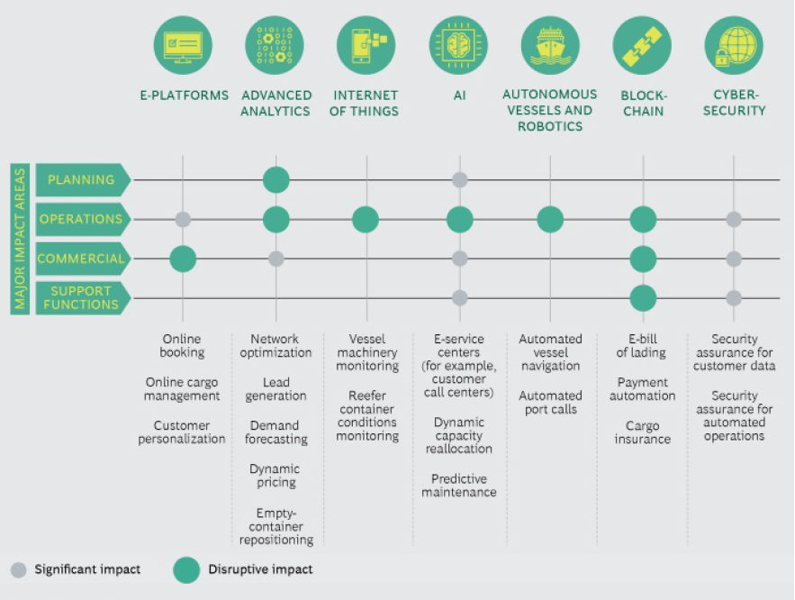
Fig. 2. Digital Trends, Source [4]

As visible from Figure 2, commercial operations which are customer oriented greatly depend on properly developed user friendly web platform. Such portal must offer complete service, from online cargo booking, tracing of shipment until final delivery details. The ultimate goal is complete transparency with highly personalized approach toward customer’s specific needs. Advanced analytical tools, software programs and algorithms that optimize vessel routing and scheduling, cargo handling in ports and on board the vessels are integral factors in operational cost savings, fuel efficiency and environmental protection.
On average, only 76% of shipments in the world are completed in time, as planned. With implementation of artificial intelligence, Internet of Thing and Block Chain technology, it is estimated that up to 99% of reliability is expected [5]. And last, but not least important, particularly in recent years is cyber security. Critical business data of carriers and customers must not be left venerable for outside access, hence improving the trust and loyalty of customer, high level of service and finally better competiveness on the market.

- PATH TO DIGITALIZATION

An approach to development and implementation of digital system within the full range of operations of container shipping company demands systematically, comprehensive and careful set of properly measured steps. The build-up must commence from its fundamentals, defining the complete system, based on industry need, taking account of all the key participants within the process. Customers, cargo booking agents, vessels, terminal operators, logistical support units, insurance, government officials, etc...
A holistic approach must be taken to digital transformation of container shipping company, answering the strategic question why we are about to start the process, clearly defining the scope of implementation. Next is to decide what should be done and in what order, clearly setting the pace of proceeding, according to carriers need and abilities. Finally, it should be agreed upon how to do the transformation, making the foundation of digitalization firm throughout the carrier’s organization.

3.1. Defining the path

The clear definition of carrier’s digital identity is of utmost importance for creating the full commitment to organization wide approach. Definition should point toward those areas [6]:
- Business needs; Primary objective must be
identifying the ways to improve its business needs along the value adding chain of service. The scope should cover all the key activities, from shipping requests to final delivery. Also, it is critical to evaluate potential impact of new competitors and how to respond to such challenges.
- Inspiration; Transportation is derivation of
trade and production. Customers and logistic forwarders set trend how to use digital technologies and what are their preferences. Those are the areas where inspirational ideas for development should be looked upon.
- Setting a pace; It is very important that all
the activities are based on real assessment how fast and how much could be done. Proper evaluation of carrier’s readiness, financial, organizational and technical to adopt digital changes is the main factor at what pace the process will proceed.

3.2. Digitalization of the Core Business

Previously mentioned major areas of business, Planning, Operational, Financial and Support functions should be addressed during the process. This is the most challenging part of the process, but the opportunities for carrier to create an exceptional values are the greatest as well. The structure and scope of process may look as below figure 3:
Digitalization of Core
Planning
Commercial
Operations
Support Functions
Voyage
Fleet
Port & Cargo
Capacity
Inter-modal
Analytic
Customer Online Experience
Sales Force Effectiveness
Dynamic Pricing

Shared Service Centers
Procurement

Fig.3 Digitalization structure of core, Source [4]
In order to properly optimize their network planning, carrier’s need advanced analytic tools and team capable of handling them. Either internal or third parties. It is estimated that more than 100 000 variables are included in day to day running of the value chains [7]. Due to such complexity, proper analysis demand steady flow of operational and commercial information, later processed in optimizing algorithms.
There is a wide range of operational activities that can benefit of digital technologies applications.
Position, speed, fuel consumption or weather influence are information that could be monitored in real time from the central point – an operation centre. In addition to providing the visibility along the voyage, the key decision could be anticipated and voyage optimized, hence operating costs significantly reduced.
Monitoring of machinery performance, proper inventory control and on time delivery of spare parts and execution of scheduled maintenance will greatly reduce the down time [8].
Container ships spend 30% of their time in ports. However, shorter port time results in longer voyages. Longer voyages lower required speed to reach destination and results in fuel savings. Digital connectivity will certainly improve documents flow among the concerned parties. Crew may have all the data in advance, creating so called “single point entry” and reducing waiting time in port for port call preparation [3].
Very same applies to cargo operations, capacity management and inter-modal operations. Expensive operations of re-stowing cargo due to poor utilization of vessels capacity may be avoided by application of comprehensive cargo forecasting, loading and planning programs, such as MACS3. At same time, major carriers are expanding their service inland, offering complete inter-modal solution with so-called “door to door” service. Solutions may calculate the final price of the transportation and offer the best option, keeping the carrier on competitive edge.
Commercial activities may be improved considering the following opportunities to increase the efficiency.
First and foremost, an on-line portal that enables the customer to receive instant quotes, receive the full range of information concerning the carriage of their good and monitor their shipping could prove to be the most demanding aspect of digitalization of core business. Due to myriad of factor involved, starting with the fluctuating fuel price, various countries tax regimes, poor satellite connections at open oceans and sheer number of parties involved it is very taxing process and it must be approached with firm resolve, funds and knowledge.
Today carriers, being very traditional business operators neglect the leading generation specific behaviour as a customers. Modern managers are data driven, web oriented with demand to instant access to solutions. If such sales offers are achieved with high level of precision, the sale force can define the personalized offering, hence creating long-term customers retention.
Container market is ever fluctuating. Information, prices and condition valid now are subject to quick change. As said before, dynamic pricing, based on historical data, pairing the evolving rates, by using the advanced statistical values, such as seasonal periods of favourable market conditions may improve the overall profitability up to 5% [4].

3.3. Expanding the Core Business

Besides the core business offering to their customers, carriers may seize the opportunity to offer a new digital solutions. Those process may go through two steps.
First will be to offer those, new opportunities to present customers, based on in-depth knowledge on their needs. For example, offer the complete trade financing.
As a second step, carriers may expand their visions outside the core business, such as industry platforms and marketplaces. Such development may remove the long standing industry inefficiency with enforcing contracts with shippers and by that increase the predictability of utilization or by offering the digital supply chain management.

- CONCLUSION

Digitalization is often referred to as a new industrial revolution within the container shipping industry. To succeed and remain competitive on the very tough shipping market, carriers must be resolute to and willing to invest a significant amount of resources and time.
The lack of vision and final goal must be overcome and detailed plans for adoption of digital technologies adopted. Step to step execution is needed to avoid pitfalls of shortages of skilled personal workers or initial troubles while implementing the system.

A structured and above all disciplined approach is imperative for successful digital adoption. Time is running short for an industry already being behind and it is a last moment to start with implementation process.

- REFERENCES

[1] V. Jerebic, S. Pavlin, Global Economy Crisis
and its Impact on Operational Container Carriers Strategy, PROMET - Traffic & Transportation, Vol. 30, No.2, pp 187-194, 2018
[2] Container News Portal, Available:
http://container-news.com/world-container-index Accesssed: August 2018
[3] Haralambides, Structure and Operations in the
Liner Shipping Industry, Handbook of Transport
Modelling, Elsevier Ltd, 2007
Accessed: August 2018
[4] H C.Egloff, U.Sanders, J.Riedl, S.Mohotalla, K.
Georgaki, The Digital Imperative in Container
Shipping, BCG Shipping portal, February 02.
2018 Aviable: http://bcg.com
Accessed: August 2018
[5] HDS- International Group, Analytical Portal,
Digitalization in a Field of Ocean Freight,
Available:
http://www.hds-international.group/en/home
Accessed: August 2018
[6] DIGITALIZATION: The Group
Transformation is Under Way, CMA CGM Magazine, Marseille, France, summer 2018, Available: http://www.cma-cgm.com/media
Accessed: August 2018
[7] Daft, R. L. , R. H. Lengel “Organizational
information requirements, media richness and
structural design.” Management Science 32 (5),
554-571.
[8] I. Constantinou, A. Shollo, K. Kreiner,
M Vendelo, Digitzationin Maritime Industry:
Coping with a Vessel’s Engine Failure, Twenty-
Fifth European Conference on Information
Systems (ECIS), Guimarães, Portugal, 2017

